Findit /ICSD and Diamond-2

Database retrieval program and visualisation software.

Short expose written by Lasse E. 25-oct-2003
Findit / ICSD

The first view of Findit/ICSD looks approximately as below.
Choose the search icon (the only available active icon) to start searching the database.

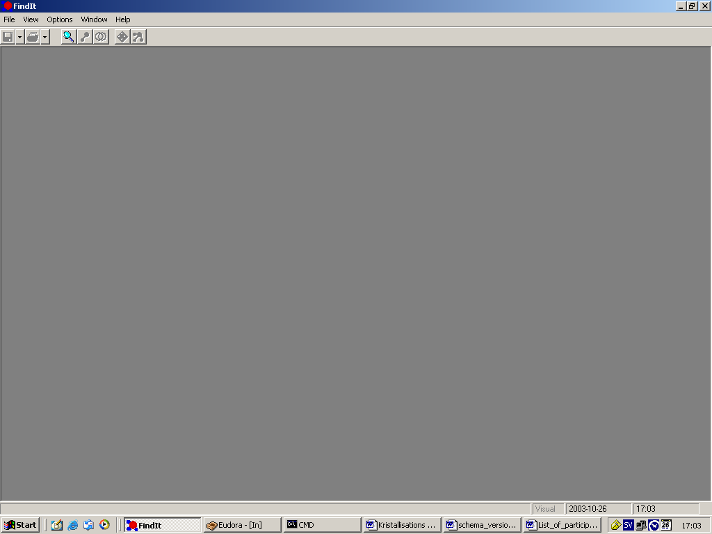

When entering Findit, one can specify searches with different criteria

- Chemistry
- Crystal data
- Reduced cell
- Symmetry
- Reference

Here below I have chosen to search for compounds containing S, Cl and Fe together with the criterion that the crystal system should be triclinic, monoclinic or orthorhombic.

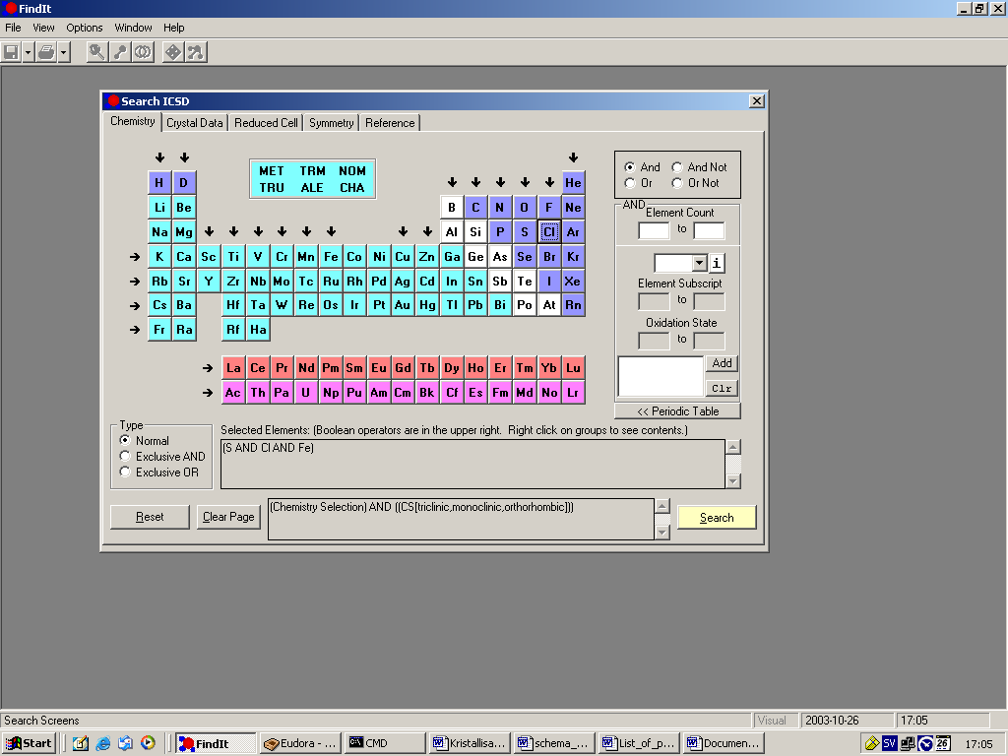

Clicking the yellow “search” button in the lower right of the window starts the search, which may take a considerable time… Previous version of search software were much faster but this one may be better in other ways…

The result of the search is shown below. In total 11 different compound was found matching the search criteria.
Use the icon “check/uncheck page” to check all boxes in the list of hits. If you know exactly what you want to keep and continue working on, just select a few of the hits.

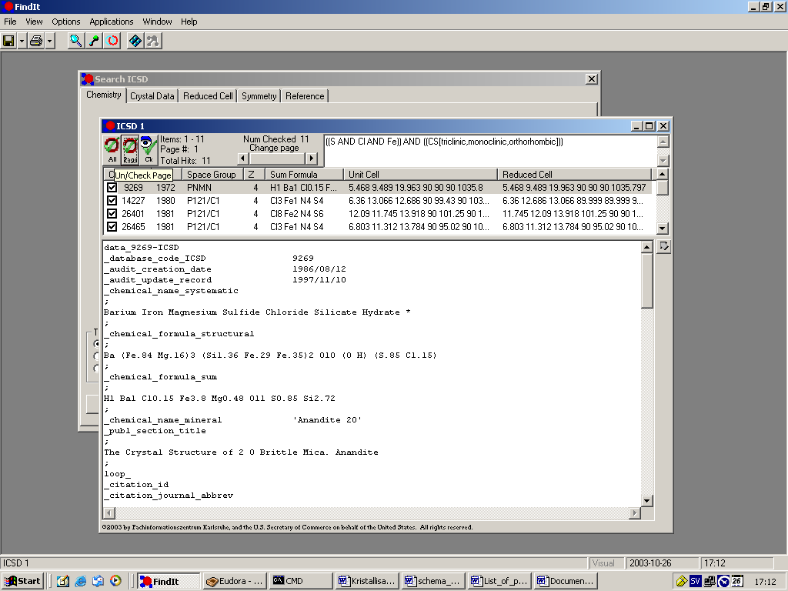

In principle now you can use the visualising software delivered by NIST/ICSD with the icon most far to the right in the Findit-window. This is however not recommended here, at least not in the beginning as we want to store the hits in an external file in the cif-format.

Of course you should experiment with the NIST/Findit visualiser as it has some features not found in some other visualiser, for example the ability to simulate powder patterns for each hit. But this is not part of this short indtroduction.

Part of the cif output for the grey marked hit is shown in the lower part of ICSD 1 window. For more details of the cif format look up the international crystallography union homepage: www.iucr.org or the Swedish mirror site: http://www.se.iucr.org/iucr-top/index.html at SU.

Export all of the checked hits to a file in the cif format. Note that you should not use file/”save search results” unless you will continue working with the findit software. Cif format is much more general and we will have use of it in other circumstances.

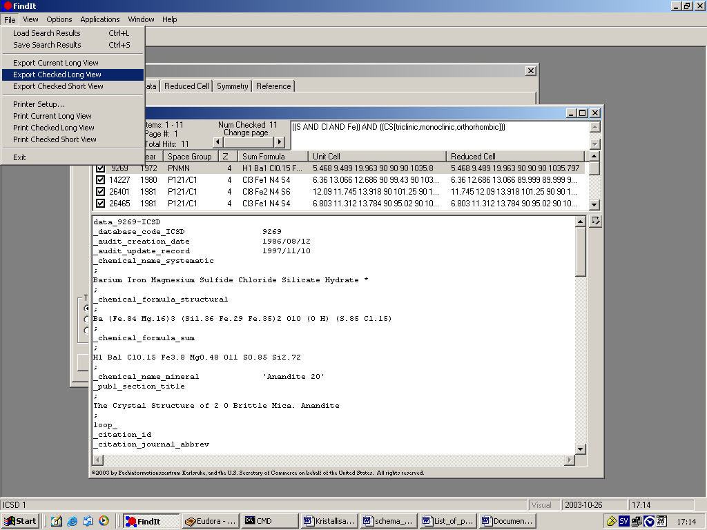

Select where to store the file: In the display below I have chose to store it at C:\kurser\struktur\ht03\icsd.cif

The natural place for storing your own data will be D:\skurs\myname\ at least when running examples at the course of structural chemistry…

The need for discipline and order cannot be underestimated when dealing with computers and modern software, producing files in an increasing rate.

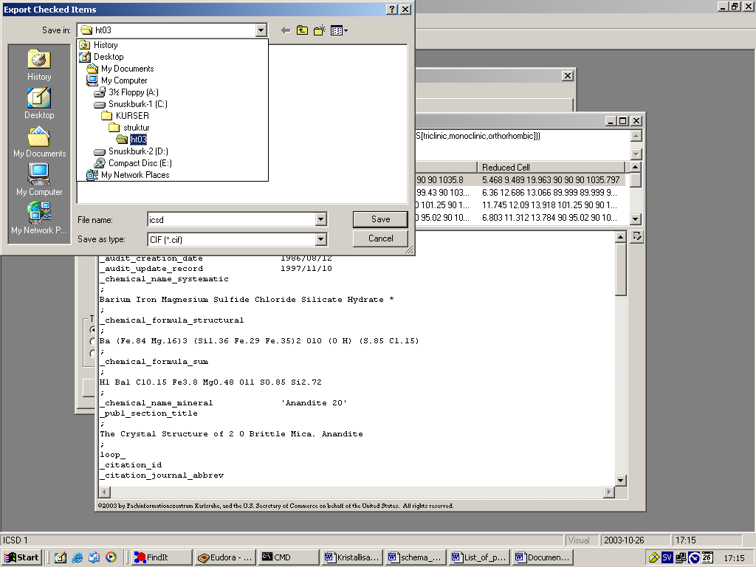

Well, actually storing the file looks something like this.

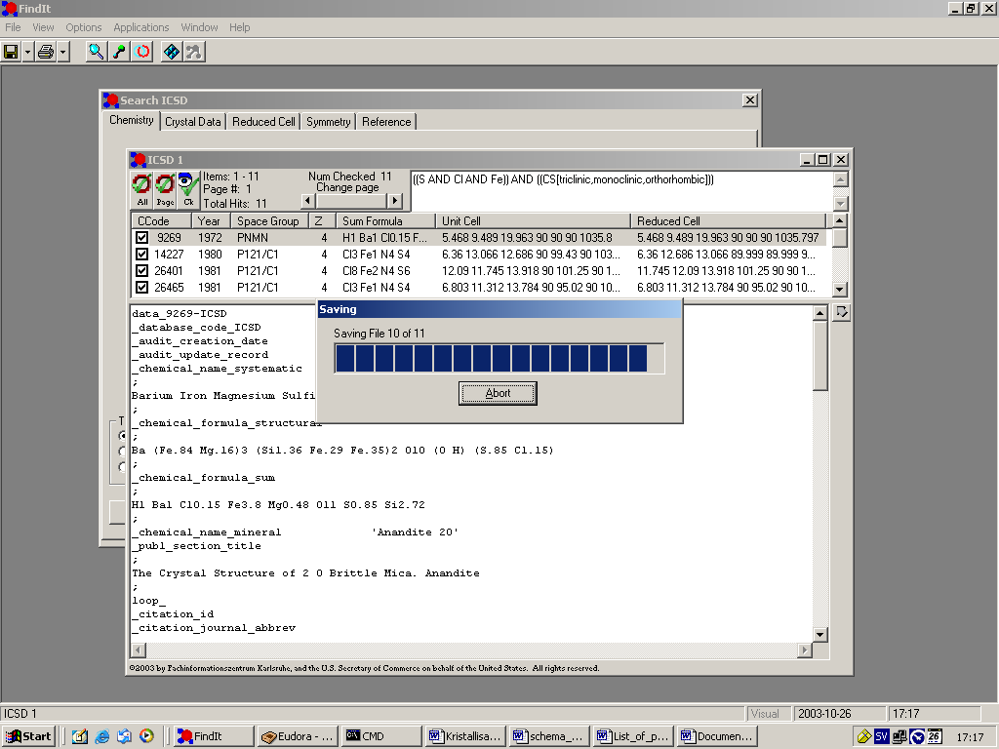

And part of the file looks like this:

data_14227-ICSD
#©2003 by Fachinformationszentrum Karlsruhe, and the U.S. Secretary of
#Commerce on behalf of the United States. All rights reserved.
_database_code_ICSD 14227
_audit_creation_date 1980/12/31
_chemical_name_systematic
;
Tetrasulfurtetraimide Iron(III) Chloride - Alpha
;
_chemical_formula_structural 'S4 N4 Fe Cl3'
_chemical_formula_sum 'Cl3 Fe1 N4 S4'
_publ_section_title
;
S4 N4 und seine Derivate: alpha-Fe Cl3*(S4 N4), ein
Uebergangsmetallkomplex mit dem S4 N4-Ligand
;
loop_
_citation_id
_citation_journal_abbrev
_citation_year
_citation_journal_volume
_citation_page_first
_citation_page_last
_citation_journal_id_ASTM
primary
;
Zeitschrift fuer Naturforschung, Teil B. Anorganische Chemie,
Organische Chemie (33,1978-41,1986)
;
1980 35 855 859 ZNBAD2
_publ_author_name 'Thewalt, U.'
_cell_length_a 6.360(2)
_cell_length_b 13.066(4)
_cell_length_c 12.686(5)
_cell_angle_alpha 90.
_cell_angle_beta 99.43(3)
_cell_angle_gamma 90.
_cell_volume 1039.96
_cell_formula_units_Z 4
_symmetry_space_group_name_H-M 'P 1 21/c 1'
_symmetry_Int_Tables_number 14
_refine_ls_R_factor_all 0.053
loop_
_symmetry_equiv_pos_site_id
_symmetry_equiv_pos_as_xyz
1 'x, -y-1/2, z-1/2'
2 '-x, -y, -z'
3 '-x, y-1/2, -z-1/2'
4 'x, y, z'
loop_
_atom_type_symbol
_atom_type_oxidation_number
Cl1- -1
Fe3+ 3
N3- -3
S3+ 3
loop_
_atom_site_label
_atom_site_type_symbol
_atom_site_symmetry_multiplicity
_atom_site_Wyckoff_symbol
_atom_site_fract_x
_atom_site_fract_y
_atom_site_fract_z
_atom_site_occupancy
_atom_site_attached_hydrogens
Fe1 Fe3+ 4 e 0.2222(2) 0.0095(1) 0.1874(1) 1. 0
Cl1 Cl1- 4 e 0.0972(5) -.1149(2) 0.0814(2) 1. 0
Cl2 Cl1- 4 e 0.4450(4) 0.1025(2) 0.1151(2) 1. 0
Cl3 Cl1- 4 e 0.3631(4) -.0525(2) 0.3426(2) 1. 0
S1 S3+ 4 e -.1318(4) 0.0893(2) 0.3260(2) 1. 0
S2 S3+ 4 e 0.2365(5) 0.1620(2) 0.4757(2) 1. 0
S3 S3+ 4 e 0.3383(5) 0.2981(2) 0.3064(2) 1. 0
S4 S3+ 4 e -.0473(4) 0.2206(2) 0.1720(2) 1. 0
N1 N3- 4 e 0.0032(12) 0.1069(6) 0.2229(6) 1. 0
N2 N3- 4 e 0.0118(14) 0.1162(7) 0.4355(6) 1. 0
N3 N3- 4 e 0.3685(13) 0.2103(7) 0.3920(7) 1. 0
N4 N3- 4 e 0.1371(15) 0.2979(6) 0.2172(6) 1. 0

loop_
_atom_site_aniso_label
_atom_site_aniso_type_symbol
_atom_site_aniso_U_11
_atom_site_aniso_U_22
_atom_site_aniso_U_33
_atom_site_aniso_U_12
_atom_site_aniso_U_13
_atom_site_aniso_U_23
Fe1 Fe3+ 0.024(1) 0.032(1) 0.036(1) 0.001(1) 0.007(1) -.004(1)
Cl1 Cl1- 0.061(2) 0.044(2) 0.041(1) -.011(1) 0.008(1) -.009(1)
Cl2 Cl1- 0.034(1) 0.064(2) 0.057(2) -.008(1) 0.015(1) 0.003(1)
Cl3 Cl1- 0.044(1) 0.050(2) 0.042(1) 0.013(1) 0.000(1) 0.001(1)
S1 S3+ 0.031(1) 0.048(2) 0.057(2) -.005(1) 0.020(1) 0.0(1)
S2 S3+ 0.055(2) 0.062(2) 0.027(1) 0.011(1) 0.005(1) 0.000(1)
S3 S3+ 0.051(2) 0.053(2) 0.060(2) -.023(1) 0.018(1) -.007(1)
S4 S3+ 0.046(2) 0.039(1) 0.034(1) 0.010(1) 0.002(1) 0.003(1)
N1 N3- 0.027(4) 0.034(5) 0.047(5) 0.004(4) 0.011(4) -.004(4)
N2 N3- 0.054(6) 0.048(5) 0.037(5) 0.002(5) 0.029(4) 0.003(4)
N3 N3- 0.034(5) 0.067(6) 0.040(5) -.005(5) 0.0(4) -.010(5)
N4 N3- 0.066(6) 0.032(5) 0.037(5) -.004(4) 0.022(4) -.004(4)
#End of data_14227-ICSD

Then a new structure begins in a similar fashion..

Diamond

Starting the visualizing software: diamond-2, and reading the crystal data from the previously stored file will enable us to draw pictures of the structures.
Fisrt do File / open and select the file to read. Note that you must specify filetype .cif or “all files” in order to be able too see the files.

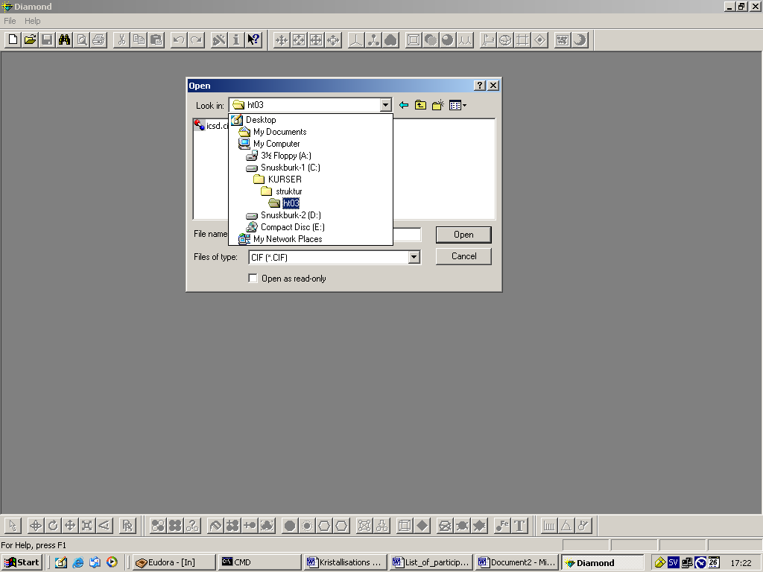

The present file contained crystal data for all of the structures that were found in the Findit search. Select one of them …

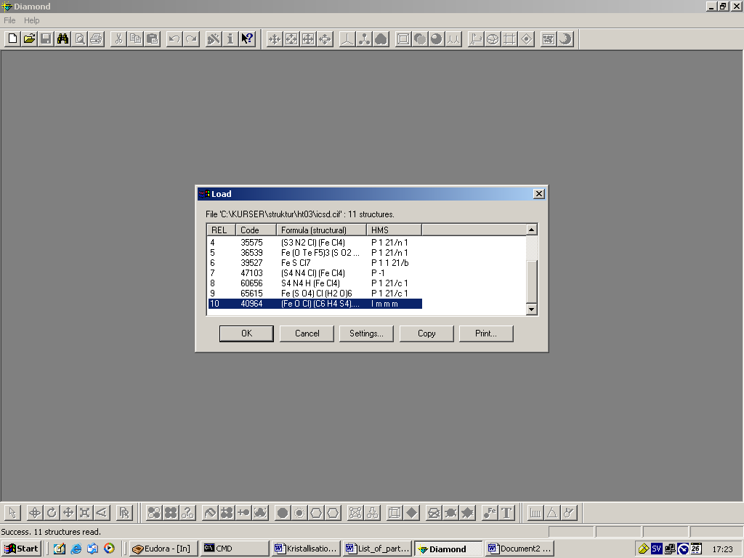

The first thing you’ll see will be a blank screen. Diamond only shows what you instruct the program to show, nothing else…
With the right button of the mouse you may have a small list of choices, here below we choose to fill the whole unitcell.

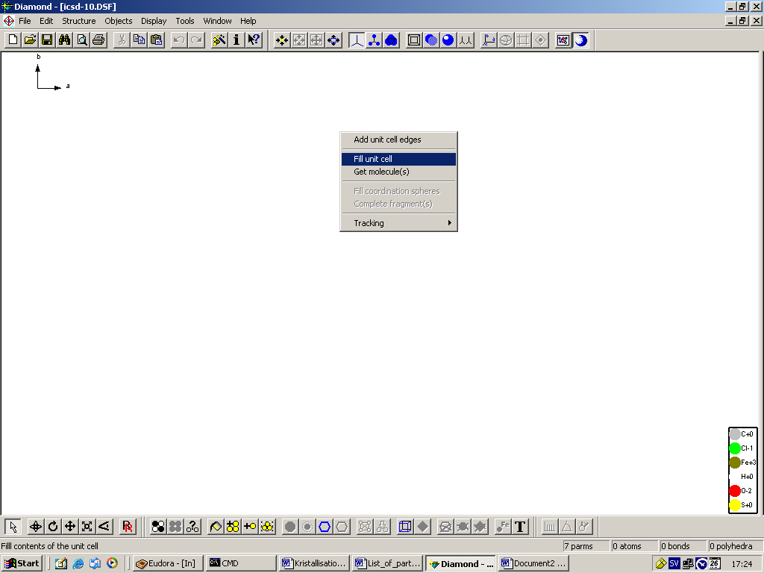

The content of the unit cell is shown below.

Rotation, zooming etc may be accomplished by the icons in lower toolbar at the left. In the picture below the rotation icon is active. Holding down the left mouse button and moving the mouse will rotate the figure. In the upper toolbar the ball and stick model and the rendering icons are selected. If the view overflows the borders of the screen one can do display/adjust to adjust the picture to the screen borders or use the icon .

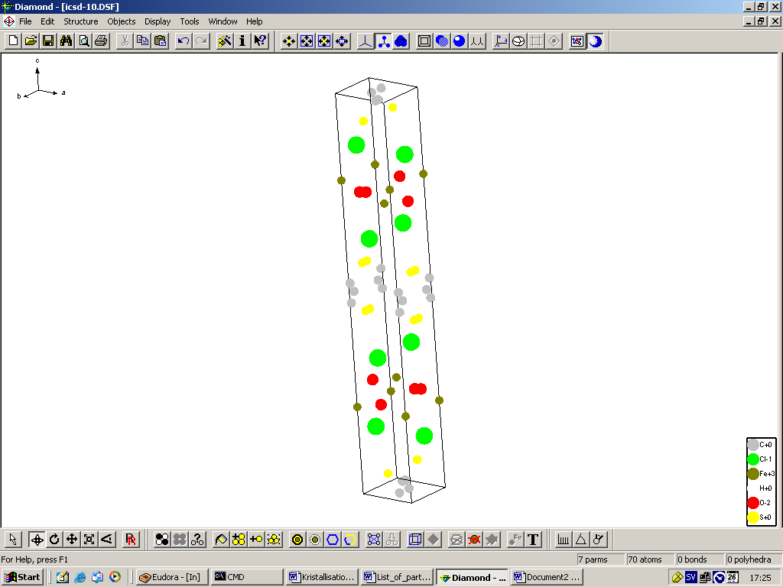

Note that no symbols for bonds are shown above. No bonds has yet been selected, furthermore the bonds are not as real as the actual atoms which may be a reason they’re invisible (?).

In order to have bonds present in the view you must use structure/connectivity and select which contacts that should be indicated as bonds, by which symbols and the lower and upper limits of the distance.

In the figure below we went back and selected another compound as the previous compound was somewhat disordered and presented quite nasty distance histograms.

Use the “evaluate” button and select lower and upper limit for each bond type. Finally select the “connect” button and the picture will be something like the one shown below, behind the connectivity window.

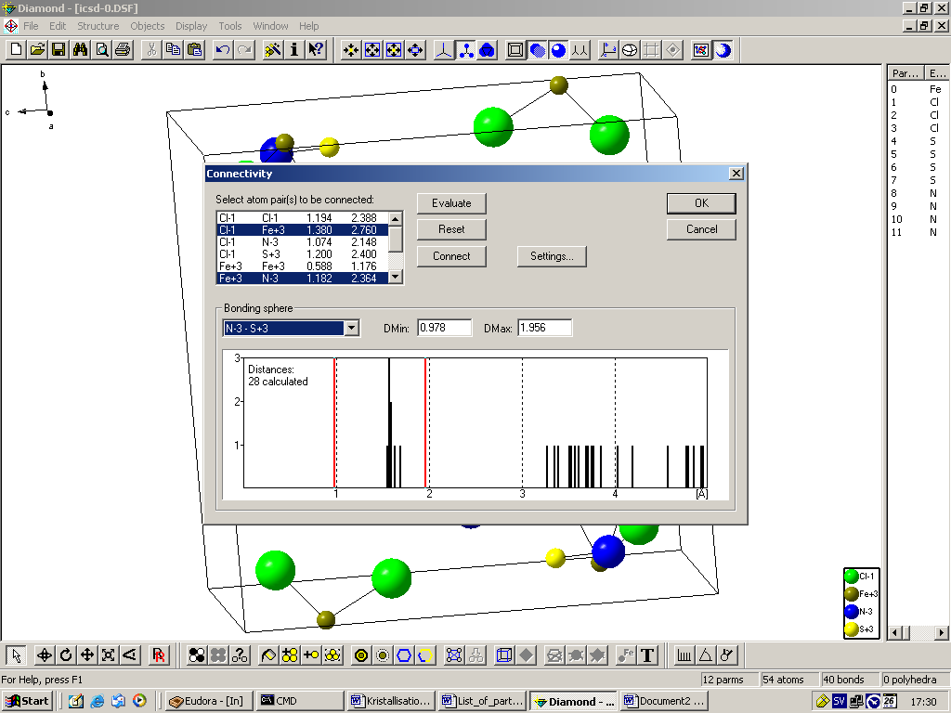

That is, something like the picture below. In this picture both of the icons , depth queuing and lightning were selected as active. The result will be more “nice” atoms. Note that the atoms shown in the picture, all are inside the unit cell or at least at the surfaces of the cell. No one is shown as lying outside the cell!

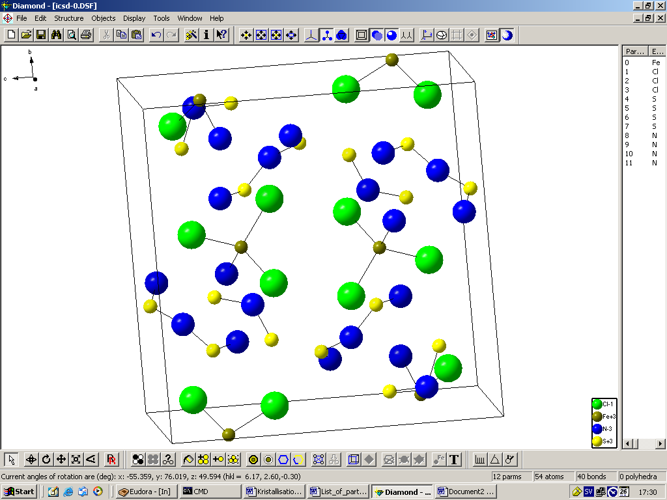

This may be a misleading picture of the crystal structure. What is missing of a molecule on one side of the unit cell can be found at the opposite side of the unitcell. Molecules passing a unit cell border or surface will thus show up as splitted molecules.

All atoms of one molecule, but strictly inside the unit cell | In the picture below the shown molecules have been “completed” to make up full molecules.

Use the right mouse button and select “complete fragments” from the shown pop up menu to build complete molecules. It is of course necessary that the compound is molecular, otherwise Diamond will try to expand it in eternity, finally giving an error message about the expansion.
Whether the compound is molecular or not can be chosen with the connectivity table but the case below is clearly molecular.

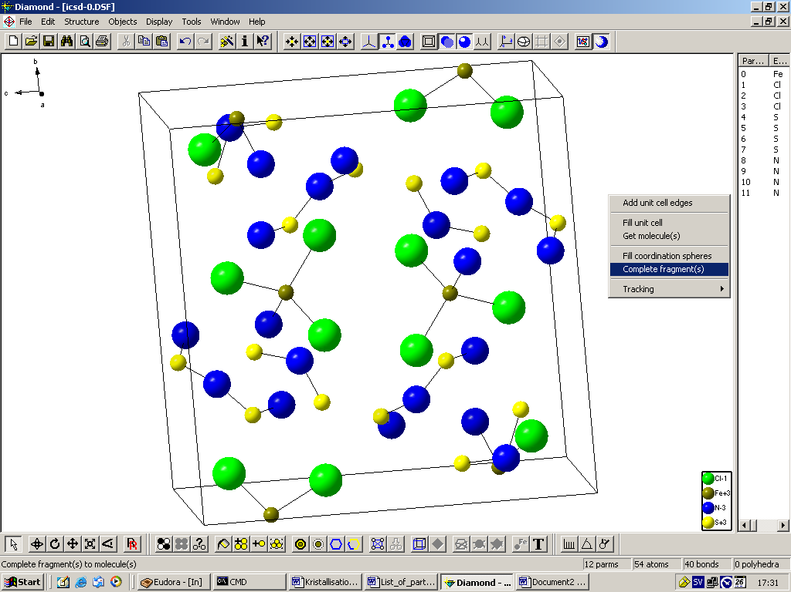

Further manipulations of the picture can be done with the icons shown below. We assume that x and y are defined within the screen surface.

rotate the displayed picture around x and/or y, i.e. out of the plane of the screen.
rotate around the z-direction, i.e. in the plane of the screen.
zoom the picture.

It is quite easy to create a much to crowded view. Then it may be better to destroy some parat of the atoms or molecules shown. Use the procedure below.

- Select one part of a molecule with the right mouse button.
- Choose “destroy” from the shown pop up menu.
- Finally choose “molecule” from the shown sub-menu.

Select the molecules that you don’t want to show and delete them…

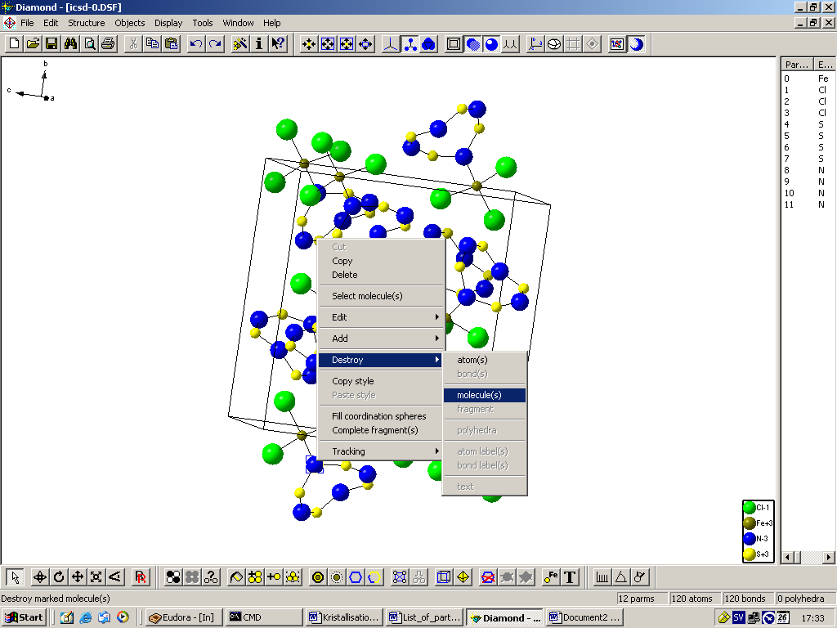

Here we decide to deleted everything shown on the screen with the function “structure / destroy / all” or “ctrl-shift-D” and create one molecule with mouse right button and selecting “Get molecule(s)” from the pop-up menu. Finally as we wanted some extra visibility we did select “stereo image” with the icon.

The resulting image is shown below. Look with your right eye at the right molecule and your left eye at the left molecule. Simsalabim! -you’ll see stereo without extra devices, glasses etc.

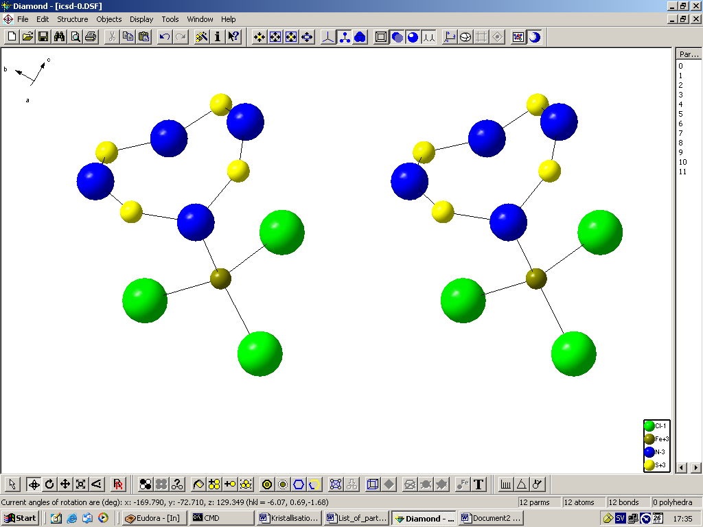

Further things to use diamond for is to measure distances, angles or torsions. Use one of the icons to achieve what you want to do.

Saving images can be done with “File / Save as”. Select the format that you like. The internal format “.dsf” is the native diamond format and stores all features if you would like to continue some other time. Here below we selected “.bmp”, i.e. standard windows bitmap format for the picture. Much more economical is to use “.wmf”, windows Meta File format but this cannot store rendered images, transparent polyhedrons etc.
Select where to store the image and click on “save”.

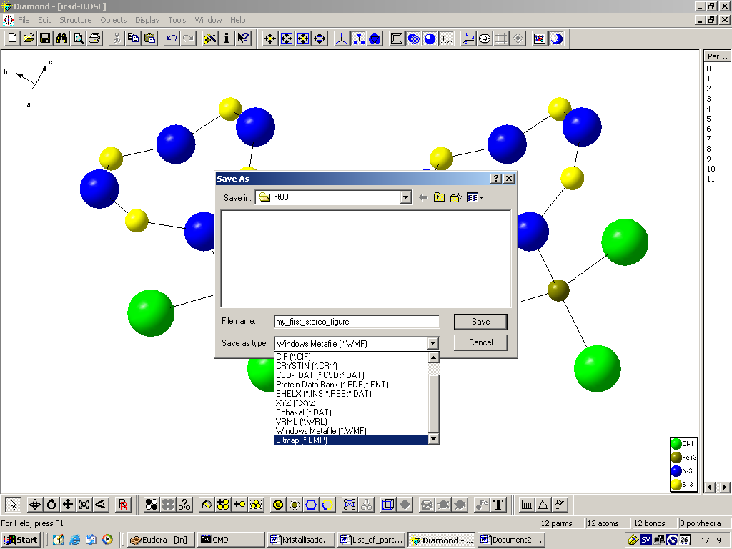

Bitmap figures can be large, the present figure required approximately 6.2 Mb. This may however not be a problem nowadays…

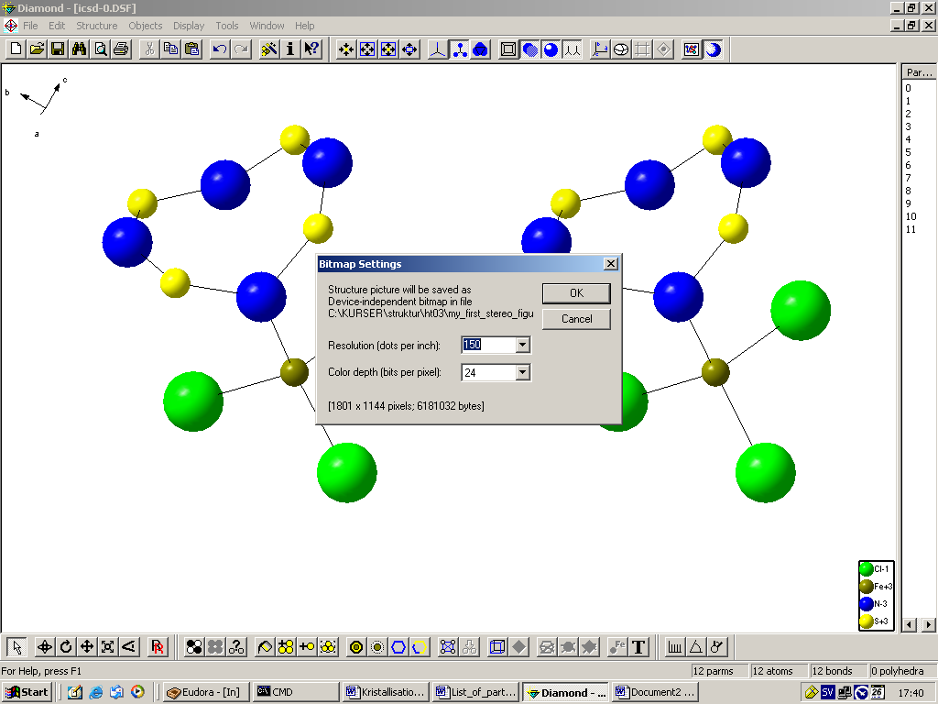

There are thousand of other choices not adhered to in this very short instruction, please play around and try different things with diamond.
Diamond may also be used for viewing pictures from hits in the Cambridge base where you can store the hits as cif-files, or to be more precise as molecular cif files which are given the extension “.cmf”. When reading such files into Diamond it may be necessary to use file type “all files” in the input dialog window. Selecting a file with any extension will be ok as long as Diamond recognize the content of the file as cif stuff and interpret as cif style data.

