Optical Characterization of Heterostructural Alloys Sn_{1-x}Ca_{x}[S,Se]

James May
Advisor: Dr. Janet Tate
2017

Table of Contents
Chapter 1 – Introduction ............................................................................................................................. 1
1.1 Objective..................................................................................................................................... 1
Chapter 2 – Methods……………................................................................................................................... #
2.1 Absorption………………………………………………………......................................................................... #
2.2 Scanning Monochromator.......................................................................................................... #
2.3 Ocean Optics Instruments....................................................................................................... #
2.4 Reflectivity Modeling.................................................................................................................. #
2.5 Determining the Bandgap........................................................................................................... #
2.6 Modeling the Bandgap from Theory........................................................................................... #
2.7 Modeling the Reflectivity from Theory....................................................................................... #
Chapter 3 – Results & Analysis................................................................................................................. #
3.1 Density of States Modeling...................................................................................................... #
3.2 Refractive index Modeling....................................................................................................... #
Chapter 5 – Conclusion.............................................................................................................................. #
References ................................................................................................................................................. #
Appendix A…………………………………………………………………………………………………………………………………………… #
Appendix B…………………………………………………………………………………………………………………………………………… #

Abstract
By measuring the transmission and reflection of the metastable heterostructural alloy Sn_{1-x}Ca_{x}Se where x ranges from 0 to 1, I show that varying the concentration of Ca effects the band gap and index of refraction. In comparing the calculated coefficients ε₁, ε₂, κ, α, and n to values predicted from first principles using the Bethe-Salpeter-Equation, I find they are in close agreement, with the exception of x = 0.5 and x = 0.7 , where the bandgap is in good agreement but the index of refraction is much lower than predicted. The discontinuity in the band gap predicted at the structural transition from orthorhombic structure at low concentration to cubic rocksalt structure at x = 0.13 is observed as a smeared minimum at x = 0.18., which is the composition of the experimentally observed transition in x-ray diffraction.

Chapter 1 – Introduction

  - Objective
The objective of this project is the optical characterization of the alloy Ca_{x}Sn_{1-x}(S, Se). By measuring photon absorption in thin films of different concentrations, I can determine the band gap and refractive index. Ca_{x}Sn_{1-x}(S,Se) is of great interest because it is heterostructural alloy of cubic Ca(S,Se), displayed in figure 1, and orthorhombic Sn(S,Se), displayed in figure 2. By measuring the material’s band gap and refractive index at different concentrations I could shed some light on the mechanisms that allow for a stable alloying of two differently structured materials.
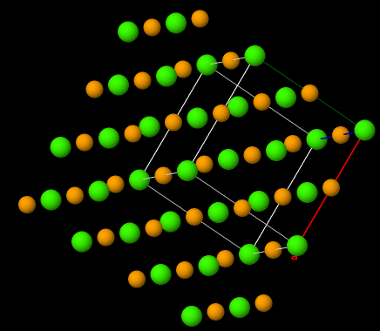
Figure 1: Ca(S,Se) Cubic structure.

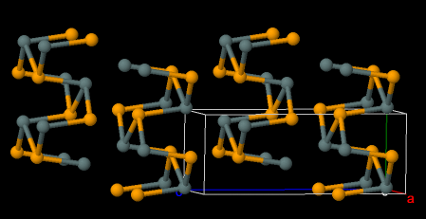
Figure 2: Sn(S,Se) Orthorhombic structure.

Chapter 2 – Theory
2.1 Transmittance and Reflectance
The standard method for optical characterization is to measure transmission and reflection of a thin film. For materials that have any absorption, a bulk sample will only produce a reflection due to any transmitted light being absorbed before it can pass through the sample. All the samples I have measured are thin films between 100-400nm. The transmittance T and reflectance R, are both a ratio of the light intensity without the film L, and with the film S, which can be seen in equation 1 and 2. This bounds T and R to a maximum of 1.
$T(λ)= \frac{S_{T}}{L}$ (1)
$R(λ)= \frac{S_{R}}{L}$ (2)
To model the interaction of light with the film, we treat it as a plane wave with a k vector normal to the air/thin film interface as seen in equation 3.
$\vec{E}={\vec{E}}_{o}e^{i(kr-ωt)}= {\vec{E}}_{o}e^{i\frac{ω}{c}(nr-ct)}$ (3)
Where E is the electric field wave front, which oscillates in the r direction at angular frequency ω, where r is parallel to the interface.

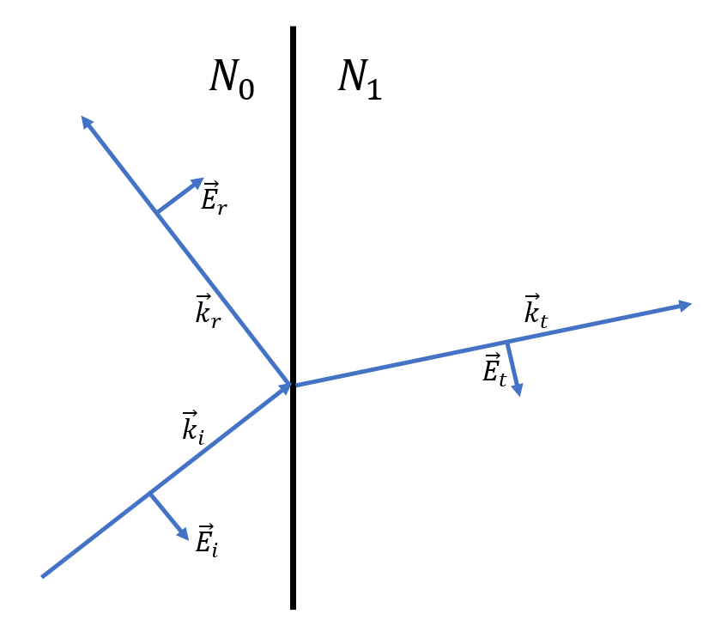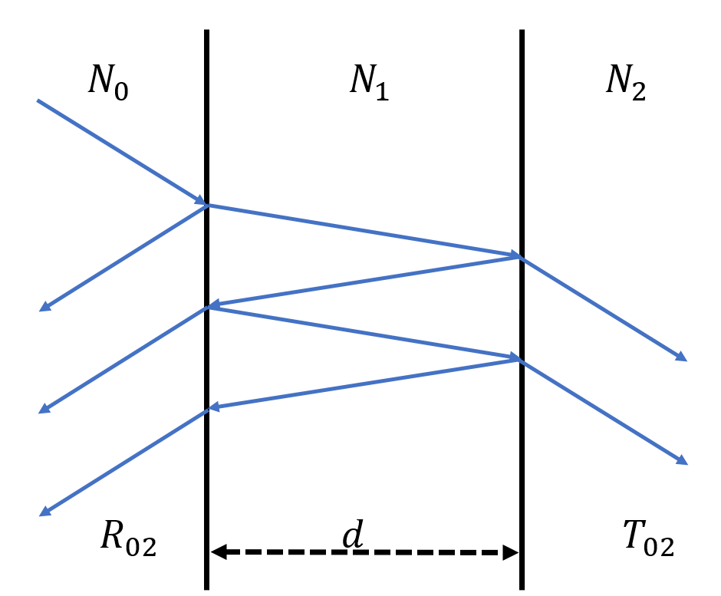
Figure 1: Transmission and reflection with the Figure 2: N₁ is the film with thickness d, phase of its electric field. while N₀ is the air and N₂ is the substrate.

Due to the film having a higher index than air, the reflected wave has a π phase shift, which is seen in Fig. 1. If the film thickness is a half integer multiple of the wavelength, the wave that is internally reflected and then transmitted through the N₀/N₁ is π out of phase with the first order reflection and will cause a minimum in measured reflectance. This will also cause internally reflected waves transmitted through the N₁/N₂ interface to be in phase with the first order transmission, which will cause a maximum in measured transmittance. This effect can be observed in figure 3 with both transmittance and reflectance plotted as a function of wavelength.
As light of the appropriate energy passes through the film, we expect to see the transmittance to fall off exponentially with respect to the extinction coefficient α and the thickness d. To correct for the interference fringes, we divide the transmittance by 1 minus the reflectance as shown in equation 4.
$\frac{T}{1-R}= e^{-αd}$ (4)
We can see from figure 3 that the corrected transmission follows what we would expect for a material whose absorption onset starts around 500nm.
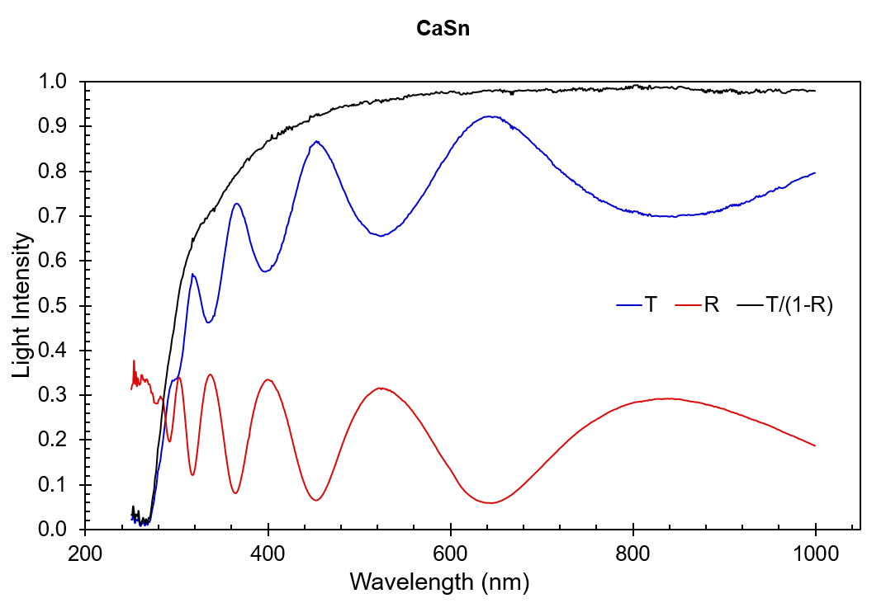
Figure 3: T is transmission, R is reflection, and $\frac{T}{1-R}$ is corrected transmission.

2.2 Finding Film Thickness and The Index of Refraction
For Eq. 4 to be useful, we need to separate the $d$ and α terms. To accomplish this, we use Eq. 5, where n is the refractive index, m is the wave order and λ is wavelength.
$2nd=mλ$ (5)
However, we do not know n either so we must employ a computational technique to model the reflectance R as a function displayed in Eq. 6[4] as well as two forms of the Sellmeier approximation, equations 7 and 8[reference].
$R=R(λ,n,s,d,κ)$ (6)
$n^{2}\left(λ\right)=A+\frac{Gλ^{2}}{λ^{2}-ϕ^{2}}$ (7)

The Sellmeier equation is used to model the index of refraction as it approaches a resonance wavelength as seen in equation 8. Where G is an amplitude coefficient for resonance wavelength φ and A is 1 plus the sum of the other G constants that occur far below the wavelengths we are measuring. This approximation becomes less accurate as it approaches the resonance wavelength and completely nonphysical afterwards, which can be seen in Fig. 4.
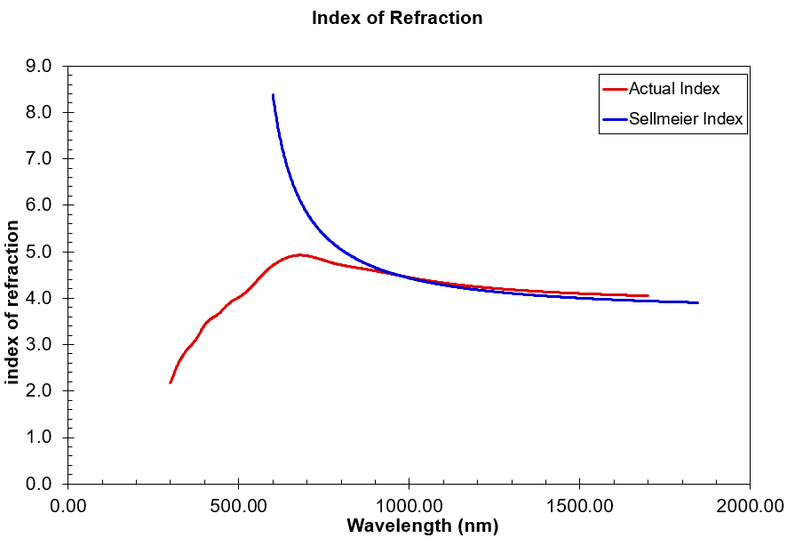
Figure 4: The actual index(red) compared to the Sellmeier approximation(blue)

To ease computational load on the excel sheet I use, I first employ a simpler version of the Sellmeier approximation, equation 7.
$n=int+\frac{slp}{λ^{2}}$ (8)
Where $int$ is the y axis intercept and $slp$ is the slope of the function $n(λ^{-2})$. With sufficient processing power, a program designed exclusively for this process could immediately employ equation 7. Both approximations of $n$ are plotted in figure 5.
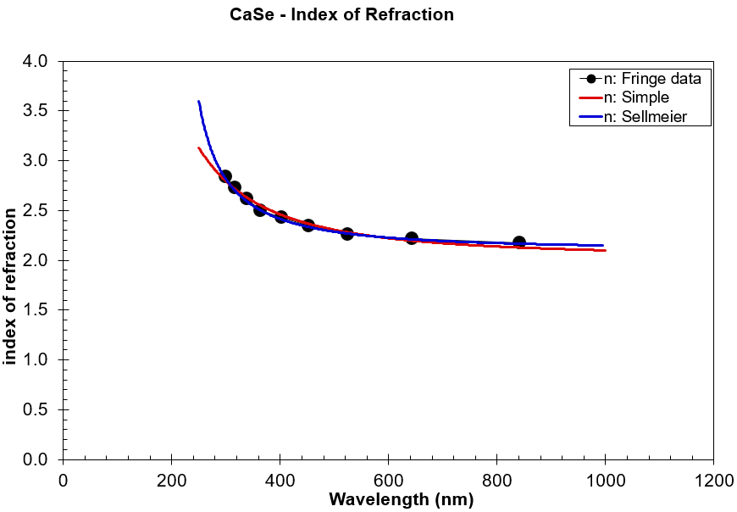
Figure 5: The simple and more accurate Sellmeier functions fit to the fringe extrema data points taken from figure 3’s reflectance.

All the unknowns are now defined or are in terms of $d$ so use them to calculate R using the equation 9[4], where all terms are defined in appendix A1.
$R=\frac{E-Fx+Gx^{2}}{B-Cx+Dx^{2}}$ (9)
This equation models R with an air, thin film, and substrate interface system, such as in figure 2, where the substrate is assumed to be infinitely thick compared to the thin film. I then computationally vary $d$ until the calculated R is the closest to the measured R. Next, $n$ is further refined by using the Sellmeier approximation, equation 8.
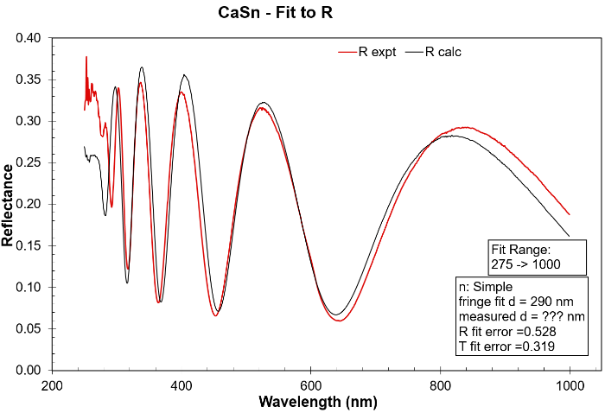
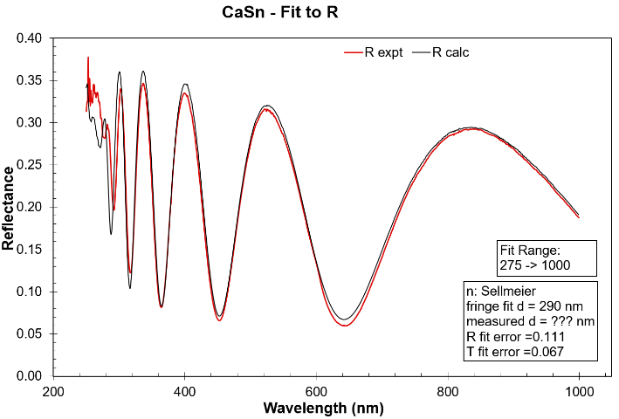

Figure 6: R calculated using n from equation 8. Figure 7: R calculated using n from equation 7.
All coefficients are adjusted computationally to facilitate the best fit to the data points which are displayed in figure 5. Equation 9 is then computed with the more accurate $n$ values to get an even better fit. The difference in using the two forms of the Sellmeier equation to predicted reflection is shown in figures 6 and 7.
2.3 Determining the Bandgap
An R fit error that is close to or less than 1 gives a relatively good approximation for the thickness d, which allows us to separate it from α. If we plot α as a function of E, such as in figure 8, we can observe what energy corresponds to an increase in absorption, which is indicative of the bandgap. Since α increases rapidly once E reaches the bandgap, we plot it in a logarithmic scale and observe at what energy it goes above 10⁴cm⁻¹, which is considered the lower bound for α measurements. It is the least precise method, however it is the least time consuming to employ and analyze.
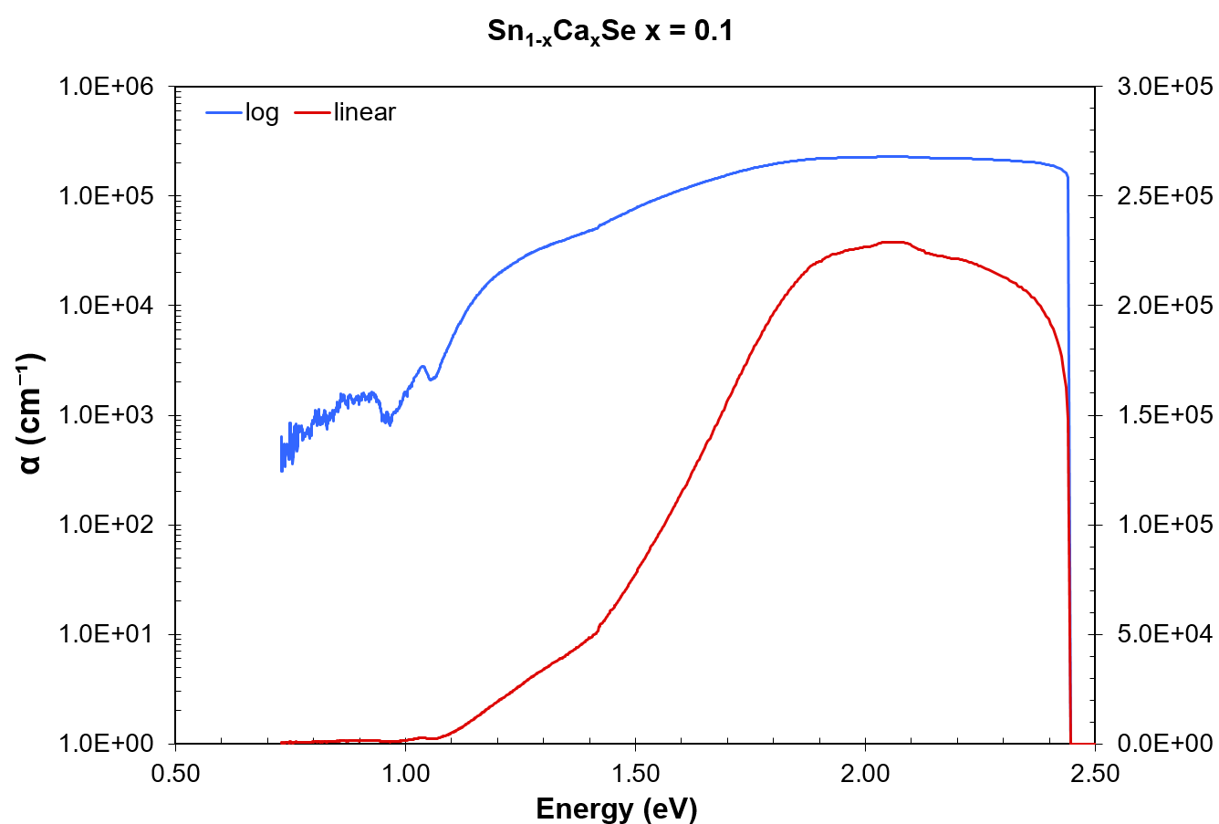
Figure 8: Plot of α as a function of E, where the left axis is logarithmic
and the right scale is linear

With α, I can also employ the Tauc method, which is plotting ${\left(Eα\right)}^{n}$ as a function energy E where n is either 0.5 or 2. The bandgap is determined by observing a linear relationship between E and ${\left(Eα\right)}^{n}$ which is signified by a large change in α. The bandgap is then extrapolated by following the linear slope to the E axis, as illustrated in figure 9, where the indirect bg is … and the direct gap is …
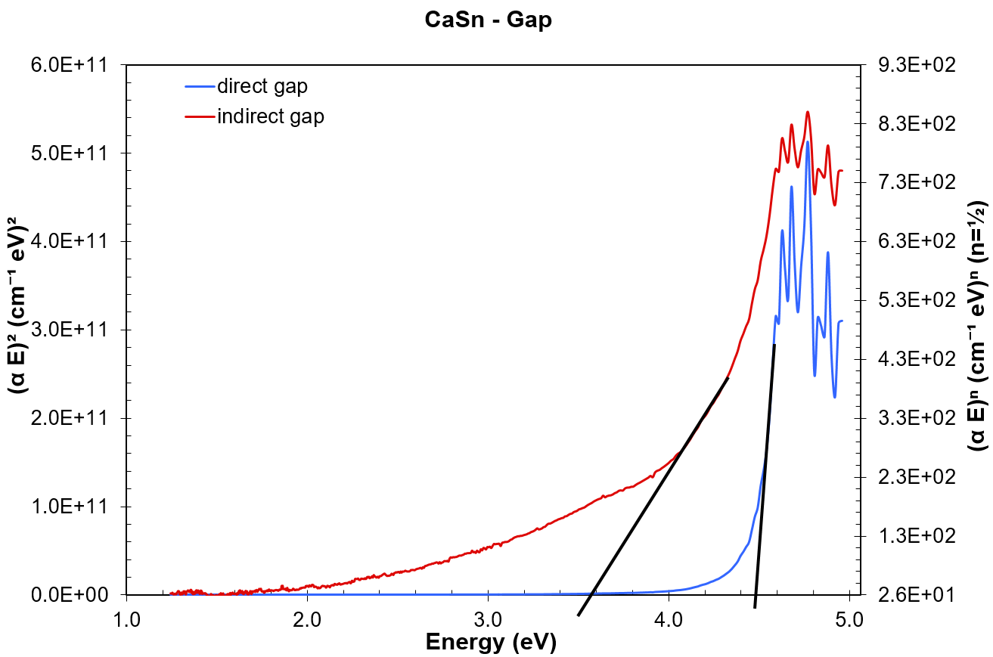
Figure 10: ${\left(Eα\right)}^{n}$ plotted as a function energy E where n is 2 or $1/2$
for a direct or indirect bandgap respectively.

2.4 Modeling from Theory
With calculated values of both the real and imaginary parts of ε provided by the BSE computational method and equation 7, 8 and 9, it is possible to calculate the index of refraction n, and the absorption coefficient α.
$n^{2}= ε_{1}+iε_{2}$ (7)
$\tilde{n}=n+iκ$ (8)
$α=\frac{2πκ}{λ}$ (9)
I have plotted the ε₁, ε₂, α, and n coefficients for each concentration in appendix A2. With α, we can employ the Tauc method to determine a bandgap. Just as before, ${\left(Eα\right)}^{n}$ is now plotted as a function energy E and the gap is extrapolated, as shown in figure 10.
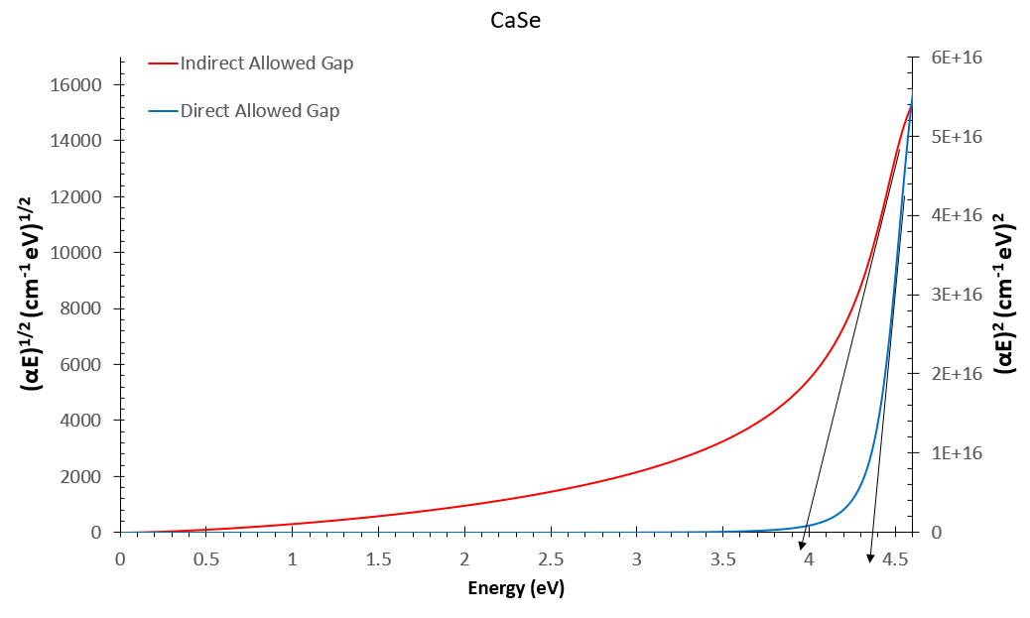
Figure 11: ${\left(Eα\right)}^{n}$ plotted as a function energy E where n is 2 or $1/2$ for a direct or indirect bandgap respectively.
We are also able to employ equation 9 to predict the reflectance for each film concentration if an appropriate thickness is used, such as in Fig. 12.
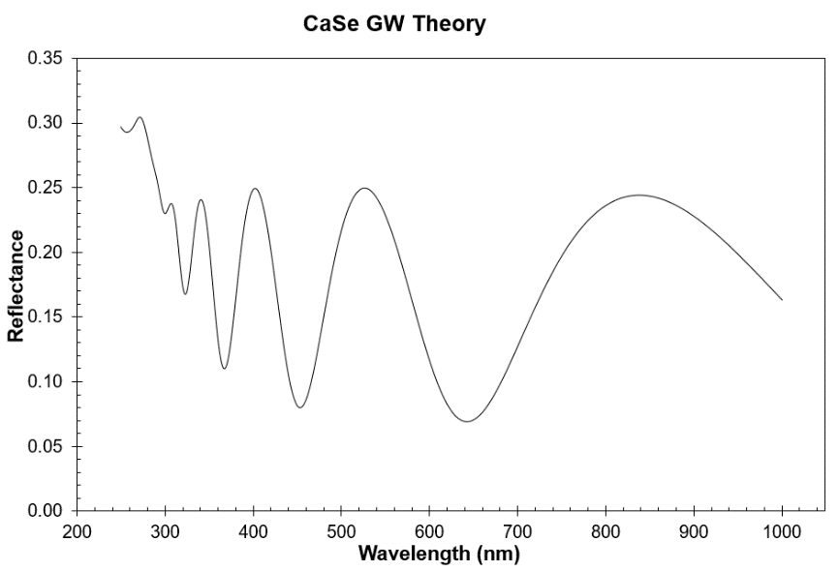
Figure 12: The theoretical R values calculated using equation 9 with a film thickness of 307nm.

Chapter 3 – Methods
3.1 Scanning Monochromator
Limited band 200-1825(nm). Having to change gratings and detectors introduce error in the measurements. Most accurate.
(figure of GS)
The monochromator setup is comprised of two lamps, Xe (200-1800nm need to verify) and W (250-3500nm need to verify), and two detectors, a Thor Labs SM1PD1A Si detector(200-1000nm need to verify) and a Thor Labs SM05PD5A InGaAs solid state detector(800-1825nm). The light goes from the lamp through a filter of 315nm, 615nm or 1115nm to block higher order reflections in the monochromator. The light reflects off of the 0.25μm, 0.5μm, 1μm, or 2μm grating depending on the range, then through a series of irises, lenses and mirrors until passes through the sample and then on to the detector. The detector position is changed for reflection measurements, however the film position is not touched and the light path length remains the same.
3.2 Ocean Optics Instruments
Larger band 250-2550(nm). Better suited for films with high thickness gradients due to its real-time analysis and pivotable film holder. Reflection alignment is difficult which makes measurements less reliable.
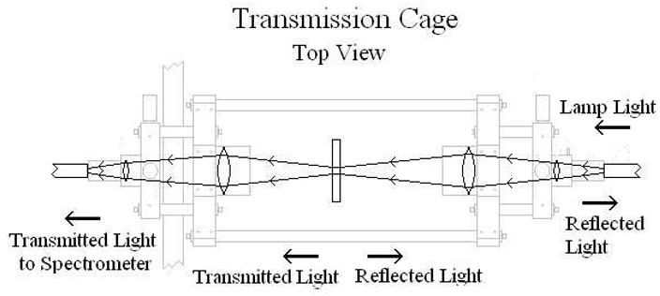
Figure 5: Transmission cage for the Ocean Optics setup.

Chapter 4 – Results & Analysis

4.1 DFT Modeling
After measuring and recording samples with different concentrations of calcium, I compiled the bandgap data points and compare them to the theoretical values from a density of states calculation seen in figure 10. It should be noted that there are two possible sources of error in this comparison. The first is that the Tauc method is not very precise and can be influenced by the experience and expectations of the person employing it. The second is that density of states calculations are notoriously lower than the actual measured values.
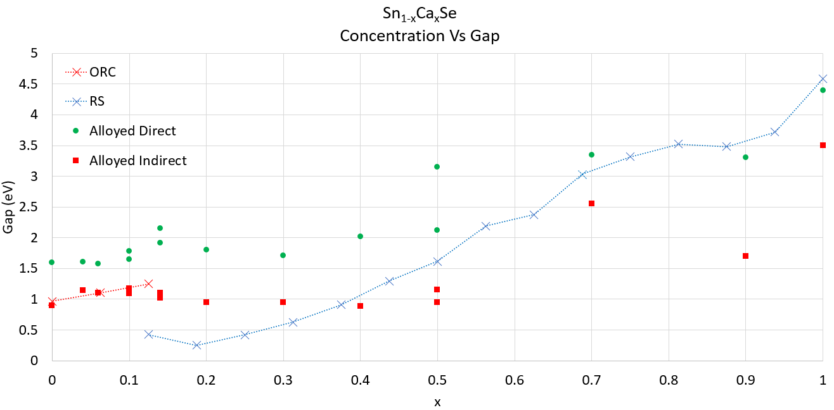
Figure 14 : The direct and indirect bandgaps vs concentrations of calcium x compared to the theoretical bandgaps using a density of states calculation. The blue is for the orthorhombic and the red is for the rock salt structure
When comparing the data points to calculated density of states, it might appear that it follows the trend, but when the density of states data is removed, this trend disappears.
4.2 BSE Modeling
It is unclear if the materials follow with predicted values from figure 12. However, this should not be used to compare actual with predicted bandgaps since there is not lab equivalent experiment to determine the density of states. Instead, I use the predicted dielectric constants calculated from the Bethe-Salpeter-Equation [reference] to calculate α and then employ the tauc method. This is a better comparison and as seen in figure 13, the measurements are quite close to the prediction.
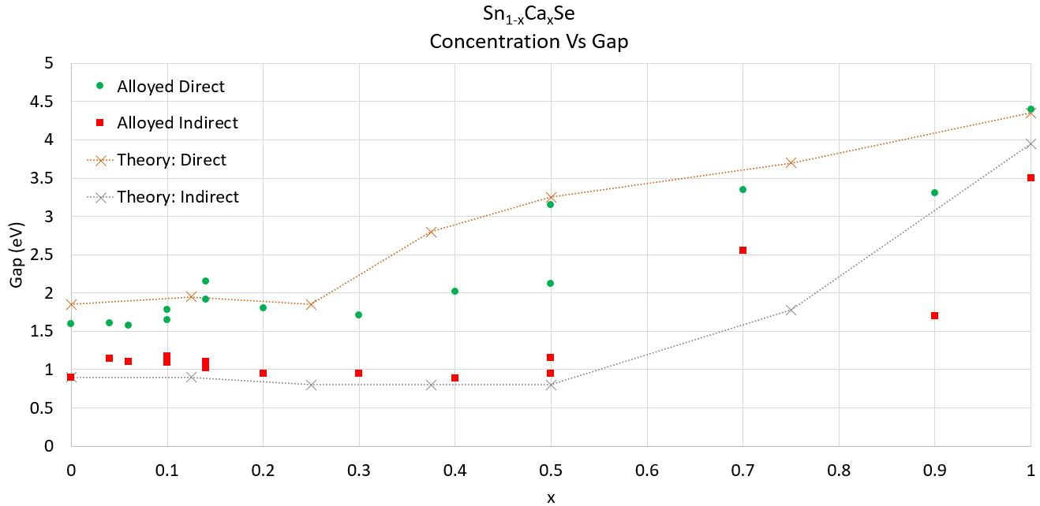
Figure 15: The direct and indirect bandgaps vs concentrations of calcium x compared to the theoretical bandgaps using a the Tuac method from the calculated complex dielectric constant.
The computation that yielded the theoretical dielectric constants from NREL also gave the bandgaps for each concentration. If I compare the gaps calculated computationally with the gaps calculated with the Tauc method, we can see that there is a large discrepancy illustrating the imprecise nature of the Tauc analysis.
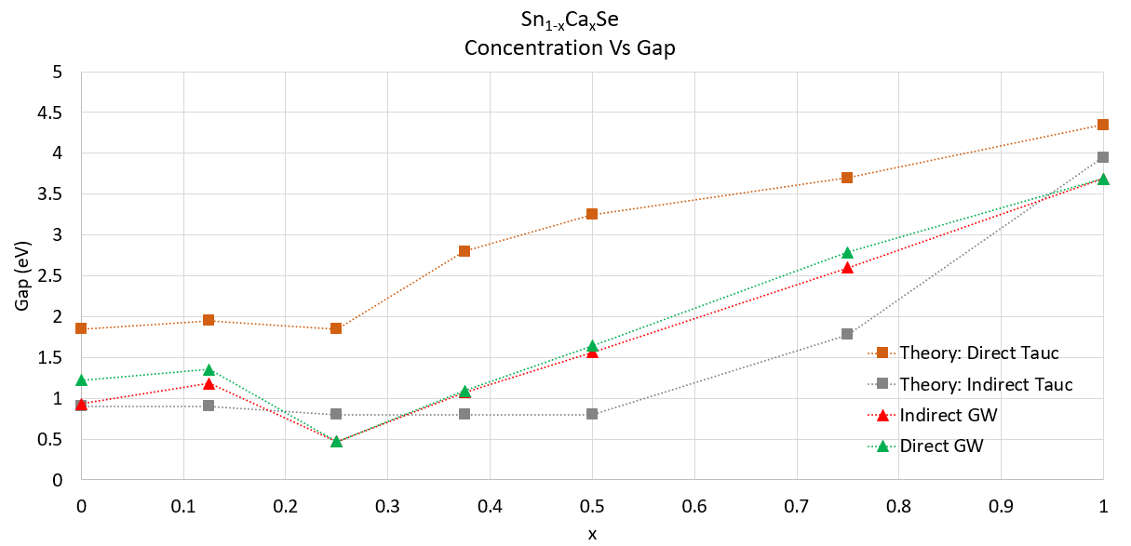
Figure 16: The direct and indirect bandgaps vs concentrations of calcium x compared to the theoretical bandgaps using a the Tauc method from the calculated complex dielectric constant.
With that reasoning, we should ignore the Tauc analysis entirely and simply look at the difference of the predicted and actual measurements of the absorption  and the index n such as in figures 17 and 18. If the n and  measurements are similar enough to the theory, it would be a good assumption that the bandgap theory is also correct. Small deviations in n and α can be attributed to the films having various defects and are not a single crystal.
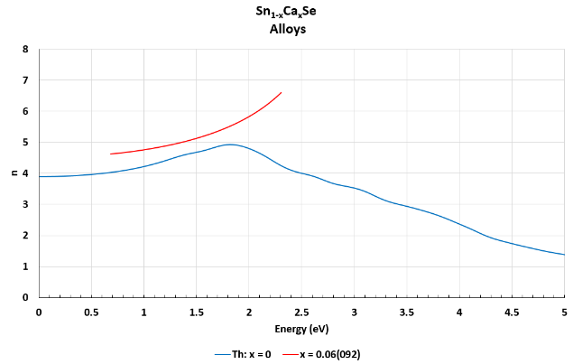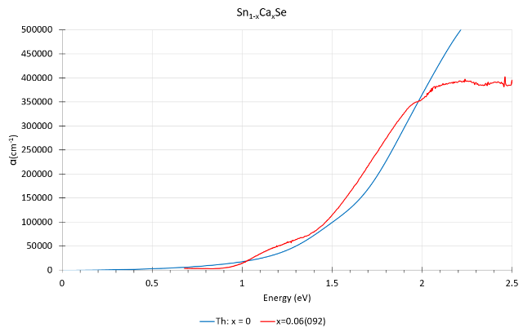
Figure 17: Theoretical index n(blue) and film measurement Figure 18: Theoretical absorption (blue) and film index n(red). measurement absorption (red).

Chapter 5 – Conclusion
In progress…..

References
- Yoshihiro Hishikawa et al. Interference-Free Determination of the Optical Absorption Coefficient and the Optical Gap of Amorphous Silicon Thin Films, J. Phys. E: Sci. Instrum. 16, 1214 (1983)
- J Tauc. et al. Optical Properties and Electronic Structure of Amorphous Germanium. phys. stat. sol. (b), 15: 627–637, (1966)
- R Swanepoel et al. “Determination of the thickness and optical constants of amorphous silicon” Journal of Physics E: Scientific Instruments, Volume 16, 12, (1983)
- S Ventura et al, Optimization Techniques for the Estimation of the Thickness and the Optical Parameters of Thin Films using Reflectance Data, Journal of Applied Physics 97, 043512 (2005)

Appendix A
A1. Fringe Modeling equation
$R=\frac{E-Fx+Gx^{2}}{B-Cx+Dx^{2}}$ (1)
$x=e^{-αd}$, $φ=\frac{4πnd}{λ}$, $κ=\frac{αλ}{4π}$, $α=-[ln\left(T\right)-ln⁡(1-R)]\frac{1}{d}$ (2)
$B=\left[{\left(n+1\right)}^{2}+κ^{2}\right][\left(n+1\right){\left(n+s^{2}\right)}^{2}+κ^{2}]$ (3)
$C=[(n^{2}-1 +κ^{2})(n^{2}-s^{2}+κ^{2})-2κ^{2}(s^{2}+ 1)]2cosφ$ $-κ[2(n^{2}-s^{2} +κ^{2}) + (s^{2}+1)(n^{2}-1 + κ^{2})]2 sin φ$ (4)
$D=\left[{\left(n-1\right)}^{2}+κ^{2}\right][\left(n-1\right)\left(n-s^{2}\right)+κ^{2}]$ (5)
$E=\left[κ^{2}+{\left(n-1\right)}^{2}\right][κ^{2}+(n+1)(n+s^{2})]$ (6)
$F=H-8{\left(s-1\right)}^{2}(\frac{p_{0}-p_{1}x+p_{2}x^{2}}{q_{0}-q_{1}x+q_{2}x^{2}})$ (7)
$H=-\left[\left(n^{2}-1\right)\left(n^{2}-s^{2}\right)+κ^{2}\left(1+2n^{2}+κ^{2}+s^{2}\right)\right]2cosφ+ κ\left(1+κ^{2}+n^{2}\right)\left(s^{2}-1\right)2sinφ$ (8)
$G=\left[κ^{2}+{(1+n)}^{2}\right][κ^{2}+(n-1)(n-s^{2})]$ (9)
$p_{0}=\left\{\left(1+κ^{2}-n^{2}\right){\left(κ^{2}+n^{2}\right)}^{2}+\left[n^{2}\left(n^{2}-1\right)+κ^{2}\left(1+κ^{2}+ 2n^{2}\right)\right]s^{2}\right\}cosφ-κn\left[{\left(κ^{2}+n^{2}\right)}^{2}-s^{2}\right]2sinφ$ (10)
$p_{1}=\left[8s+2\left(1-κ^{2}+n^{2}\right)\right]{\left(κ^{2}+n^{2}\right)}^{2}+2\left[n^{2}\left(n^{2}+1\right)+ κ^{2}\left(-1+κ^{2}+2n^{2}\right)\right]s^{2}$ (11)
$p_{2}=\left\{\left(1+κ^{2}-n^{2}\right){\left(κ^{2}+n^{2}\right)}^{2}+\left[n^{2}\left(n^{2}-1\right)+κ^{2}\left(1+κ^{2}+ 2n^{2}\right)\right]s^{2}\right\}cosφ+κn{[\left(κ^{2}+n^{2}\right)}^{2}-s^{2}]2sinφ$ (12)
$q_{0}=\left[κ^{2}+{\left(1+n\right)}^{2}\right][κ^{2}+{(n+s)}^{2}]$ (13)
$q_{1}=\left\{\left(n^{2}-1\right)\left(n^{2}-s^{2}\right)+κ^{2}\left[-1+2n^{2}+κ^{2}-s\left(4+ s\right)\right]\right\}2cosφ+κ\left(κ^{2}+n^{2}-s\right)\left(1+s\right)4sinφ$ (14)
$q_{2}=\left[κ^{2}+{\left(n-1\right)}^{2}\right][κ^{2}+{(n-s)}^{2}]$ (15)

Appendix A2
A2. BSE coefficients

