Spectroscopic Ellipsometry on Thin Films of TiO₂:
Comparing CompleteEASE Cauchy and Cody-Lorentz Models

By: Joseph Kreb

An undergraduate thesis
Advised by Dr. Janet Tate
Submitted to the Department of Physics, Oregon State University
In partial fulfillment of the requirements for the degree in BSc in Physics
Submitted on May 23rd, 2020
Table of Contents
List of Figures 2
Abstract 3
Introduction 3
Theory 7
2.1 – Interaction of Light with Matter 7
2.2 – Reflection of Light from a Surface 9
2.3 – Ellipsometry: Detecting the Change in Polarization Upon Reflection 11
2.4 – Modeling Physical Quantities with Ellipsometry 12
Methods 13
3.1 – J.A. Woolam M-2000X Spectroscopic Ellipsometer 13
3.2 – CompleteEASE v.6.54 14
3.2.1 – CompleteEASE substrate models 15
3.2.2 – CompleteEASE Cauchy model 16
3.2.3 – CompleteEASE Cody-Lorentz model 17
Results 18
4.1 – Tables of Fitted Parameters from CompleteEASE Models 18
4.2 – Correspondence of CompleteEASE Cauchy and Cody-Lorentz Models 19
4.3 – Change in TiO₂ Films from Amorphous to Crystalline 20
4.4 – Refractive Index of Crystalline TiO₂ Films 22
4.4 – Comparison of CompleteEASE and IndexCalc Modeling Results 24
Conclusion 27
References 28
Appendix A: Tables of CompleteEASE modeling results 29
TABLE A1: Subset of CompleteEASE Cauchy and Cody-Lorentz model fitting results for TiO₂ films on fused silica substrates 29
TABLE A2: Subset of CompleteEASE Cauchy model fitting results for TiO₂ films on silicon substrates 34
TABLE A3: Additional CompleteEASE Cauchy model fitting results for TiO₂ films on fused silica substrates 36
TABLE A4: Additional CompleteEASE Cody-Lorentz model fitting results for TiO₂ films on fused silica substrates 39
Appendix B: CompleteEASE User Reference 41
CompleteEASE User Reference Guide 41

List of Figures

- Diagram of the crystal structures of rutile, anatase, and brookite from Ref. [2]
- Graph of the polymorph distribution of TiO₂ films deposited by pulsed-laser deposition (PLD) and annealed to crystallize from Ref. [2]
- Schematic diagram that illustrates the orientation of the p- and s-planes of polarization
- Schematic diagram that depicts the total reflection of light from a multi-layer surface
- Picture taken by the author of the M-2000X ellipsometer used in this thesis at the Advanced Technology and Manufacturing Institute (ATAMI), in Corvallis, OR
- Screenshot of CompleteEASE open to the Analysis tab, with sample #44, pre-annealed being fit with the CompleteEASE Cauchy model
- Screenshot of the Fused Silica (Sellmeier).mat CompleteEASE model, used to model fused silica substrates
- Screenshot of the TiO₂ (Cauchy).mat model used to model TiO₂ films as transparent, with a Cauchy equation, from 400 – 1000 nm
- Screenshot of the TiO₂ (CodyLor).mat model used to model our TiO₂ films with a Cody-Lorentz oscillator model, from 200 – 1000 nm
- Plot of the estimates of TiO₂ film thickness (in nm) for a set of pre-annealed films from the CompleteEASE Cauchy model vs. corresponding estimates from the CompleteEASE Cody-Lorentz model
- Plot of the estimates of the refractive index at 633 nm of a set of pre-annealed TiO₂ films from the CompleteEASE model vs. corresponding estimates from the CompleteEASE Cody-Lorentz model. Same set of films as figure 10.
- Graph depicting the change in TiO₂ film thickness from pre- to post-annealed for four films that were well modeled with the CompleteEASE Cauchy model
- Graph depicting the change in refractive index at 633 nm from pre- to post-annealed of four TiO₂ films that were well modeled with the CompleteEASE Cauchy model
- Bar graph showing the refractive index at 633 nm of the TiO₂ film for nine crystalline films from both the CompleteEASE Cauchy and Cody-Lorentz models
- Bar graph showing the correspondence in estimates of TiO₂ film thickness between Index Calc, and the CompleteEASE Cauchy and Cody-Lorentz models for
- Bar graph showing the correspondence in estimates of the refractive index at 633 nm of the TiO₂ films of six crystalline films that Cameron and I measured in common
- Bar graph comparing the modeling results between IndexCalc and the CompleteEASE Cauchy and Cody-Lorentz model

Abstract

Spectroscopic ellipsometry (SE) is used to characterize amorphous and crystalline thin films of TiO₂. Amorphous precursor films of TiO₂ are deposited by radio frequency magnetron sputtering on fused silica and silicon substrates. Annealing the amorphous precursor films induces them to crystallize into either pure or mixed phases of the three crystal polymorphs of TiO₂: rutile, brookite, and anatase. Previous research in our group has shown that TiO₂ crystal polymorph formation post-annealing, in both pulsed-laser deposition (PLD) and radio frequency magnetron sputtered deposition, is dependent on the thickness of the deposited film, among other deposition parameters.
A set of thin film samples has been made at varying sputtered deposition parameters. SE was employed to accurately estimate the thickness and optical constants of the TiO₂ films. The samples were measured on the wavelength range of 200 – 1000 nm (UV-NIR) with a Woolam M-2000X spectroscopic ellipsometer. The modeling software CompleteEASE was used for data acquisition, and to fit the measured ᴪ and $∆$ spectra with two different optical models: a Cauchy dispersion and a Cody-Lorentz oscillator model. Model fit parameter results from the two different CompleteEASE models were compared and contrasted with eachother.

Acknowledgements
I am extremely grateful to the many people who are responsible for enabling my scientific education which has resulted, in part, in the production of this undergraduate physics research thesis. My dear parents gifted me with a life of love, support, and quality such that I could pursue a higher education in physics. My sister convinced me to move from NH to OR to begin going to college at Central Oregon Community College (COCC) in Bend, OR, which set me on this path which I am now completing. I am eternally grateful to her, and my brother, for their support, love, and humor in the first years of my undergraduate education.
Studying physics means a great deal to me and has changed my life in profound ways. I feel very fortunate to have been introduced to physics by professors who study physics education research, and apply the tenets of that research to the design of their courses. I feel that I have been given a high quality education in a difficult subject by these professors, and I thank each of them for their tireless efforts and passion in teaching each of the students who pass before them.
Dr. Wendi Wampler instructed me through my first physics courses at COCC. Her passion for quality of physics education and for the subject itself were infectious and convinced me to switch my major from mathematics to physics, a decision which I am very happy with. At Oregon State University (OSU), I was thrilled to find Wendi’s standard of physics education met if not exceeded by the instruction that I received from Dr. Liz Gire in a number of courses. I owe Dr. Giree an indelible debt of gratitude for the intense personal attention and support she gave me, as she tirelessly gives to many students, during my time at OSU. She and Dr. Wampler, both of whom research physics education, are exceptionally dedicated and effective instructors.
I am also extremely grateful to my physics research professor, Dr. Janet Tate for the many opportunities and lessons that she has afforded me personally and in her research group. She has been extremely supportive of me in the completion of this undergraduate physics research thesis, and in the performance of work for her research group, the Tate Labs. I have felt very lucky to work for such a consummate professional and distinguished scientist, and have looked to her as a role model in physics.
I would also like to thank Dr. Doug Keszler of the OSU Chemistry Dept., and his graduate students Jennie Amador and Nizan Kenane for training me in using the ellipsometer and CompleteEASE. Special thanks to James Hilfiker, of the Woolam company, for explaining the details of optical modeling in CompleteEASE.

Introduction
Spectroscopic ellipsometry (SE) is a well-established optical technique that is commonly used to characterize thin films. The primary objective of this thesis was to use SE to measure the film thickness and optical constants of amorphous and crystalline thin films of Titanium Dioxide (TiO₂). A J.A. Woolam M-2000X spectroscopic ellipsometer was used to measure ᴪ and $∆$ spectra of the films, and the modeling software CompleteEASE was used to build and fit optical models to the SE data. Two different CompleteEASE models were developed and fit to the SE data: a Cauchy equation that modeled the films as transparent between 400 – 1000 nm, and a Cody-Lorentz oscillator equation which accounted for the absorption of the bandgap region over the wavelength range of 200 – 1000 nm. The results of these two models were compared to evaluate the consistency of modeling results.
TiO₂ is widely studied for its useful material properties and has many technological and commercial applications. It is a wide band gap, transparent semi-conductor with a high refractive index and a high dielectric constant. Crystalline TiO₂ has three polymorphs: rutile, brookite, and anatase. Brookite is understudied compared to rutile, which is the low-energy, stable crystalline phase (polymorph); brookite and anatase are meta-stable phases. Figure 1 is a diagram from Ref. [1] that shows the crystalline structures of rutile, brookite, and anatase:
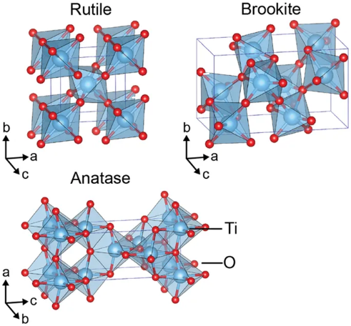
Figure 1: Diagram showing the crystal lattice structure of the different polymorphs of TiO₂. Rutile and anatase have tetragonal crystal structures, while brookite has an orthorhombic crystal structure. Brookite has a larger cell volume than either rutile or anatase Ref. [1].
Our research group has been investigating the crystallization of thin films of TiO₂. Amorphous (non-crystalline) precursor TiO₂ films were previously deposited by pulsed-laser deposition (PLD) onto substrates of both fused silica (pure fused SiO₂) and silicon (Si). Annealing the films in an oven induces the amorphous precursor films to crystallize into one of the three crystal polymorphs of TiO₂: rutile, brookite, or anatase. Previous graduate students of the Tate research group, James Haggerty and Okan Agirseven, investigated how the pressure of oxygen (pO2) in the PLD chamber and the deposited film thickness influenced which polymorph a precursor film crystallized into when annealed. Figure 2 is a graph from Ref. [2] showing the effect of deposition parameters in PLD deposition of TiO₂ films on crystal polymorph formation post-annealing:
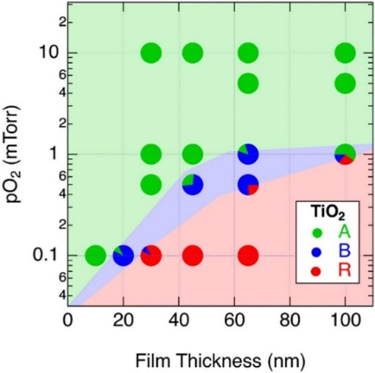
Figure 2: Graph from Ref. [2] illustrating the dependency of crystal polymorph formation on the pO₂ in the PLD deposition chamber and the film thickness. Red, blue and green signify the rutile, brookite, and anatase polymorphs respectively. Notice how brookite only exists in a thin band in the center and how it is easier to crystallize films of rutile or anatase by PLD in comparison.
As can be seen in Figure 2, crystal polymorph formation of TiO₂ films post-annealing was shown to depend on the thickness of the deposited film. Following this discovery, Agirseven began to further explore the dependence of film thickness on polymorph formation in a series of films that he deposited by radio frequency magnetron sputtering. I was employed with the task of learning and utilizing SE to estimate the film thickness and the optical constants of this new set of sputter-deposited thin film samples. Agirseven has deposited a set of these films at various film thicknesses and deposition rates, to explore the role of those two deposition factors in polymorph formation post-annealing.
The primary objective of my assignment was to learn SE and employ it to accurately estimate the thickness of the sputtered TiO₂ films, so that our research group could make conclusions about the effect of film thickness on crystal polymorph formation post-annealing. However, there were other questions that I was capable of addressing and exploring with SE.
We had evidence from electron probe micro analysis (EPMA) that suggested that the films were contracting by perhaps a nanometer or two when annealed. However, this trend in the EPMA data was affected by the fact that we were using the same density for amorphous films and each of the polymorphs. The crystal polymorphs rutile, brookite, and anatase have different crystal structures, and different densities. Once we used appropriate densities in the EPMA calculation, the trend in thickness contracting when the films were annealed was practically eliminated. We now think that if there is a thickness change from pre- to post-annealed, that it is negligible if it is occurring at all. SE was used to address the question of change in film thickness pre- to post-annealing in this thesis.
SE also enabled me to estimate the refractive index of the films. I measured and modeled a large set of both pre- and post-annealed films, and sought to note the difference in their thicknesses and refractive indices. I expected to measure all of the amorphous films to have the same index, no matter which crystal polymorph they annealed to.
It was also a secondary goal of this thesis from the start to compare results from SE with results from intensity-based reflection & transmission spectroscopy that was done by my fellow physics undergraduate, Cameron Stewart. In Stewart’s undergraduate thesis work for our group, he measured the reflection and transmission spectra of our TiO₂ films using a grating spectrometer and a silicon detector. Stewart then fit the reflection spectra with projections from a Sellmeier model, in a procedure that is similiar to my fitting of ᴪ & $∆$ spectra with a Cauchy and Cody-Lorentz model. The Sellmeier model lives in an Excel workbook developed in our group to model our films which is called IndexCalc. Fitting the Sellmeier model in IndexCalc yields TiO₂ film thickness and refractive index measurements, as does my method.
In February 2020, Okan Agirseven authored an article from our research group that was published online in the AIP Advances Journal for which I was a listed co-author. In that article, Agirseven reported on the group’s findings regarding polymorph formation of the sputter-deposited TiO₂ films. I am listed as a coauthor for having contributed film thickness estimates from SE, which are compared in the article to estimates from EPMA. The TiO₂ films that were measured for that article were on silicon substrates, and the modeling results from SE are listed in Table A2 in Appendix A. The AIP Advances article itself is listed as Ref. [3].

Theory
Ellipsometry is an optical technique that measures the change in the polarization state of light upon reflection from the surface of a material. The way that the polarization of light changes upon reflection from a film depends on the film’s thickness and optical properties. The change in polarization of reflected light is measured over a range of wavelengths in spectroscopic ellipsometry (SE). The change in polarization, ρ, is represented by two measurable parameters: ᴪ (λ) and $∆$ (λ), which are defined in Section 2.4. A spectroscopic ellipsometer measures ᴪ and $∆$ spectra.
Due to multiple reflections inherent in thin film systems, there is no simple relationship between ᴪ, $∆$, n, κ, (defined in the next sections) and the film thickness; for this reason, a regression model is used to fit model projections to the experimentally derived ᴪ & $∆$ spectrum data. In this experiment, the modeling software CompleteEASE was used to model the TiO₂ thin film systems. Model fit parameters (namely, the film thickness and optical constants) are adjusted until the model projections of ᴪ & $∆$ spectra closely match the experimentally derived ᴪ & $∆$ spectra. The closeness of the fit is measured by the mean square error (MSE), essentially an average of the difference between experimental values and model values of ᴪ & $∆$. A low MSE corresponds to a good fit.
If the model is prudently developed, and parameters are fit to reduce MSE so that the model corresponds with the experimental data, then those parameters closely mirror their true physical values. It is in this way that SE “measures” the film thickness and optical constant values; in truth they are estimations as parameters like film thickness are not directly measured.

2.1 – Interaction of Light with Matter
When light encounters a boundary between two media, some of the light reflects from the boundary and some transmits through. The light that is transmitted into the new medium has its’ path deflected by some angle (refracted) according to Snell’s Law of refraction:
 | $$ñ_{1}sin \left(θ_{i}\right) = ñ_{2}sin⁡(θ_{t})$$ | (1)
where $θ_{i}$ is the angle from normal to the interface surface of the incident light path and $θ_{t}$ is the angle from normal of the transmitted light path, which has been refracted to a different angle based on the refractive index n. The transmitted light also has its phase velocity altered according to the refractive index of the new medium:
 | v = $\frac{c}{n}$ | (2)
The transmitted light may also experience absorption, where the intensity of the light decreases in proportion to the depth, d, into the material that the light travels and the absorption coefficient, α, according to Beer’s Law:
 | I (d) = $I_{0}e^{-αd}$ | (3)
The absorption coefficient is proportional to the extinction coefficient, κ:
 | κ = $\frac{λ}{4π}α$ | (4)
The refractive index and extinction coefficient together are the components of the complex index of refraction, ñ, which encapsulates this information about how light interacts with a given material, of a given index of refraction. n and κ are also referred to as the optical constants:
 | ñ = n + iκ | (5)
The phrase “optical constants” is a misnomer however, because the value of the refractive index n is proportional to the wavelength of the light in dispersive materials. Optical dispersion is a phenomenon where the phase velocity of light depends on its wavelength. Dispersion is what causes white light to split into a rainbow when it passes through a prism. Since refractive index is a function of wavelength, n($λ$), the different colors of light (which have different wavelengths) refract through the material at different angles (according to Snell’s law) and thus separate into the rainbow.
Three equations used to model the optical dispersion of the TiO₂ films were used in this thesis:
The Cauchy equation is used to model normal dispersion in the visible wavelength range. The equation is solved by finding the values of the Cauchy coefficients A, B, and C, for a given material:
 | n($λ$) = A + $\frac{B}{λ^{2}}$ + $\frac{C}{λ^{4}}$ | (6)
The Sellmeier equation is an improvement made on the Cauchy equation to account for its failures to model dispersion correctly outside of the visible wavelength range. The Sellmeier coefficients to be found for a given material will be referred to here as D and E, in order to keep them distinguishable. The Sellmeier equation is:
 | $n^{2}$($λ$) = 1 + Σ $\frac{Dλ^{2}}{λ^{2}-E}$ | (7)

2.2 – Reflection of Light from a Surface
In this thesis, reflective spectroscopic ellipsometry was used; ellipsometry can also be done with transmitted light. Light is reflected from specular (uniform) surfaces according to the specular law of reflection:
 | $θ_{i}$ = $θ_{r}$ | (8)
There is symmetry to the geometry of the reflection. We describe the polarization of light as having components in two separate planes and these two planes of polarization are based on the geometry of the reflected ray. The incident and reflected ray form a plane, and the component of the electric field that oscillates in that plane is called the p-plane polarization (p stands for parallel). The electric field oscillation in the direction perpendicular to that is called the s-plane polarization (s stands for “senkrecht”, the German word for perpendicular). The p- and s-plane polarizations are depicted in Figure 3:
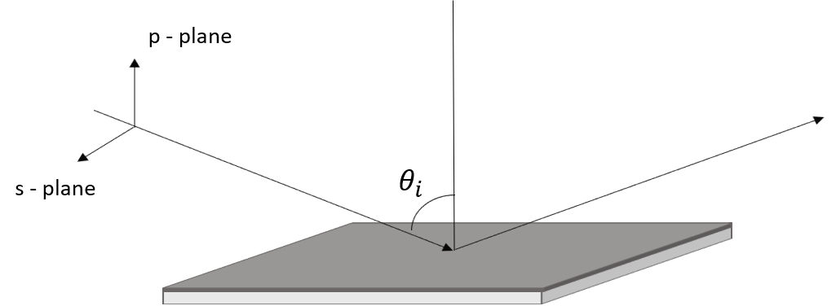
Figure 3: A diagram created by the author that depicts the orientation of the p- and s-plane polarizations. The incident and reflected rays form the p-plane, which is perpendicular to the sample surface. The s-plane polarization is parallel to the sample surface. The gray sample surface represents a TiO₂ film atop the white fused silica substrate.
The amplitude of the electric field changes upon reflection from a surface according to the Fresnel equations for the reflection coefficients in the different planes of polarization:
 | $$r_{p}= \frac{ñ_{2}cos(θ_{i})- ñ_{1}cos⁡(θ_{t})}{ñ_{2}cos\left(θ_{i}\right)+ ñ_{1}cos⁡(θ_{t})}$$ | (9a)
 | $$r_{s}=\frac{ñ_{1}cos(θ_{i})- ñ_{2}cos⁡(θ_{t})}{ñ_{1}cos\left(θ_{i}\right)+ ñ_{2}cos⁡(θ_{t})}$$ | (9b)
These equations only describe reflection from one surface, however. Our samples are nanometers thin films of TiO₂ on 1 mm thick substrates of either fused silica or silicon. There are two layers in our samples: the TiO₂ film and the substrate. To account for multiple interfaces, we define the total reflection coefficients in terms of the film phase thickness, ꞵ:
 | $$R_{p}= \frac{r_{12}^{p}+ r_{23}^{p}e^{-i2ꞵ}}{1+ r_{12}^{p}+ r_{23}^{p}e^{-i2ꞵ}}$$ | (10a)
 | $$R_{s}= \frac{r_{12}^{s}+ r_{23}^{s}e^{-i2ꞵ}}{1+ r_{12}^{s}+ r_{23}^{s}e^{-i2ꞵ}}$$ | (10b)
 | ꞵ = 2п ($\frac{d}{λ}$) $ñ_{2}$ cos ($θ_{2}$) | (11)
Where $r_{12}^{p}$ refers to the Fresnel reflection coefficient at the interface between medium 1 and medium 2, for p-plane polarized light, etc. Ellipsometry measures the total reflection coefficients, which are the sum of the initial reflection as well as the internal reflections which are transmitted in turn. The rays that reflect internally before transmitting out of the boundary experience a phase change so that the overall reflected light has a phase change relative to the incident light. Medium 1, 2, and 3 would refer to air, TiO₂, and a substrate of either SiO₂ or Si in this work, as shown in Figure 4:
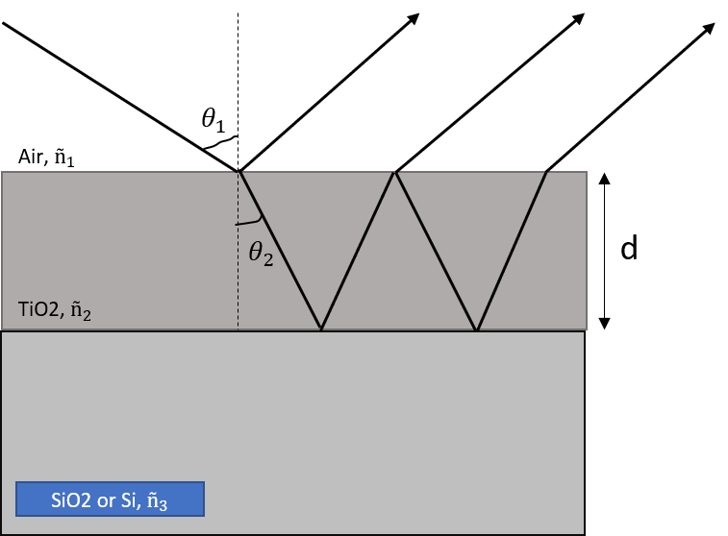
Figure 4: A schematic diagram created by the author that depicts internal reflections due to multiple interfaces. The proportions of this diagram are not correct; in our samples, the films are approximately 1/100 the thickness of the substrate. In our thin films systems, we have a thin film of TiO₂ (varying in thickness from <5 nm to 150+ nm) atop a substrate of either fused silica or silicon (1 mm thick).

2.3 – Ellipsometry: Detecting the Change in Polarization Upon Reflection
Light is modeled as a transverse electromagnetic wave. When we discuss light we typically speak primarily of the electric field, which at any point in time is described as a vector with some magnitude and pointing in some orientation in space, that oscillates in some manner over time. If we observe the shape that the electric field traces in a plane perpendicular to propagation, then it may trace a line, circle, or ellipse. This is known as linearly, circularly, or elliptically polarized light, and it is from elliptically polarized light that ellipsometry gets its name.
Light undergoes a change in amplitude and phase upon reflection from a surface. The phase change is not necessarily the same for s and p-plane polarizations. Therefore, linearly polarized light, with s and p-plane polarization components has its amplitudes and phases change differently, resulting in elliptically polarized light. This is where ellipsometry gets its name. In ellipsometry, light of a known linear polarization state is reflected off the surface of a sample and the change in the polarization to elliptically polarized light is measured. The central equation of ellipsometry is:
 | ρ = $\frac{R_{p}}{R_{s}}$ = tan(ᴪ)$e^{i∆}$ | (12)
The change in polarization of the light upon reflection, ρ, is physically measured as the ratio of the total reflection coefficients. This ratio is parameterized with two variables to represent the amplitude change, ᴪ, and the phase shift, $∆$:
 | tan(ᴪ) = $\frac{\left|R_{p}\right|}{\left|R_{s}\right|}$ | (13)
 | $∆ = δ_{1}$ - $δ_{2}$ | (14)
Where $δ_{1}$ is the phase difference between the s and p-plane polarized light for the incident light ray and $δ_{2}$ is the same phase difference but for the outgoing, reflected light ray. SE measures ᴪ and $∆$ as functions of wavelength, ᴪ (λ) and $∆$ (λ).

2.4 – Modeling Physical Quantities with Ellipsometry
The objective of SE is to closely “fit” experimentally measured ᴪ and $∆$ spectra with projected curves from a model of the system that is being measured. An optical model is built with adjustable parameters such as film thickness and value of the optical constants. These are referred to as the model fit parameters. When the model projections closely replicate the measured SE data (ᴪ and $∆$ spectra), then the model fit parameters closely approximate their real physical values. In this way, we estimate the film thickness and optical constants and do not directly measure it. The degree to which a model is closely “fitting” the data is gauged by using the Mean-Square-Error (MSE) estimator.
MSE averages the root of the squares of the difference between real values and model values. When this difference is minimized, the model values are close to the real values and the model is closely fitting the data. When this occurs, the model fit parameters are closely approximating their true, physical values.
 | $${MSE}_{NCS}= \sqrt{\frac{1}{3n-m}\sum_{i=1}^{n}{{\left(\frac{N_{E_{i}}- N_{G_{i}}}{0.001}\right)}^{2}+{\left(\frac{C_{E_{i}}- C_{G_{i}}}{0.001}\right)}^{2}+{\left(\frac{S_{E_{i}}- S_{G_{i}}}{0.001}\right)}^{2}}}$$ | (15)
where n is the number of data points and m is the number of fit parameters. N, C and S are entries in the Mueller matrix, which is an optics concept that is relevant to ellipsometry but does not need to be discussed in detail here. N, C and S are related to ᴪ and $∆$ in the following way:
 | $$N=\cos{(2ᴪ)}$$ | (16)
 | $$C=\sin{(2ᴪ)}$$ | (17)
 | $$S=\sin{(2ᴪ)}\sin{(∆)}$$ | (18)
Measuring MSE in terms of N, C, and S is analogous to measuring MSE in terms of difference in the ᴪ and $∆$ of the measured SE data and model projections. References for the development of this theory section were Ref. [4] and Ref. [5].

Methods

3.1 – J.A. Woolam M-2000X Spectroscopic Ellipsometer
The ᴪ and $∆$ spectra of our TiO₂ films were measured with an M-2000X model spectroscopic ellipsometer made by the J.A. Woolam Company, Inc. This model of ellipsometer has a patented rotating analyzer that measures all wavelengths simultaneously for very quick measurement; data acquisition time is a few seconds. The sample stage and polarizer/analyzer arms are motorized to translate to different positions and incident angles. The light source is a 75W Xenon lamp, which emits a broadband spectrum in the UV and visible light wavelength range, 200 – 1000nm. Figure 5 is a picture of the M-2000X ellipsometer at its current home: The Advanced Technology and Manufacturing Institute (ATAMI) in Corvallis, Oregon:
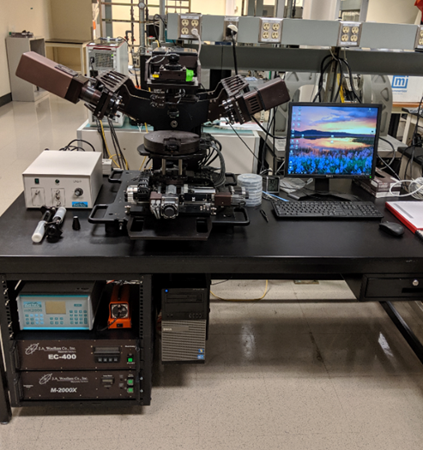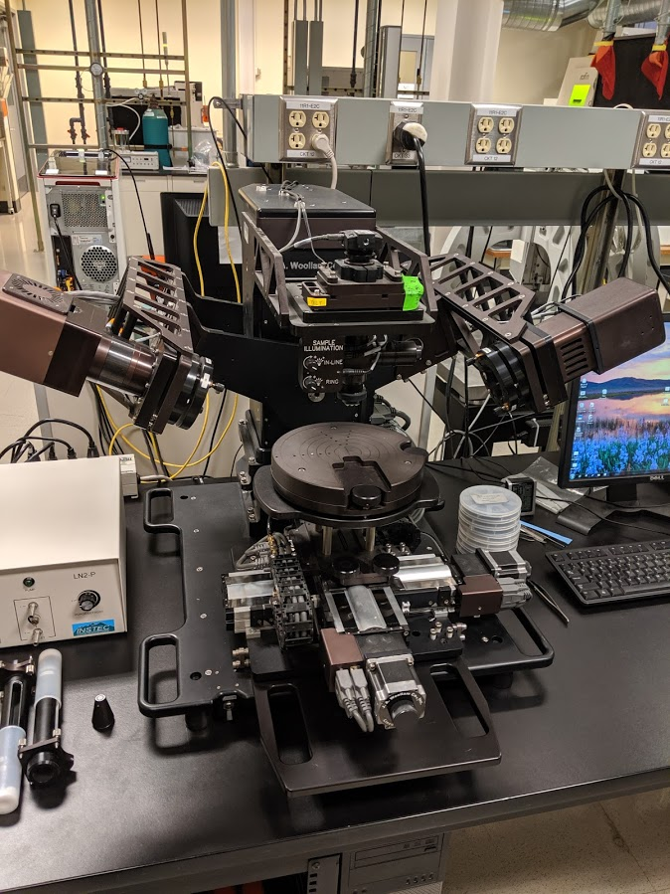
Figure 5: The M-2000X spectroscopic ellipsometry system used in these results (pictures taken by author). The polarizer and analyzer arms (left and right, respectively) are pointed down at the sample stage in the center.

3.2 – CompleteEASE v.6.54
The Woolam company’s M-2000X ellipsometer was run in conjunction with their proprietary data acquisition and modeling software, CompleteEASE. This software works with the ellipsometer and is used to select data acquisition parameters for measurement of ᴪ and $∆$ spectra, as well as to build and fit optical models of measured samples to those spectra. Figure 6 shows CompleteEASE open to the Analysis tab, where model building and fitting is done on SE data for sample # 44, pre-annealed. The CompleteEASE Cauchy model, discussed later, is being applied to the data, and the result is a good fit. As can be seen in Figure 6, the model projections (dashed lines) lie closely over the measured ᴪ and $∆$ spectra (red and green lines, respectively), with a low MSE of 2.781.
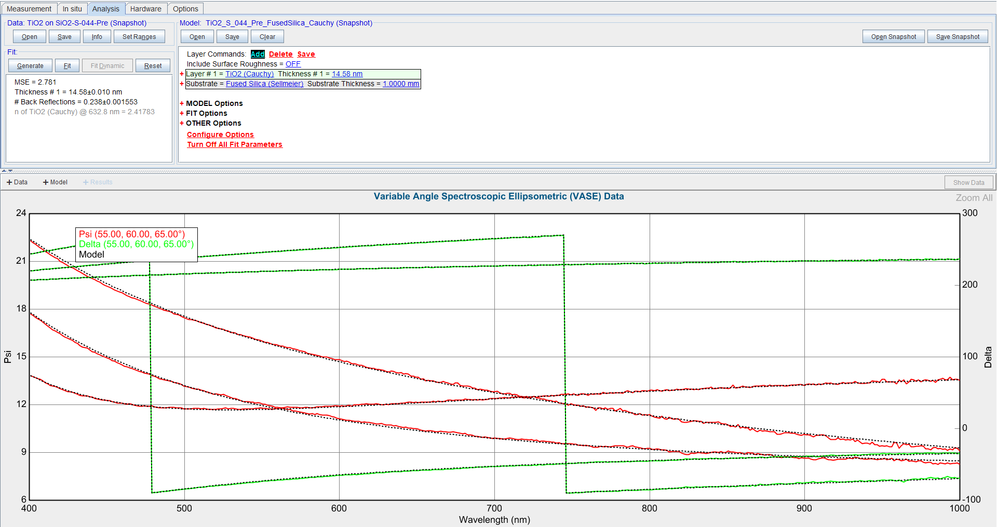
Figure 6: CompleteEASE open to the Analysis tab, where layer optical models are developed. The ᴪ and $∆$ spectra of sample #44, pre-annealed are displayed in the VASE Data window. The Cauchy model for fused silica substrates is open and being applied, resulting in an MSE of 2.701, as seen in the Fit window, and a film thickness of 14.58 nm.
Every SE measurement in this thesis was made with a common set of data acquisition parameters. ᴪ and $∆$ spectra were measured at three incident angles (55°, 60°, 65°). Since two parameters, ᴪ and $∆$, are measured at each incident angle, the result is six curves in the Data window, as seen in Figure 6. High accuracy mode was used for measurements on of TiO₂ films on fused silica substrates. These films are mostly transparent on the measured wavelength range, and coupled with the transparent fused silica substrates produce a weak reflection signal that is accounted for by the high accuracy mode. Measurements were made with a single point scan pattern and a data acquisition time of 4 seconds.
The CompleteEASE manual (Ref. [6]) is a good general reference on how to use CompleteEASE prudently for various types of modeling. A user guide to CompleteEASE with specific information and advice on how CompleteEASE was used in the modeling of these TiO₂ films was written by the author. This guide can be found in Appendix B, labeled as CompleteEASE User Reference Guide.

3.2.1 – CompleteEASE substrate models
Optical models of each of the two types of substrate (fused silica and silicon) were chosen from selections in the available databases in CompleteEASE:
The fused silica substrate was modeled with the “Fused Silica (Sellmeier).mat” model. Figure 7 shows the expanded window view of the Fused Silica (Sellmeier).mat model:
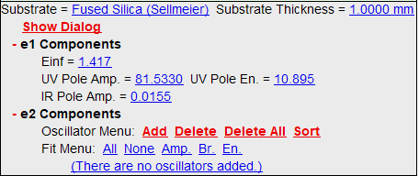
Figure 7: Fused Silica (Sellmeier).mat model used to model the fused silica substrate of our TiO₂ films. The model fit parameters of the substrate were kept at the above, initial values of the model for all results in this thesis.
The model fit parameters of the substrates were not fitted, or allowed to alter from their initial values, as the substrates are ideally the same between different TiO₂ films.
The silicon substrate was modeled with the “Si_JAW.mat” model. This model of silicon has no fittable model parameters, so there is no expanded window view.

3.2.2 – CompleteEASE Cauchy model
The TiO₂ films were modeled in CompleteEASE with an available Cauchy model called, “TiO₂ (Cauchy).mat”. Figure 8 shows the expanded window view of the TiO₂ (Cauchy).mat model, with the Fused Silica (Sellmeier) substrate model applied:
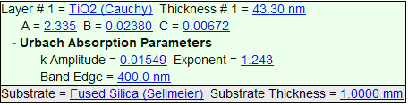
Figure 8: The TiO₂ (Cauchy).mat model used to model thin films of TiO₂ as transparent in the visible wavelength range, in this case with the fused silica substrate. The model fit parameters are at their initial values.
The model fit parameters are the values in blue in the model which can be changed, apart from band edge and substrate thickness, which were kept at the above values. The model fit parameters are “fit” or adjusted by using a standard, iterative, non-linear regression algorithm (the Levenberg-Marquardt method) to automatically reduce the MSE by altering the fit parameters. This model was used on the wavelength range 400 – 1000 nm, which is visible to near infrared. The Cauchy model can’t model the absorption near the bandgap well, which is in the UV just below 400nm, which is why the wavelength range was restricted for this model.
This Cauchy model for the TiO₂ layer was used to model films on both fused silica and silicon substrates.

3.2.3 – CompleteEASE Cody-Lorentz model
The TiO₂ films were also modeled in CompleteEASE with a Cody-Lorentz model called, “TiO₂ (CodyLor).mat”. Figure 9 shows the expanded window view of this model:
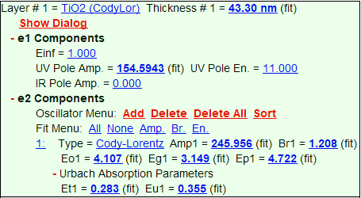
Figure 9: The TiO₂ (CodyLor).mat model used to model TiO₂ films in CompleteEASE. The parameters of the model which were fitted are highlighted in dark blue with (fit) next to them. All other model parameters were kept at their initial values, as shown above.
This model was used over the full measured wavelength range of 200 – 1000 nm, as it does account for the absorption of the bandgap, with a Cody-Lorentz oscillator model.

Results

4.1 – Tables of Fitted Parameters from CompleteEASE Models
The ᴪ and $∆$ spectra of sixty-eight thin films of TiO₂ on fused silica substrates and ten TiO₂ films on silicon substrates were measured using an M-2000X spectroscopic ellipsometer. The ᴪ and $∆$ spectra of these films were then fit in CompleteEASE with one of two options developed to model the TiO₂ film: the TiO₂ (Cauchy) or TiO₂ (Cody-Lorentz) models. Depending on the substrate of the film being modeled, the Fused Silica (Sellmeier) or Si_JAW.mat were used (for fused silica and silicon substrates, respectively). The results of fitting model parameters for these films are contained in Tables A1 – A4, found in Appendix A.

Table A1 lists an important subset of fitted model parameters for the sixty-eight films on fused silica substrates that includes:
- Sample identification number, MSE, TiO₂ film thickness (nm), refractive index at 633 nm, and band gap energy (Eg1) from the Cody-Lorentz model
Table A2 lists the following fitted model parameters from applying the CompleteEASE Cauchy model to the set of ten TiO₂ films on silicon substrates that were measured:
- Sample ID, MSE, TiO₂ film thickness (nm), Cauchy coefficients A, B, and C
Table A3 has the following additional model fitting parameters, not listed in Table 1, from applying the CompleteEASE Cauchy model to the fused silica substrate films:
- Cauchy coefficients A, B, and C, amplitude of the extinction coefficient (k amplitude), and exponent (k amplitude and corresponding exponent are the Urbach absorption parameters defined in this Cauchy model)
Table A4 lists the following model fit parameters from applying the CompleteEASE Cauchy model to a set of ten TiO₂ films on silicon substrates on the wavelength range of 400 – 1000 nm:
- Sample ID, MSE, TiO₂ film thickness (nm), and the Cauchy coefficients A, B, and C

4.2 – Correspondence of CompleteEASE Cauchy and Cody-Lorentz Models
Many of the thin TiO₂ films were successfully modeled with both the Cauchy and Cody-Lorentz models. One model did not clearly work better than the other and good results were gained from using both. The Cody-Lorentz model had the advantage of providing an estimate of the band gap energy, however the Cauchy model is simpler, was more familiar to the author, and can be easier to use and understand. Figure 10 shows how the thicknesses of amorphous films that were estimated by the two different CompleteEASE models compare to one another:
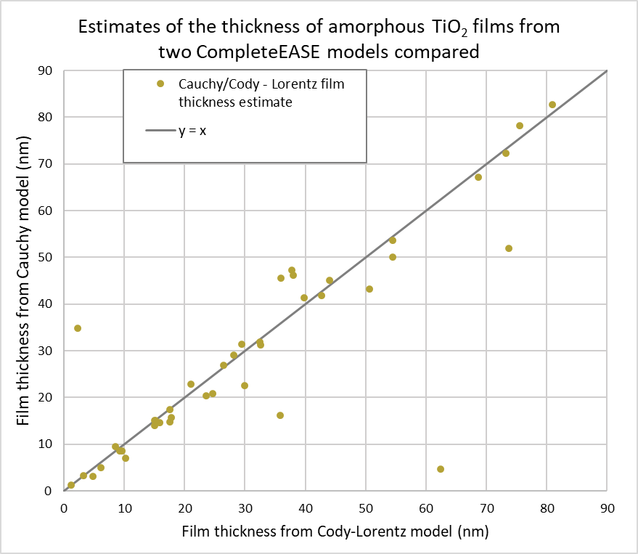
Figure 10: Film thickness from Cauchy model plotted against film thickness from Cody-Lorentz model. The points lie on the line when the models agreed in their thickness estimates. It can be seen that the models were generally in agreement.
The Cauchy and Cody-Lorentz CompleteEASE generally corresponded well in their estimates of the thickness of the TiO₂ films, apart from some outlying cases. Figure 11 shows the correspondence between estimates of the refractive index of the TiO₂ films between the two CompleteEASE models. This figure also shows a clustering of datapoints around a refractive index of 2.4 for the amorphous films. It was expected that we would measure a distinct, and low, refractive index for all of the amorphous films, and this clustering around a single value serves as evidence of that fact:

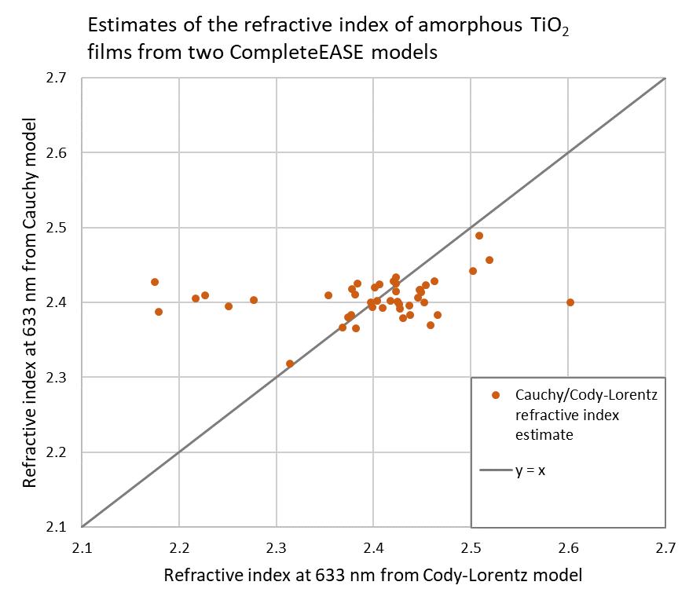
Figure 11: Correspondence of refractive index at 633 nm between Cauchy and Cody-Lorentz CompleteEASE models. The models did not agree as well in refractive index estimates as they did with film thickness estimates. The magnitude of the refractive index of amorphous TiO₂ films appears to cluster around a value of ~2.4.

4.3 – Change in TiO₂ Films from Amorphous to Crystalline
We had wondered whether the thickness of the TiO₂ film was changing when the film crystallized upon annealing. There was some evidence from EPMA to suggest that the films were shrinking by a few nanometers during annealing. Figure 12 shows TiO₂ film thickness estimates from applying the CompleteEASE Cauchy model for four films on fused silica substrates, in both the pre- and post-annealed state. The film thickness changes are inconsistent: some model results showed the films increasing in thickness, or staying the same. Many modeling results did show a decrease in film thickness, although I would say the modeling of the fused silica substrate films wasn’t done well enough to be able to conclusively state that a particular change in film thickness was occurring when the films were annealed.
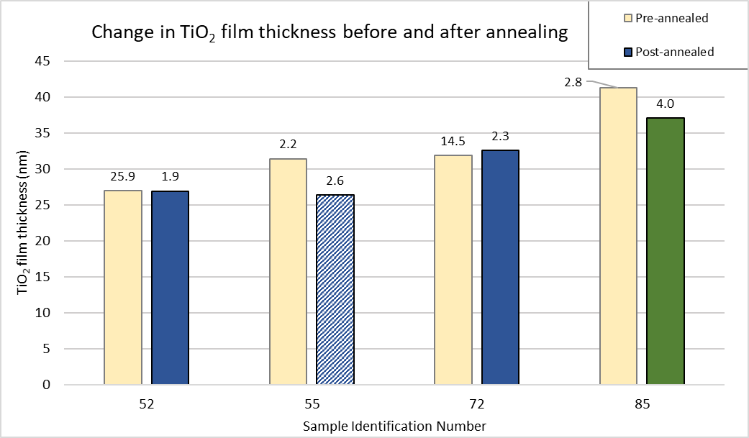
Figure 12: Pre- and post-annealed film thicknesses for TiO₂ films that were well modeled with the CompleteEASE Cauchy model. The crystal polymorphs of the post-annealed versions of the films are color-coded (green for anatase, blue for brookite). Sample 55 is cross-hatched as it is a mixed phase crystalline film, as opposed to the other three which are pure phase. The numbers at the top of each column are the corresponding MSEs of each model fit.
The general trend of the refractive index increasing upon annealing into crystalline films was established, as can be seen in Figure 13, which lists the refractive indices of the same set of four films on fused silica substrates modeled with the CompleteEASE Cauchy model:
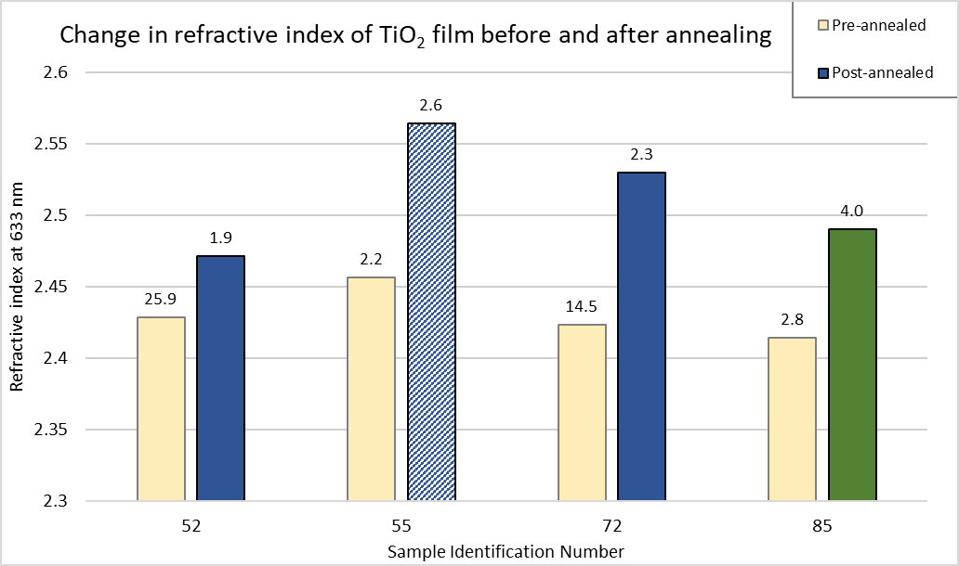
Figure 13: Refractive index increasing from pre- to post-annealed films modeled with the CompleteEASE Cauchy model. The refractive index of the amorphous TiO₂ films was found to be ~2.4, while the index of the three polymorphs were higher, and distinct from one another. The numbers at the top of each column are the corresponding MSE of the model fits.

4.4 – Refractive Index of Crystalline TiO₂ Films
A subset of TiO₂ films were targeted for measurement in the post-annealed, crystalline state due to the distribution of polymorphs (rutile, brookite, or anatase) that they attained. Figure 14 shows estimates of the refractive index from applying the CompleteEASE Cauchy and Cody-Lorentz model to a subset of nine crystalline TiO₂ films, followed by a Table 6 which lists the crystal phase fractions of each sample as determined by EPMA:
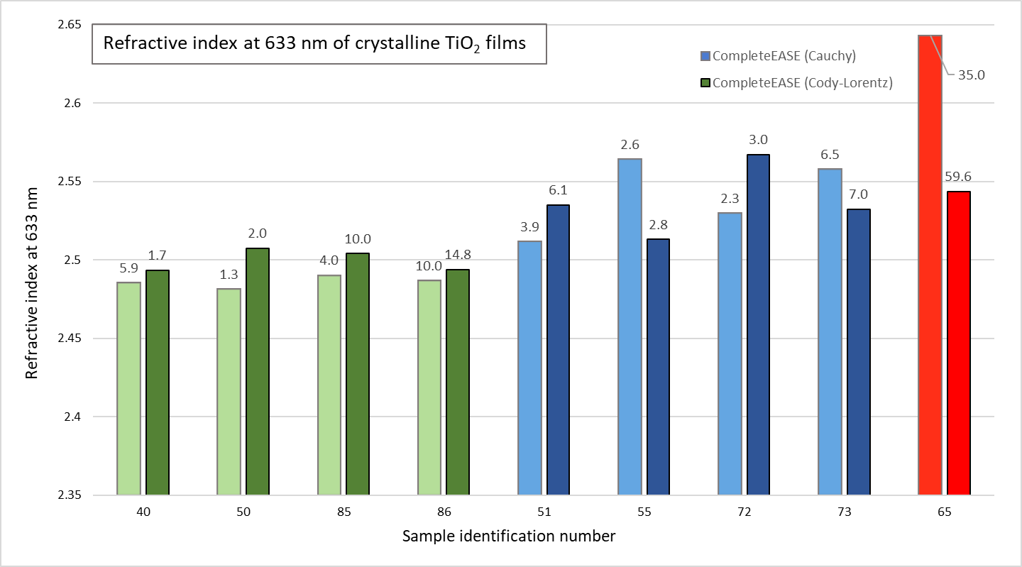
Figure 14: Graph showing the refractive index of crystalline TiO₂ films modeled in CompleteEASE. The Cauchy model results are in a lighter color than the Cody-Lorentz model results. The MSE of the model fit is listed at the top of each column. Anatase, brookite, and rutile films are color-coded as green, blue, and red, respectively. The difference in magnitude of the refractive index of the different crystal polymorphs of TiO₂ is depicted in this graph.
Table 6 lists the crystal phase fractions for the films listed in Figure 14, in terms of the percentage of each polymorph (anatase, brookite, or rutile) that the film was found to consist of from EPMA measurement by Okan Agirseven:
Sample ID | % Anatase | % Brookite | % Rutile
40 | 100 | - | -
50 | 95 | 5 | -
85 | 100 | - | -
86 | 100 | - | -
51 | - | 95 | 5
55 | 47 | 53 | -
72 | - | 99.85 | 0.15
73 | 3.75 | 95.75 | 0.5
65 | - | - | 100

Figure 14 nominally shows how the index for anatase is lower than brookite, which is lower than rutile. Unfortunately, the only pure rutile film that I measured, sample # 65, was not well modeled so these results are inconclusive. I was able to measure a high index on sample # 65 with the Cauchy model, but expected to find the index even higher than that, at approximately 2.7. While sample # 65 makes the results a little inconclusive, the expected order in magnitude of refractive index from anatase, to brookite, to rutile (low to high), was found. Figure 14 also serves to show some of the discrepancy that exists between the two CompleteEASE models, particularly in the case of sample # 55, which is well modeled by both models, but the refractive index is estimated to be two noticeably different magnitudes.

4.4 – Comparison of CompleteEASE and IndexCalc Modeling Results
As discussed previously, fellow physics undergraduate Cameron Stewart performed intensity-based reflection and transmission spectroscopy on our TiO₂ film samples. He then fit the reflection spectra with a Sellmeier equation in an Excel workbook called IndexCalc. Readers are encouraged to reference Cameron’s thesis for more details on his procedure. Cameron and I measured some films in common, and sought to compare the results of modeling with the two CompleteEASE models to that from IndexCalc. Figure 15 shows the estimates of thickness (in nm) of the TiO₂ film from the three models for a set of seven pre-annealed films that we measured in common:
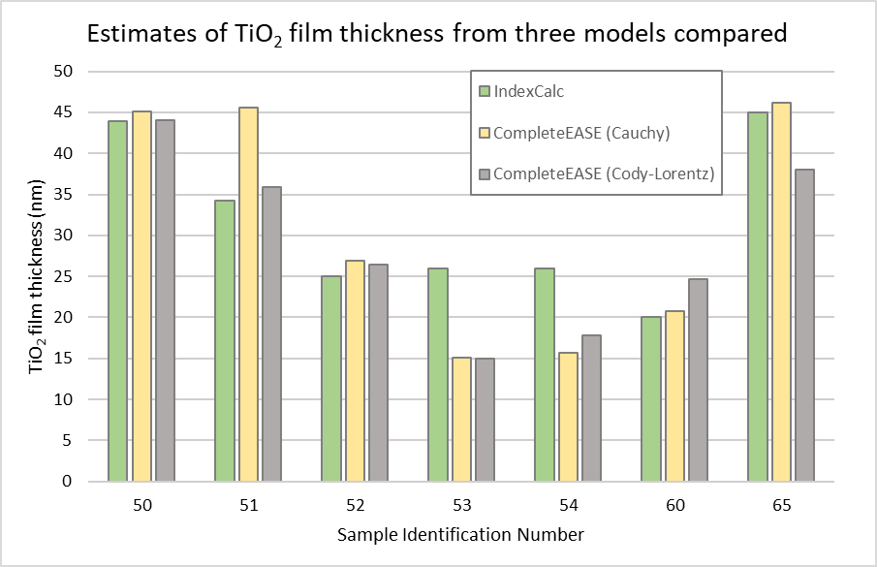
Figure 15: Estimates of the thickness of the TiO₂ film from IndexCalc and the two CompleteEASE models developed for this thesis compared. These seven films are all in the amorphous, pre-annealed state.
Figure 16 shows the estimates of the refractive index at 633 nm of the TiO₂ film for a set of post-annealed, crystalline films that Cameron and I both measured. The three models (IndexCalc, and the CompleteEASE Cauchy and Cody-Lorentz models) agree much more closely in their estimates of the refractive index of the films in Figure 17 than they agree on the film thicknesses in Figure 16. There is variability in the results of each of the models that makes it difficult to know what the exact film thicknesses or refractive indices are, to an exacting detail.
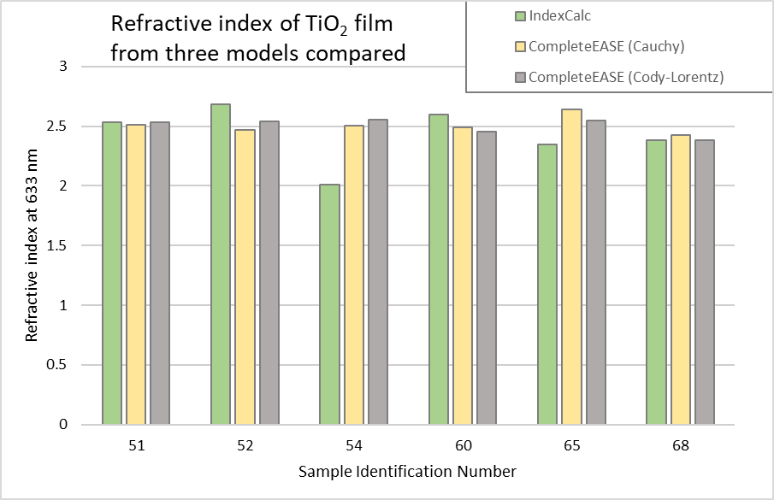
Figure 17: Estimates of the refractive index at 633 nm of six crystalline TiO₂ films from IndexCalc and the two CompleteEASE models developed for this thesis compared. As can be seen, there is close agreement between the models for these films.

Conclusion
The ᴪ and $∆$spectra of sixty-eight TiO₂ films on fused silica substrates and ten TiO₂ films on silicon substrates were measured using a M-2000X spectroscopic ellipsometer. The ᴪ and $∆$ spectra were then fit with optical models developed in CompleteEASE. A Cauchy model was developed in CompleteEASE that modeled the films as mostly transparent on the wavelength range of 400 – 1000 nm. In addition, a Cody-Lorentz oscillator model was developed in CompleteEASE to include modeling of the bandgap of the TiO₂ films (and provide an estimate of the band gap energy) on the wavelength range of 200 – 1000 nm.
Both CompleteEASE models were relatively successful in modeling our TiO₂ films and extracting meaningful data, especially reliable estimates of the film thickness which are very useful in our research group. The models were shown to generally correspond with each other, as in Figures 10 and 11, which showed that the estimates of TiO₂ film thickness and refractive index at 633 nm were mostly the same between the two models. The author was more familiar with, and spent more time with, the Cauchy model, and therefore those results are likely to be overall better and more reliable than the Cody-Lorentz model results. Table 1 provides the best way to judge the correspondence of results between the models for every measured film.
Several of the expected physical measurements were found using these models. The thickness of the TiO₂ film was not found to conclusively change in one way or another upon annealing. The refractive index of the films was shown to increase upon annealing. The refractive index of pre-annealed, amorphous TiO₂ films was shown to be the same, no matter which polymorph the amorphous film annealed to. The refractive index of amorphous TiO₂ films at 633 nm was shown to be approximately 2.4.
The refractive indices of the crystal polymorphs of TiO₂ (rutile, brookite, anatase) were shown to be ordered in magnitude as expected: rutile being the largest, followed by brookite, anatase, and the amorphous films. The variability of modeling results makes it difficult to know to what degree the magnitude of these estimates correspond with expected values of the index.
Finally, results from SE were compared with Cameron Stewart’s IndexCalc estimates from applying a Sellmeier equation to fit the reflection spectra of our TiO₂ films. Figures 16 and 17 show the general close correspondence between our models in estimating the TiO₂ film thickness and refractive index. To improve on these results, it would be advised to gain a further understanding of the Cauchy, Sellmeier, and Cody-Lorentz models, and to more closely watch the values of the model fit parameters, and have them correspond with literature values.

References
- Haggerty, J. E., Schelhas, L. T., Kitchaev, D. A., Mangum, J. S., Garten, L. M., Sun, W., . . . Tate, J. (2017). High-fraction brookite films from amorphous precursors. Scientific Reports, 7(1). doi:10.1038/s41598-017-15364-y
- Mangum, J. S., Agirseven, O., Haggerty, J. E., Perkins, J. D., Schelhas, L. T., Kitchaev, D. A., . . . Gorman, B. P. (2019). Selective brookite polymorph formation related to the amorphous precursor state in TiO2 thin films. Journal of Non-Crystalline Solids, 505, 109-114. doi:10.1016/j.jnoncrysol.2018.10.049
- Agirseven, O., Rivella, D. T., Haggerty, J. E., Berry, P. O., Diffendaffer, K., Patterson, A., . . . Tate, J. (2020). Crystallization of TiO2 polymorphs from RF-sputtered, amorphous thin-film precursors. AIP Advances, 10(2), 025109. doi:10.1063/1.5140368
- Azzam, R. M., & Bashara, N. M. (1979). ELLIPSOMETRY AND POLARIZED LIGHT. BY R.M.A. AZZAM AND N.M. BASHARA. AMSTERDAM (U.A.): NORTH-HOLLAND PUBL.
- Tompkins, H. G. (2006). A user's guide to ellipsometry. Mineola, NY: Dover Publications.

Appendix A: Tables of CompleteEASE modeling results

TABLE A1: Subset of CompleteEASE Cauchy and Cody-Lorentz model fitting results for TiO₂ films on fused silica substrates
Table 1 shows a subset of results from fitting both a Cody-Lorentz oscillator and a Cauchy equation in CompleteEASE to ᴪ and $∆$ spectra measured by an M-2000X spectroscopic ellipsometer, as described in the methods. This table lists modeling results for TiO₂ films on fused silica substrates. For each film in this table, there are two rows: the first row reports the Cauchy model results (which don’t report an estimate of the band gap energy, Eg1), followed by a row that reports the Cody-Lorentz model results (which do have estimates for Eg1).
Sample ID | MSE | TiO2 film thickness (nm) | n of TiO₂ film @ 632.8 nm | Eg1
30 pre | 22.57 | 78.15 | 2.4006
30 pre | 23.16 | 75.53 | 2.39747 | 3.177
31 pre | 17.39 | 16.21 | 2.3871
31 pre | 35.995 | 35.81 | 2.17883 | 3.432
32 pre | 3.751 | 4.67 | 2.4099
32 pre | 63.235 | 62.38 | 2.22682 | 2.526
32 post | 44.66 | 30.61 | 2.4968
32 post | 53.97 | 41.98 | 2.3766 | 2.876
36 pre | 18.681 | 20.35 | 2.4091
36 pre | 12.316 | 23.62 | 2.35397 | 3.392
40 post | 5.866 | 29.93 | 2.4852
40 post | 1.726 | 28.49 | 2.49341 | 3.226
41 pre | 1.44 | 3.12 | 2.4269
41 pre | 1.498 | 4.79 | 2.17542 | 3.135
42 pre | 2.162 | 7.03 | 2.4053
42 pre | 2.668 | 10.17 | 2.21692 | 3.221
42 post | 1.29 | 7.33 | 2.518
42 post | 2.056 | 9.29 | 2.32997 | 3.526
43 pre | 3.801 | 29 | 2.3925
Sample ID | MSE | TiO2 film thickness (nm) | n of TiO₂ film @ 632.8 nm | Eg1
43 pre | 3.964 | 28.14 | 2.4094 | 3.231
44 pre | 2.781 | 14.58 | 2.4178
44 pre | 2.238 | 15.91 | 2.37767 | 2.937
44 post | 6.632 | 13.63 | 2.4631
44 post | 16.928 | 15.67 | 2.51098 | 3.106
46 pre | 3.105 | 3.29 | 2.4255
46 pre | 7.309 | 3.3 | 2.4234 | 3.36
47 pre | 1.125 | 1.28 | 2.3976
47 pre | 1.341 | 1.25 | 2.42641 | 3.159
48 pre | 5.179 | 53.56 | 2.4172
48 pre | 8.553 | 54.52 | 2.44693 | 3.142
49 pre | 20.417 | 43.14 | 2.3918
49 pre | 75.445 | 50.58 | 2.42727 | 2.657
50 pre | 1.161 | 45.05 | 2.4896
50 pre | 2.065 | 44.02 | 2.50858 | 3.13
50 post | 1.296 | 45.12 | 2.4813
50 post | 1.98 | 43.3 | 2.50731 | 3.149
51 pre | 31.062 | 45.55 | 2.3832
51 pre | 18.012 | 35.94 | 2.46588 | 3.185
51 post | 3.858 | 36.24 | 2.5116
51 post | 6.092 | 35.9 | 2.53506 | 2.976
52 pre | 25.921 | 26.95 | 2.4287
52 pre | 14.718 | 26.47 | 2.42087 | 3.191
52 post | 1.881 | 26.9 | 2.4714
52 post | 2.926 | 26.22 | 2.53665 | 3.209
53 pre | 1.974 | 15.05 | 2.3664
53 pre | 2.369 | 15.02 | 2.3679 | 3.199
54 pre | 30.914 | 15.64 | 2.3963
Sample ID | MSE | TiO2 film thickness (nm) | n of TiO₂ film @ 632.8 nm | Eg1
54 pre | 14.356 | 17.78 | 2.43701 | 3.204
54 post | 3.924 | 13.29 | 2.5063
54 post | 6.036 | 12.95 | 2.5566 | 2.753
55 pre | 2.2 | 31.4 | 2.4565
55 pre | 2.829 | 29.44 | 2.51877 | 3.744
55 post | 2.634 | 26.32 | 2.5641
55 post | 2.76 | 29.3 | 2.51308 | 3.225
58 pre | 31.452 | 138.78 | 2.3999
58 pre | 23.79 | 135.58 | 2.45182 | 3.092
58 post | 50.397 | 131.95 | 2.4811
58 post | 31.468 | 132.46 | 2.51141 | 3.134
59 pre | 31.151 | 47.2 | 2.36985
59 pre | 18.047 | 37.77 | 2.45833 | 3.198
60 pre | 18.56 | 20.81 | 2.3937
60 pre | 17.97 | 24.65 | 2.39869 | 3.403
60 post | 1.35 | 21.09 | 2.4869
60 post | 1.44 | 22.39 | 2.45149 | 3.222
61 pre | 11.732 | 67.13 | 2.4019
61 pre | 17.663 | 68.7 | 2.41726 | 3.008
61 post | 4.438 | 64.47 | 2.4975
61 post | 13.567 | 67.39 | 2.46477 | 3.599
62 pre | 34.504 | 271.36 | 2.40142
62 pre | 34.4 | 269.05 | 2.42427 | 3.157
62 post | 34.541 | 259.13 | 2.4838
62 post | 35.261 | 259.54 | 2.49041 | 3.16
63 pre | 3.494 | 4.96 | 2.4033
63 pre | 3.538 | 6.15 | 2.27649 | 3.186
64 post | 3.339 | 67.6 | 2.5121
Sample ID | MSE | TiO2 film thickness (nm) | n of TiO₂ film @ 632.8 nm | Eg1
64 post | 5.475 | 68.69 | 2.49149 | 3.311
65 pre | 42.033 | 46.16 | 2.3999
65 pre | 23.26 | 38.01 | 2.60246 | 2.836
65 post | 35.027 | 26.85 | 2.6431
65 post | 59.647 | 38.79 | 2.54365 | 2.927
67 pre | 1.469 | 9.5 | 2.4147
67 pre | 2.473 | 8.55 | 2.42309 | 2.964
68 pre | 9.54 | 22.91 | 2.3789
68 pre | 7.007 | 21.09 | 2.43039 | 3.144
69 pre | 0.275 | 14.03 | 2.4248
69 pre | 3.29 | 15.09 | 2.38346 | 3.131
70 pre | 3.116 | 14.84 | 2.33955
70 pre | 2.61 | 17.56 | 2.25096 | 3.221
71 pre | 15.1 | 41.74 | 2.4171
71 pre | 15.469 | 42.69 | 2.44811 | 3.137
72 pre | 14.486 | 31.85 | 2.4232
72 pre | 18.225 | 32.52 | 2.45372 | 3.129
72 post | 2.285 | 32.57 | 2.5298
72 post | 3.009 | 2.23 | 2.56713 | 4.038
73 pre | 12.171 | 22.56 | 2.4104
73 pre | 25.386 | 29.94 | 2.38143 | 3.84
73 post | 6.549 | 25.49 | 2.5577
73 post | 6.988 | 26.56 | 2.53216 | 3.229
75 pre | 7.61 | 15.14 | 2.4337
75 pre | 7.384 | 15.1 | 2.42312 | 3.281
76 pre | 12.855 | 50.03 | 2.3804
76 pre | 15.983 | 54.42 | 2.37364 | 3.089
77 pre | 27.546 | 132.74 | 2.3831
Sample ID | MSE | TiO2 film thickness (nm) | n of TiO₂ film @ 632.8 nm | Eg1
77 pre | 26.027 | 134.41 | 2.37689 | 2.984
77 post | 44.523 | 125.78 | 2.5344
77 post | 66.004 | 123.3 | 2.58329 | 3.266
78 pre | 14.311 | 31.17 | 2.4279
78 pre | 16.396 | 32.6 | 2.46227 | 3.206
79 pre | 1.462 | 34.87 | 2.3832
79 pre | 1.169 | 2.25 | 2.43783 | 4.072
80 pre | 1.428 | 17.46 | 2.4024
80 pre | 1.493 | 17.57 | 2.40333 | 3.199
80 post | 1.984 | 16.67 | 2.50576
80 post | 2.883 | 17.91 | 2.43996 | 3.526
81 pre | 2.046 | 8.63 | 2.4197
81 pre | 4.167 | 9.66 | 2.4009 | 3.006
82 pre | 17.913 | 72.24 | 2.365
82 pre | 27.858 | 73.26 | 2.38215 | 3.093
82 post | 35.057 | 68.39 | 2.4985
82 post | 146.9 | 63.1 | 2.58847 | 5.33
83 post | 1.756 | 17.06 | 2.5497
83 post | 1.991 | 18.63 | 2.49782 | 3.129
85 pre | 2.765 | 41.28 | 2.4141
85 pre | 1.868 | 39.8 | 2.44887 | 3.133
85 post | 4.041 | 37.01 | 2.49
85 post | 10.014 | 39.82 | 2.50396 | 3.211
86 pre | 27.221 | 170.82 | 2.442
86 pre | 33.155 | 165.54 | 2.50192 | 2.995
86 post | 9.957 | 167.14 | 2.4868
86 post | 14.753 | 166.96 | 2.49369 | 3.028
87 pre | 4.758 | 8.56 | 2.4246
Sample ID | MSE | TiO2 film thickness (nm) | n of TiO₂ film @ 632.8 nm | Eg1
87 pre | 5.3 | 9.32 | 2.40585 | 3.273
88 pre | 7.678 | 82.71 | 2.4068
88 pre | 3.005 | 80.92 | 2.44544 | 3.333
89 pre | 47.052 | 51.84 | 2.3186
89 pre | 95.088 | 73.67 | 2.31416 | 15

TABLE A2: Subset of CompleteEASE Cauchy model fitting results for TiO₂ films on silicon substrates
Table 2 shows a subset of modeling results from optically modeling TiO₂ films on silicon substrates in the modeling software CompleteEASE, as discussed in methods. The Cauchy coefficients A, B, and C are reported, as well as the MSE of the fit and the estimated TiO₂ film thickness. A low MSE corresponds to a good fit, and more reliable estimates of model fit parameters. Multiple rows for a sample correspond to multiple instances of applying the Cauchy model and finding different results for model fit parameters, which are all reported.
Sample ID | TiO₂ film thickness (nm) |  |  | MSE | A | B | C
9 pre | 47.84 | 5.564 |  |  | 1.359 | 0.0617 | 0
 | 34.89 | 0.886 |  |  | 2.267 | 0.00562 | 0.00977
 | 35.06 | 0.988 |  |  | 2.255 | 0.02374 | 0.00676
9 post | 48.19 | 5.564 |  |  | 1.238 | 0.1465 | 0
 | 35.28 | 1.579 |  |  | 2.499 | 0.0238 | 0.00695
10 pre | 46.65 | 6.183 |  |  | 1.458 | 0.0933 | 0
 | 32.34 | 17.123 |  |  | 1.965 | 0.0237 | 0.00668
10 post | 45.64 | 6.973 |  |  | 1.535 | 0.1629 | 0
 | 33.5 | 14.956 |  |  | 2.285 | 0.001257 | 0.00614
Sample ID | TiO₂ film thickness (nm) |  | MSE |  | A | B | C
12 pre | 31.67 | 0.546 |  |  | 2.226 | 0.0346 | 0.0061
12 post | 32.74 | 0.361 |  |  | 2.44 | 0.0238 | 0.011
22 pre | 24.26 | 0.506 |  |  | 2.309 | 0.0254 | 0.002
 | 25.05 | 0.535 |  |  | 2.235 | 0.02042 | 0.00669
 | 25.34 | 10.713 |  |  | 2.325 | 0.02333 | 0.000707
22 post | 23.27 | 0.0962 |  |  | 2.393 | 0.0121 | 0.0117
 | 25.77 | 0.394 |  |  | 2.352 | 0.02221 | 0.00593
 | 29.45 | 8.228 |  |  | 2.353 | 0.02575 | 0.00681
29 pre | 25.49 | 0.48 |  |  | 2.301 | 0.0243 | 0.0024
30 pre | 59.27 | 12.54 |  |  | 2.346 | 0.0236 | 0.0134
 | 69.3 | 6.789 |  |  | 2.449 | 0.02795 | 0.00834
30 post | 60.68 | 10.05 |  |  | 2.315 | 0.0859 | 0.0066
 | 70.76 | 6.152 |  |  | 2.409 | 0.02954 | 0.0076
31 pre | 22.37 | 1.359 |  |  | 2.248 | 0.0464 | 0.006
 | 21.69 | 0.0958 |  |  | 2.327 | 0.02521 | 0.00698
 | 21.04 | 20.646 |  |  | 2.285 | 0.04166 | 0.00716
 | 22.488 | 22.488 |  |  | 2.201 | 0.04236 | 0.00722
31 post | 23 | 19.101 |  |  | 2.47 | 0.02953 | 0.00743
32 pre | 40.1 | 1.277 |  |  | 2.032 | 0.091 | 0.0019
 | 43.36 | 13.189 |  |  | 2.255 | 0.02316 | 0.00672
32 post | 43.71 | 2.145 |  |  | 2.237 | 0.091 | 0.0019
 | 50.22 | 20.576 |  |  | 2.48 | 0.02051 | 0.00783
Sample ID | TiO₂ film thickness (nm) |  | MSE |  | A | B | C
33 pre | 5.35 | 0.102 |  |  | 2.284 | 0.0108 | 0
 | 7.26 | 0.089 |  |  | 2.053 | 0.00445 | 0.00693
33 post | 5.81 | 0.0525 |  |  | 2.401 | 0.0386 | 0
 | 8.14 | 0.231 |  |  | 2.337 | 0.01662 | 0.00876
36 pre | 22.79 | 0.16 |  |  | 2.258 | 0.024 | 0.005
36 post | 22.83 | 0.0553 |  |  | 2.281 | 0.0282 | 0.007

TABLE A3: Additional CompleteEASE Cauchy model fitting results for TiO₂ films on fused silica substrates
Table 3 lists additional fitted model parameters from applying the CompleteEASE Cauchy model to the sixty-eight TiO₂ films on fused silica substrates that are featured in Table 1, but were not reported in that table. Table 1 was limited to an important subset of model fit parameters from applying both the Cauchy and Cody-Lorentz models to the sixty-eight measured TiO₂ films on fused silica substrates. Table 3 lists as yet unreported model fit parameters for the Cauchy model, and Table 4 does the same for the Cody-Lorentz model. The results in this table are additional parts of the overall modeling results of the sixty-eight Cauchy entries of Table 1.
The Cauchy coefficients A, B, and C are reported in addition to the Urbach absorption parameters of k amplitude and Exponent. The films were modeled as mostly transparent in the wavelength range of 400 – 1000 nm for the Cauchy model, so the k amplitude and exponent often fit to be near or at zero.
Sample ID | MSE | A | B | C | k amplitude | Exponent
30 pre | 22.57 | 2.343 | 0.00887 | 0.00564 | 0.14058 | 0
31 pre | 17.39 | 2.316 | 0.00862 | 0.008 | 0.31257 | 0
32 pre | 3.751 | 2.311 | 0.02398 | 0.00624 | 0.12479 | 1.243
32 post | 44.66 | 2.262 | 0.07722 | 0.00665 | 0.60982 | 0
Sample ID | MSE | A | B | C | k amplitude | Exponent
36 pre | 18.681 | 2.312 | 0.01794 | 0.00846 | 0.15223 | 1.3
40 post | 5.866 | 2.387 | 0.0226 | 0.00665 | 0 | 1.233
41 pre | 1.44 | 2.324 | 0.02584 | 0.00618 | 0.09014 | 1.114
42 pre | 2.162 | 2.311 | 0.02008 | 0.00715 | 0.10264 | 0.823
42 post | 1.29 | 2.429 | 0.01937 | 0.00652 | 0.04498 | 1.285
43 pre | 3.801 | 2.303 | 0.01922 | 0.00665 | 0 | 0
44 pre | 2.781 | 2.32 | 0.01961 | 0.00778 | 0.11085 | 0.663
44 post | 6.632 | 2.308 | 0.04927 | 0.00521 | 0.13399 | 0.627
46 pre | 3.105 | 2.344 | 0.01456 | 0.00716 | 0.09893 | 0.649
47 pre | 1.125 | 2.295 | 0.02988 | 0.00444 | 0.07192 | 0.02988
48 pre | 5.179 | 2.32 | 0.01535 | 0.0094 | 0.10579 | 0
49 pre | 20.417 | 2.291 | 0.02697 | 0.00543 | 0.18008 | 0
50 pre | 1.161 | 2.358 | 0.03411 | 0.0074 | 0.03049 | 0.429
50 post | 1.296 | 2.359 | 0.03142 | 0.00708 | 0 | 1.243
51 pre | 31.062 | 2.328 | 0.02021 | 0.00077 | 0 | 1.243
51 post | 3.858 | 2.39 | 0.02549 | 0.00925 | 0.06246 | 0
52 pre | 25.921 | 2.313 | 0.2886 | 0.007 | 0.14106 | 0
52 post | 1.881 | 2.317 | 0.04704 | 0.00584 | 0.03364 | 0
53 pre | 1.974 | 2.304 | 0.000489 | 0.008 | 0.00977 | 0
54 pre | 30.914 | 2.3 | 0.02004 | 0.00747 | 0.10236 | 0
54 post | 3.924 | 2.378 | 0.03632 | 0.006 | 0.12364 | 0.433
55 pre | 2.2 | 2.319 | 0.04179 | 0.00538 | 0 | 1.243
55 post | 2.634 | 2.413 | 0.04356 | 0.00673 | 0.646 | 0
58 pre | 31.452 | 2.183 | 0.08554 | 0.000308 | 0 | 1.73E-17
58 post | 50.397 | 2.336 | 0.01819 | 0.01595 | 0.16286 | 1.243
59 pre | 31.151 | 2.345 | 0.00011 | 0.00401 | 0.00011003 | 0
60 pre | 18.56 | 2.303 | 0.01619 | 0.00813 | 0.05 | 0.17
60 post | 1.35 | 2.362 | 0.03462 | 0.00617 | 0.04517 | 0.772
Sample ID | MSE | A | B | C | k amplitude | Exponent
61 pre | 11.732 | 2.312 | 0.01656 | 0.00774 | 0.15387 | 0
61 post | 4.438 | 2.374 | 0.02277 | 0.01069 | 0.07211 | 0
62 pre | 34.504 | 2.297 | 0.01926 | 0.009 | 0.05591 | 0
62 post | 34.541 | 2.361 | 0.02799 | 0.00855 | 0.06478 | 0
63 pre | 3.494 | 2.274 | 0.04027 | 0.00467 | 0.0579 | 1.1
64 post | 3.339 | 2.344 | 0.05759 | 0.00392 | 0.01501 | 0
65 pre | 42.033 | 2.271 | 0.02841 | 0.00934 | 0.05206 | 0
65 post | 35.027 | 2.451 | 0.04483 | 0.01285 | 0.44115 | 0
67 pre | 1.469 | 2.347 | 0.01016 | 0.00687 | 0.03706 | 0.924
68 pre | 9.54 | 2.285 | 0.02339 | 0.0057 | 0 | 0.03
69 pre | 0.275 | 2.322 | 0.02536 | 0.00629 | 0.06398 | 0.64
70 pre | 3.116 | 2.339 | 0.00376 | 0.00758 | 0.06571 | 0.06571
71 pre | 15.1 | 2.314 | 0.0254 | 0.00632 | 0.17066 | 0
72 pre | 14.486 | 2.338 | 0.01701 | 0.00678 | 0.1569 | 0
72 post | 2.285 | 2.419 | 0.02399 | 0.00824 | 0.02148 | 0
73 pre | 12.171 | 2.313 | 0.02161 | 0.007 | 0.18087 | 0
73 post | 6.549 | 2.451 | 0.02173 | 0.00839 | 0.06929 | 0.997
75 pre | 7.61 | 2.348 | 0.02094 | 0.00541 | 0 | 0.929
76 pre | 12.855 | 2.291 | 0.02425 | 0.00467 | 0.22274 | 0
77 pre | 27.546 | 2.28 | 0.02516 | 0.00652 | 0.10348 | 0
77 post | 44.523 | 2.398 | 0.03725 | 0.00695 | 0.07404 | 0
78 pre | 14.311 | 2.33 | 0.02134 | 0.0072 | 0.13551 | 0
79 pre | 1.462 | 2.274 | 0.03885 | 0.00595 | 0 | 1.243
80 pre | 1.428 | 2.291 | 0.03035 | 0.0057 | 0.01037 | 0
80 post | 1.984 | 2.41 | 0.02257 | 0.00635 | 0.04916 | 1.806
81 pre | 2.046 | 2.336 | 0.01171 | 0.00879 | 0.07606 | 0.688
82 pre | 17.913 | 2.277 | 0.01989 | 0.00608 | 0.17271 | 0
82 post | 35.057 | 2.348 | 0.04135 | 0.00765 | 0.087 | 0
Sample ID | MSE | A | B | C | k amplitude | Exponent
83 post | 1.756 | 2.403 | 0.04608 | 0.00508 | 0.06353 | 0.645
85 pre | 2.765 | 2.302 | 0.0289 | 0.00637 | 0 | 1.821
85 post | 4.041 | 2.362 | 0.03261 | 0.00751 | 0.17066 | 0.761
86 pre | 27.221 | 2.374 | 0.01695 | 0.00417 | 0.0451 | 0
86 post | 9.957 | 2.334 | 0.05062 | 0.00422 | 0.02735 | 0
87 pre | 4.758 | 2.345 | 0.01827 | 0.00527 | 0.05216 | 0
88 pre | 7.678 | 2.323 | 0.01623 | 0.007 | 0.0053 | 2.345
89 pre | 47.052 | 2.209 | 0.02 | 0.00958 | 0.43909 | 0

TABLE A4: Additional CompleteEASE Cody-Lorentz model fitting results for TiO₂ films on fused silica substrates
Table 4 lists additional model fitting parameters from applying the CompleteEASE Cody-Lorentz model to the sixty-eight TiO₂ films on fused silica substrates that are listed in Table 1. The results in this table are additional parts of the overall modeling results of the sixty-eight Cody-Lorentz entries of Table 1.
Sample ID | UV Pole Amp. | Amp 1 | Br1 | Eo1 | Eg1 | Ep1 | Et1
30 pre | 162.9329 | 186.752 | 0.959 | 4.059 | 3.177 | 4.194 | 0.395
31 pre | 226.1427 | 336.791 | 3.391 | 4.217 | 3.432 | 7.403 | 3.078
32 pre | 16.6665 | 88.778 | 2.875 | 3.791 | 2.526 | 3.206 | 0.986
32 post | 50.1684 | 225.311 | 0.95 | 3.894 | 2.876 | 4.77 | 0.576
33 pre | 100.6896 | 272.421 | 1.416 | 4.02 | 3.311 | 5.862 | 0
36 pre | 179.8848 | 75.121 | 1.833 | 4.174 | 3.392 | 2.077 | 0
40 post | 113.4388 | 444.625 | 1.074 | 4.135 | 3.226 | 6.203 | 0.216
41 pre | 63.8205 | 714.661 | 1.394 | 4.087 | 3.135 | 10.59 | 0.318
42 pre | 36.1419 | 910.183 | 1.383 | 4.052 | 3.221 | 10.525 | 0.405
42 post | 206.8826 | 68.998 | 1.495 | 3.733 | 3.526 | 1.251 | 0.246
43 pre | 113.8222 | 440.14 | 1.129 | 4.131 | 3.231 | 6.551 | 0.353
Sample ID | UV Pole Amp. | Amp 1 | Br1 | Eo1 | Eg1 | Ep1 | Et1
44 pre | 62.4006 | 745.899 | 1.306 | 4.07 | 2.937 | 10.371 | 0.451
44 post | 221.4475 | 174.323 | 1.063 | 4.086 | 3.106 | 4.284 | 0.36
46 pre | -40.3766 | 1000 | 1.153 | 4.017 | 3.36 | 8.038 | 0.725
47 pre | 53.7056 | 721.373 | 1.418 | 4.114 | 3.159 | 8.849 | 0.359
48 pre | 155.6268 | 234.522 | 1.416 | 4.116 | 3.142 | 4.941 | 0.288
49 pre | -25.788 | 984.224 | 0.888 | 2.648 | 2.657 | 4.956 | 0.338
50 pre | 143.426 | 295.177 | 1.199 | 4.112 | 3.13 | 5.304 | 0.277
50 post | 154.5947 | 245.954 | 1.208 | 4.107 | 3.149 | 4.722 | 0.283
51 pre | 201.4482 | 227.237 | 1.087 | 4.073 | 3.185 | 4.815 | 0.401
51 post | 172.2419 | 140.697 | 1.522 | 4.153 | 2.976 | 3.767 | 0.242
52 pre | 149.9088 | 238.775 | 1.045 | 4.096 | 3.191 | 4.784 | 0.391
52 post | 84.9089 | 795.408 | 1.161 | 4.123 | 3.209 | 8.38 | 0.0869
53 pre | 137.8814 | 199.467 | 1.496 | 4.053 | 3.199 | 4.293 | 0
54 pre | 149.966 | 234.842 | 1.32 | 4.136 | 3.204 | 4.812 | 0.367
54 post | 106.8711 | 715.286 | 1.208 | 4.052 | 2.753 | 10.463 | 0.63
55 pre | 187.4045 | 377.828 | 0.432 | 3.769 | 3.744 | 1.827 | 0.19
55 post | 83.9723 | 740.763 | 1.116 | 4.105 | 3.225 | 7.944 | 0.172
58 pre | 125.0236 | 305.794 | 1.1 | 4.028 | 3.092 | 5.36 | 0.262
58 post | 154.6826 | 264.196 | 1.075 | 3.942 | 3.134 | 4.465 | 0.242
59 pre | 192.1756 | 228.736 | 1.14 | 4.063 | 3.198 | 4.752 | 0.393
60 pre | 229.2818 | 166.126 | 1.164 | 4.422 | 3.403 | 4.524 | 0
60 post | 90.1705 | 719.274 | 1.007 | 4.125 | 3.222 | 8.163 | 0.173
61 pre | 159.925 | 307.593 | 1.218 | 4.178 | 3.008 | 6.751 | 0.471
61 post | 186.6257 | 35.211 | 2.895 | 4.35 | 3.599 | 0.402 | 0.267
62 pre | 45.8079 | 286.56 | 1.228 | 3.979 | 3.157 | 4.447 | 0.228
62 post | 77.1772 | 358.86 | 1.092 | 3.929 | 3.16 | 4.862 | 0.227
63 pre | 34.5536 | 880.627 | 1.369 | 4.056 | 3.186 | 10.109 | 0.215
64 post | 120.2546 | 354.235 | 1.139 | 4.096 | 3.311 | 5.018 | 0.179
Sample ID | UV Pole Amp. | Amp 1 | Br1 | Eo1 | Eg1 | Ep1 | Et1
65 pre | 169.5154 | 222.607 | 1.114 | 3.954 | 2.836 | 4.808 | 0.456
65 post | 241.3117 | 203.246 | 0.989 | 4.003 | 2.927 | 5.017 | 0.357
67 pre | 30.4853 | 1000 | 1.377 | 4.08 | 2.964 | 11.446 | 0.428
68 pre | 166.8739 | 151.731 | 1.38 | 4.063 | 3.144 | 3.696 | 0.231
69 pre | 119.5729 | 241.876 | 1.42 | 4.067 | 3.131 | 4.924 | 0.6
70 pre | 70.0741 | 470.484 | 1.342 | 4.058 | 3.221 | 7.22 | 0
71 pre | 153.1371 | 227.903 | 1.377 | 4.042 | 3.137 | 4.721 | 0.404
72 pre | 185.823 | 228.055 | 1.118 | 4.068 | 3.129 | 4.927 | 0.399
72 post | 31.7 | 184.5548 | 172.081 | 1.322 | 4.038 | 3.296 | 3.143
73 pre | 237.0526 | 143.838 | 0.663 | 3.841 | 3.84 | 1.231 | 0.44
73 post | 143.1518 | 442.89 | 0.96 | 4.012 | 3.229 | 5.726 | 0.196
75 pre | 208.7292 | 81.533 | 1.68 | 4.007 | 3.281 | 2.155 | 0.269
76 pre | 96.9955 | 225.878 | 1.487 | 4.083 | 3.089 | 4.877 | 0.438
77 pre | 166.992 | 203.689 | 1.262 | 4.2 | 2.984 | 5.642 | 0.482
77 post | 224.7342 | 116.794 | 1.415 | 3.275 | 3.266 | 1.202 | 0.687
78 pre | 213.8578 | 220.387 | 1.094 | 4.176 | 3.206 | 5.012 | 0.382
79 pre | 32.46 | 54.621 | 785.621 | 1.39 | 4.072 | 3.169 | 8.85
80 pre | 111.3402 | 299.432 | 1.401 | 4.04 | 3.199 | 5.165 | 0.222
80 post | 210.5712 | 59.703 | 1.846 | 3.767 | 3.526 | 0.915 | 0.211
81 pre | 55.0404 | 10000 | 1.425 | 4.119 | 3.006 | 11.668 | 0.74
82 pre | 182.2439 | 54.311 | 1.633 | 4.233 | 3.093 | 2.097 | 0.407
82 post | 9.9422 | 220.706 | 0.002 | 4.645 | 5.33 | 0.001 | 0
83 post | 81.7286 | 1000 | 1.097 | 4.111 | 3.129 | 10.166 | 0.241
85 pre | 83.4641 | 535.81 | 1.441 | 4.07 | 3.133 | 7.378 | 0.507
85 post | 309.6099 | 32.535 | 1.784 | 4.306 | 3.211 | 1.316 | 0
86 pre | 282.3578 | 134.497 | 1.163 | 4.113 | 2.995 | 4.417 | 0.361
86 post | 124.1585 | 318.187 | 1.22 | 4.17 | 3.028 | 6.013 | 0.242
87 pre | 206.2529 | 96.594 | 1.708 | 4.05 | 3.273 | 2.629 | 0.156
Sample ID | UV Pole Amp. | Amp 1 | Br1 | Eo1 | Eg1 | Ep1 | Et1
88 pre | 182.2017 | 94.046 | 1.966 | 3.757 | 3.333 | 1.771 | 0.27
89 pre | 510.2707 | 0.001 | 10000 | 11.076 | 15 | 15 | 15

Appendix B: CompleteEASE User Reference

CompleteEASE User Reference Guide
CompleteEASE is a data acquisition and modeling software made by the J.A. Woolam Company and used in conjunction with their M-2000X model spectroscopic ellipsometer to do the ellipsometry in this thesis. The following guide, written by the author, gives details as to how I used CompleteEASE for SE data collection and developing optical layer models. This guide can help to instruct a user as to how to attain similar results to what were found in this thesis.
Analysis Tab
In this tab, the user employs a building tool and a database of many optical models to build a layered optical model of the sample and fit the model parameters to the experimental SE data. The act of fitting the model to ᴪ and $∆$ spectra is the most important step of ellipsometry, and it is easy to do wrong. Figure 7 shows CompleteEASE open to the Analysis tab with ᴪ and $∆$ spectra for sample #086 pre-annealed loaded and the TiO2(Cauchy).mat model fit to it.
It is very possible to fit model parameters to values that are not correct, but which reduce the MSE significantly and result in a good fit. It is helpful for the user to know the nominal values of model parameters, such as the approximate film thickness or refractive index, and to evaluate with each fitting step whether any parameters have taken on values which are not physically possible. As can be seen in the fit window in Figure 6, the user can generate the model projections based on current model parameter values, but there is also the option to fit model parameters. By right-clicking model parameters, they become highlighted in dark blue and (fit) appears next to them in parentheses.
When you hit the ‘fit’ button, the selected parameters will be fitted to the experimental ᴪ and $∆$ spectra using a standard, iterative, non-linear regression algorithm (the Levenberg-Marquardt method) to automatically reduce the MSE by altering the fit parameters [CompleteEASE manual citation]. The L-M method does a good job of finding the minimum MSE provided that:
- The optical model accurately represents the sample
- The initial starting values of the fit parameters are reasonably close to their expected values
However, it is possible for there to be variability in the results gained from modeling if one does not pay close attention to how the fitting is done, and what values the model parameters are arriving at. Simply fitting the parameters in a different order will alter the end result.
It is advised to use the simplest model possible that fits the data well. Model complexities, such as surface roughness or refractive index gradients, should only be added to the model if they meaningfully reduce the MSE without causing other issues. In these experiments, a very simple Cauchy model was used for the TiO₂ films. Though it is hard to quantify, in repeated instances of modeling it was noted that the film thickness varied by approximately 4 nm. This variability is due to the many different ways a model can be fit to data. Ideally, one would want to test the uniqueness of a model, by comparing it to the results of many other models, but this is difficult to do in general and in practice.
In order to attain correct estimates of model fit parameters, it is essential that you provide good initial guesses as to what these values are. This can be difficult to do, especially if there is limited literature to call upon as to what those values are. However, one can run into the issue of fitting parameters into a local minimum of MSE, rather than the global minimum of MSE which represents model fit parameters that are physically accurate. For example: If I know my film is more than 100 nm thick then I would never begin fitting model parameters at a film thickness of 50 nm. The fitting algorithm would almost certainly begin fitting the other model parameters around the 50nm thickness, which is not correct, and the other parameters will take on values which are not correct.
To ensure that the fit of your model is accurate and well done, heed these steps:
- Provide good initial guesses for model parameters
- Use the mouse roller wheel to quickly change the value of fit parameters
  - This is an important tool. If you hold the right mouse button over a fit parameter, then the mouse roller wheel can be used to quickly change the value of the parameter and explore how it might affect the fit. Spend some time in between fitting steps adjusting parameters quickly with this tool to get better fitting results.
- In an ideal fit, the model projections lie directly over the ᴪ and $∆$ spectra
  - The whole point of modeling is to get the model projections to lie over the data, so that they are perfectly modeling the ᴪ and $∆$ spectra. Pay close attention to how model parameters can be tweaked to get the projections as close as possible to recreating the ᴪ and $∆$ spectra. It is possible for them to overlap, but for the model to have incorrect fit parameter values that are not physically correct, so be careful
- Lower the MSE
  - The MSE is being used to gauge how close the model projections are to the ᴪ and $∆$ spectra. A lower MSE corresponds to a better fit, so you are seeking to adjust the model fit parameters until the MSE is as low as possible. It is possible to get a very low MSE from improper modeling. An MSE of above 20 is too high and should not be used. An MSE of below 2 is ideal.
- Model fit parameters must be physical
  - It serves to know something about your sample, the relevant optics, and what is reasonable to expect for certain parameter values. In these experiments, I was looking for the following things:
    - Cauchy coefficients A, B, and C cannot be negative
    - B is approximately 0.02, C is approximately 0.006
    - A should be between 2.3 and 2.7
    - Extinction coefficient κ should be near zero
    - IR pole Amp. cannot be negative
- Evaluate how the model fit parameters change after each instance of fitting them
  - Clicking fit in the fit window applies the L-V algorithm to the selected parameters. Every time you do this, you should evaluate whether the fitting step has meaningfully reduced MSE and not caused any model parameters to attain unphysical values. If an error such as that occurs, undo the fitting step and try a different method.
Generally, for the simple models that I created, I relied on the model fit parameters that the models I chose started with as reasonably good initial guesses. In these models, B and C start at 0.02 and 0.006, for example, and using these values allowed me to get good fits. I also took the values of the model fit parameters for the SiO₂ substrate in the CompleteEASE model to be good initial guesses, and will discuss this in the next two subsections. Relying on these initial model parameters may have contributed to not accurately modeling the dispersion of samples, as will be discussed.
Additional Modeling Options
There are a number of additional modeling options that are available to help improve the fit. As is seen in Figure 8, beneath the model building tool are three expandable menus:
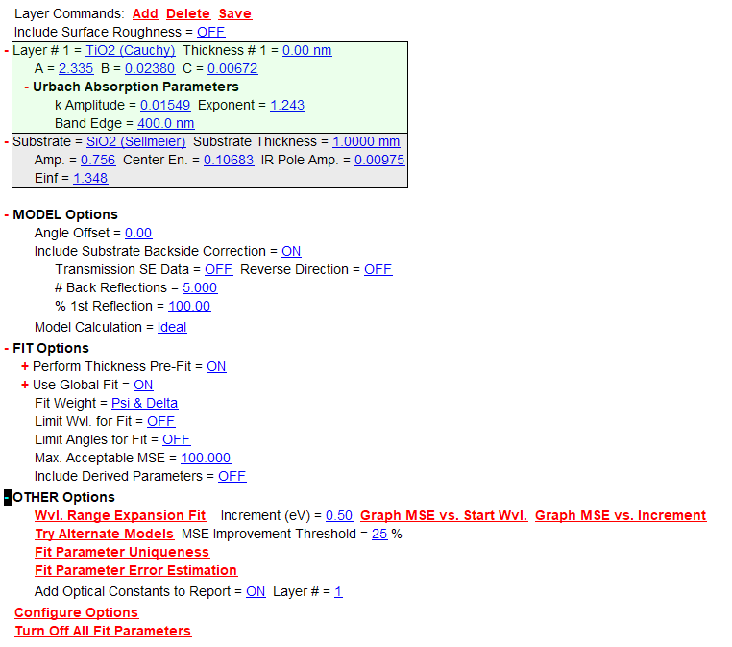
Figure 8: Screenshot of CompleteEASE showing the additional modeling options available in modeling. These are found in the Analysis tab, below the model building tool in expandable menus. The mode building tool is currently displaying the TiO₂ on SiO₂ model.
- MODEL Options
  - The most important option in this menu is Include Substrate Backside Correction. This is a necessary model complexity for TiO₂ films on fused silica. Since this is a transparent film on a transparent substrate (and since the substrate does not have a roughened backside to mitigate specular reflection), the backside reflections off the substrate have to be accounted for. They impact the reflection signal and not accounting for them will alter your results.
- FIT options
  - I kept the Thickness Pre-Fit on. The thickness pre-fit cycles through a range of initial thicknesses, fits them, and chooses the one with the lowest MSE. Global fit does the same for the initial refractive index. These are tools developed by Woolam to help ensure a good fit to model parameters.
  - In this section you can find the “fit weight”. The fit weight should remain on “N.C.S.”. N, C, and S are useful because they’re bounded between -1 and 1, so their values don’t blow up like ᴪ and $∆$.
- OTHER options
  - The most important tool in this menu is the Try Alternate Models feature. This will automatically build and apply different variations of the currently applied model. For example, it will show the user the MSE and results from applying surface roughness, index grading, surface roughness & index grading, or by modeling the film as anisotropic. It is worthwhile to see if the MSE is meaningfully reduced by this quick check, but those modeling complexities did not result in dramatically better fits for these results.
Hardware Tab
In this tab, one can access the top-down camera looking at the sample stage. I often used the camera to look at the surface of my sample and translate the sample stage until the beam was hitting a smooth part of the surface. We stored these films on double-sided tape and so both of their surfaces ended up getting dirty and covered in tape glue. With the camera, you can find a spot on the surface that is clearer, and the ᴪ and $∆$ for measuring on such a spot will be much cleaner than if you measure over a dirty spot (the ᴪ and $∆$ lines will be less noisy).
Assorted Advice on Modeling
One simple thing to watch for is the oscillations known as interference fringes in the measured ᴪ and $∆$ spectra. The thicker the film, the more oscillations due to interference from the internal reflections. This effect can be seen clearly in Figure 9:
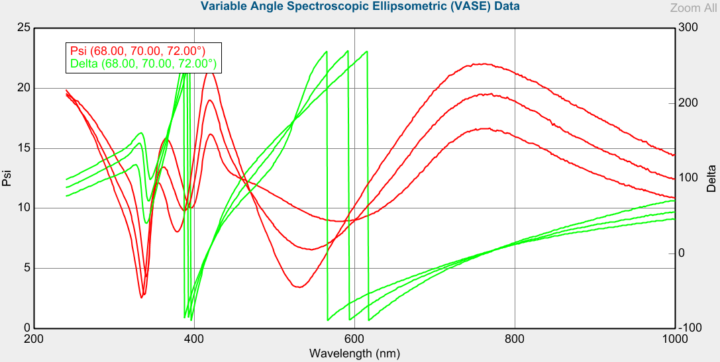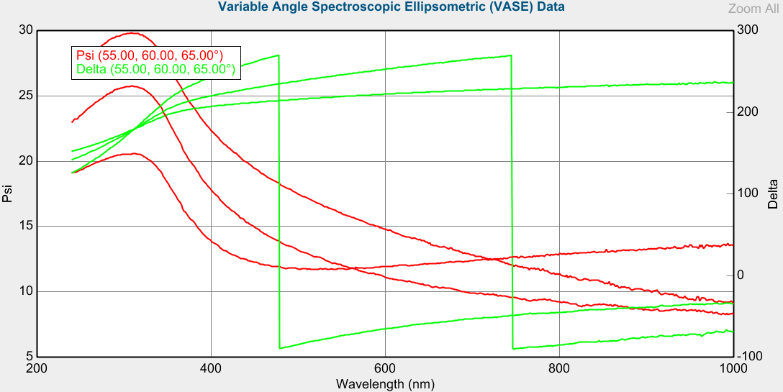
Figure 9: These screenshots show graphs of ᴪ and $∆$ spectra for two films. The top graph is the SE data of sample #86 pre, which was estimated to be ~170 nm thick. The bottom graph is the SE data for sample #43 pre, which was estimated to be ~30 nm thick. Note how the thicker film has many more oscillations in the ᴪ and $∆$ spectra.

