Thin-film transport measurements of misfit layer compounds
Paul Newhouse and Janet Tate
20 August, 2008

Films on glass substrates were supplied by Colby Heideman and Qiyin Lin (D. C. Johnson group, University of Oregon). These measurements were performed by Paul Newhouse (J. Tate group, Oregon State University) during 2007 and finalized and analyzed in winter and spring, 2008.

1.1 Hall effect and resistivity
Room temperature Hall effect and resistivity measurements were performed on as-received thin films of misfit layer compounds {[(PbSe)_{1.0}]_{n}[(MoSe₂)]_{m}}_{k} and {[(PbSe)_{0.99}]_{n}[(WSe₂)]_{m}}_{k} using a Lakeshore model 7504 Hall effect system equipped with a Keithley 2182 nanovoltmeter. The cross-shaped samples were deposited onto amorphous SiO₂ substrates and contacted using colloidal gold paste. Tungsten (W) wires were affixed to the gold paste, which was allowed to dry under a desk lamp at 40-60 °C for 5-10 minutes. Subsequently, the other end of the W wire was soldered to the measurement card using In. The films were measured in a 2.75-T magnetic field using the maximum allowable excitation current, usually of order 1 - 10 µA. Linear IV curves were obtained for each sample, indicating Ohmic contact. The transport results are summarized in Table 1. All samples for which the Hall coefficient could be measured indicated p-type conductivity. For sample no. 75, only the resistivity could be obtained reliably.
Film ID | d (nm) | ρ (Ωcm) | μ (cm²/Vs) | p (cm⁻³) | R_{H} (cm³/C)
71 {[(PbSe)_{1.0}]₃[(MoSe₂)]₁}₄₄ | 99.3 | 3.89 | 3.48 | 4.63 E17 | 13.5
72 {[(PbSe)_{1.0}]₁[(MoSe₂)]₅}₃₀ | 108.5 | 2.29 | 0.12 | 2.27 E19 | 0.275
73 {[(PbSe)_{1.0}]₁[(MoSe₂)]₁}₈₄ | 107 | 4.27 | 1.26 | 1.17 E18 | 5.35
74 {[(PbSe)_{1.0}]₁[(MoSe₂)]₁}₈₄ | 101.2 | 3.87 | 1.43 | 1.13 E18 | 5.49
75 {[(PbSe)_{1.0}]₁[(MoSe₂)₁}₈₄ | 94.8 | 5.10 | -- | -- | --
2-44 {[(PbSe)_{0.99}]₁[(WSe₂)]₃}₃₂ | 81.0 | 0.112 | 0.023 | 2.48 E21 | 0.0025
2-66 {[(PbSe)_{0.99}]₂[(WSe₂)]₂}₄₀ | 102.4 | 0.047 | 5.3 | 2.54 E19 | 0.25
2-75 {[(PbSe)_{0.99}]₁[(WSe₂)]₁}₆₄ | 81.4 | 0.97 | 4.0 | 1.63 E18 | 3.83
2-76 {[(PbSe)_{0.99}]₁[(WSe₂)]₁}₁₀₀ | 127 | 0.434 | 9.7 | 1.49 E18 | 4.18
2-63{[(PbSe)_{0.99})]₂[(WSe₂)]₁}₁₂₄ | 231 | 6.77 | 0.89 | 1.04 E18 | 6.0
2-36 {[(PbSe)_{0.99})]₁[(WSe₂)]₃}₄₀ | 100 | 4.91 | 1.2 | 1.06 E18 | 5.89

Table 1. Transport properties measured from thin films of misfit compounds. For sample #75, only the resistivity could be measured reliably. All measurable samples exhibit a positive Hall coefficient, indicating p-type conductivity. 2-63 and 2-36 are N₂-annealed samples; the rest of the 2-series are annealed in WSe_{2.}

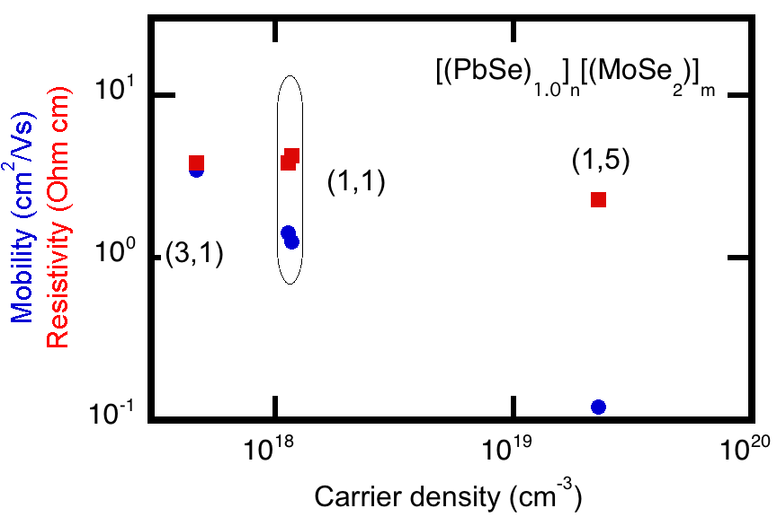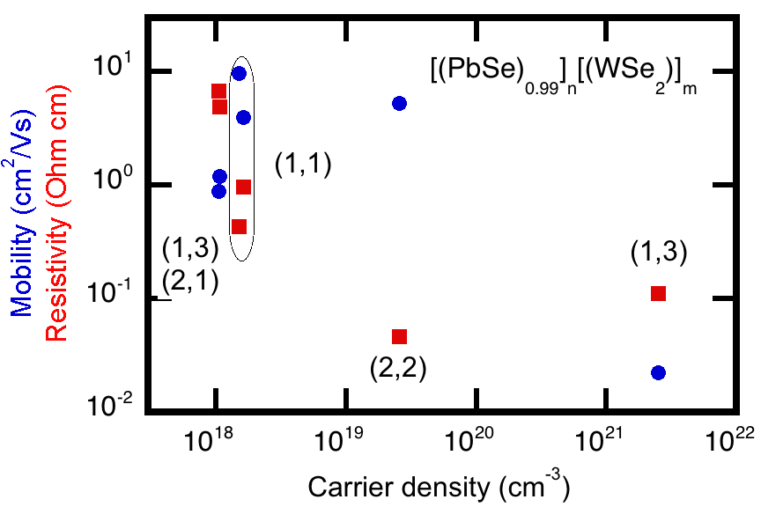
Fig 1. Mobility (blue circles) and resistivity (red squares) of the [(PbSe)_{1.0}]_{n}(MoSe₂)_{m}] (left graph) and [(PbSe) _{0.99}]₁[(WSe₂)]₁](right graph) misfit layer compounds on a log-log scale. (n,m) values are indicated.

In the case of [PbSe][MoSe₂] (left graph in Fig. 1), the increased carrier density corresponds to a decreased mobility, which is a common feature since the carriers are generated by defects. These effects compensate to keep the resistivity constant. The two (1,1) samples give almost identical results, which is reassuring as they were prepared under identical conditions. In the case of [PbSe][MoSe₂] (right graph in Fig. 1), the trend is less clear. Excluding the (1,3) point at p = 2.48 x10²¹ cm⁻¹, one is tempted to conclude constant mobility regardless of carrier concentration and a corresponding decrease in resistivity (i.e. the opposite trend). However, inclusion of that (1,3) point indicates both mobility and resistivity decreasing with increased carrier concentration, a trend that is hard to explain. Again, reproducibility of the (1,1) samples is encouraging, but the two (1,3) samples differ markedly with carrier concentrations differing by more than 3 orders of magnitude – perhaps because of the different anneal protocols.

1.2 Seebeck coefficient
The temperature dependent Seebeck coefficient was measured for film #2-55 [(PbSe) _{0.99}]₁[(WSe₂)₁]₂₆₅ on a fused silica substrate using a custom measurement system consisting of a Keithley 195A digital multimeter and a Tektronix DM5120 digital multimeter. The 5 x 20 mm² sample was positioned across two Cu blocks inside a vacuum chamber. Indium foil strips were used to make electrical contact between the Cu blocks and the film. The chamber was evacuated and the sample was cooled to about 10 K in a closed cycle He refrigerator. At low temperature, the resistance of the film increased, and voltmeter noise was too large for reliable thermovoltage measurement below 60 K. At 60 K, the conductivity of the sample was high enough for reliable measurement of the thermovoltage. A resistive heater was used to heat the sample blocks to the desired temperature, after which the sample was allowed to equilibrate for 0.5-1 hr. After equilibration, a temperature gradient of 3 - 5 °C across the sample was established and the corresponding thermovoltage was recorded. This process was repeated at 30 K temperature intervals from 60 K to 300 K. Thermovoltage measurements at selected temperatures are plotted in Fig. 2, with the Seebeck coefficient at each temperature given in the legend. The Seebeck coefficient measured at 300 K using the above procedure is in close agreement with preliminary measurements at ambient temperature and pressure (i.e. non-vacuum, no heating) thus providing a check on temperature control and system reliability.
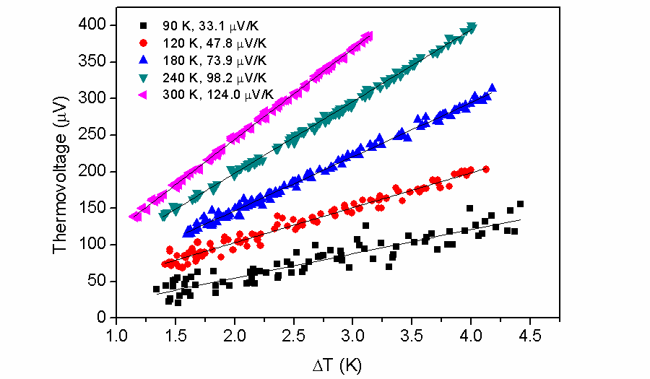
Figure 2. The thermovoltage vs. temperature gradient from [(PbSe)_{n}(WSe₂)_{m}]_{k} #2-55 at various temperatures. Low temperature data exhibit lower signal-to-noise due to the increased resistivity of the film at low temperature.

The temperature-dependent Seebeck coefficient of the [(PbSe)_{n}(WSe₂)_{m}]_{k} #2-55 film is shown below in Fig. 3. The Seebeck coefficient exhibits a linear dependence on temperature, almost intersecting the origin. The suggestion of a level-off below 60 K was not able to be investigated because of the high resistance of the sample. This linear temperature dependence is characteristic of metals, or heavily doped semiconductors (it is also seen in the n-type indium tin oxide).
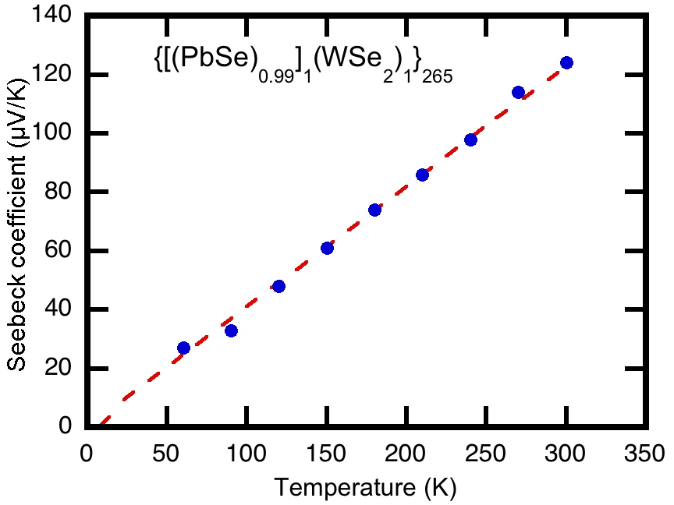
Figure 3. Linear dependence of the Seebeck coefficient on temperature for sample [(PbSe)_{0.99}]₁[(WSe₂)]₁ #2-55. The dashed line is a fit that excludes the 60K point.

