Chemistry 221 Oregon State University Worksheet 7

1. A student dissolves 13.13 grams of NaOH (0.3282 moles) in 239.61 grams of water in a calorimeter (the total solution has a mass of 13.13 grams + 239.61 grams = 252.74 grams). The specific heat capacity of this solution is 4.18 J/g·ºC. The temperature increases from 34.14 ºC to 47.91 ºC. The calorimeter heat capacity is 58.84 J/ºC. How much heat is given off from the dissolving of the NaOH? How much heat would be given off from dissolving 1 mole of NaOH?

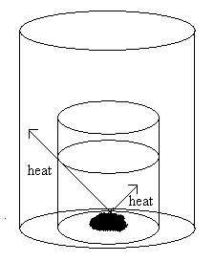

2. A student dissolves 30.0 grams of a solid into 540.0 grams of water in a calorimeter. The solution takes in 55 J of heat and the calorimeter takes in 175 J of heat. How much heat was released from the reaction when the solid was dissolved?

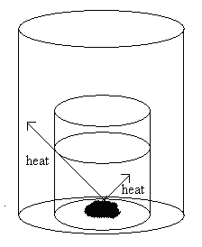

3. Determine ΔH° for this reaction:
2 N₂(g) + 5 O₂(g) → 2 N₂O₅(g)
using the following three equations:
(1) H₂(g) + (1/2) O₂(g) → H₂O(l) | ΔH₁° = -285.8 kJ
(2) N₂O₅(g) + H₂O(l) → 2HNO₃(l) | ΔH₂° = -76.6 kJ
(3) 2 N₂(g) + 6 O₂(g) + 2 H₂(g) → 4 HNO₃(l) | ΔH₃° = -696.4 kJ

4. Consider:

C₇H₁₆ (l) + 11 O₂ (g) → 7 CO₂ (g) + 8 H₂O (l) ΔH˚_{reaction} = - 4130 kJ

How much energy is released when 2.000 moles of C₇H₁₆, is combusted?

5. What is ΔH˚_{reaction} for the following reaction?

CH₃OH (g) + 3/2 O₂ (g) → CO₂ (g) + 2 H₂O (g)

-201.2 kJ/mol 0 kJ/mol -393.5 kJ/mol -241.8 kJ/mol

