Chemistry 221  
Worksheet 5 Notes

1. The combustion of octane yielded 5.02 grams of carbon dioxide. Theoretically, 6.78 grams of carbon dioxide should have been produced. What is the percent yield of the reaction?

*Percent Yield* =  = (5.02 g/6.78 g)(100%) = 74.0%

2. 2 Fe (s) + 3/2 O2 (g) → Fe2O3 (s)

Iron reacts with oxygen to produce Iron (III) oxide as represented in the above equation. A 75.0 g sample of Iron is mixed with 39.99 g of oxygen. (A) Calculate the number of moles of each of the reactants before the reaction begins. (B) Identify the limiting reactant when the mixture is heated to produce Fe2O3 (s). Support your answer with calculations. (C) Calculate the number of moles and grams of Fe2O3 (s) when the reaction has run to completion. (D) Calculate the mass of the remaining reactant. (E) If 102.3 grams of Fe2O3 (s) is recovered, what is the percent yield of the reaction?

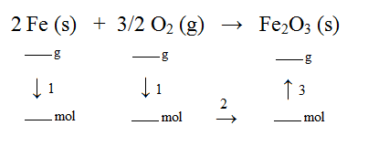

A.

Step 1: 75.0 g Fe (1 mol/55.85 g) = 1.34 mol Fe

39.99 g O2 (1 mol/32.00 g) = 1.25 mol O2

B.

Although there are fewer moles of oxygen present, iron is the limiting reagent because 2 moles of iron are required to react with 1.5 moles of oxygen.

The following determines the mass of iron required to react with 1.25 mol O2:

1.25 mol O2 (2 mol Fe/1.5 mol O2) = 1.67 mol Fe

There is less than 1.67 mol Fe present (we will run out of Fe)

C.

Step 2: 1.34 mol Fe (1 mol Fe2O3/2 mol Fe) = 0.67 mol Fe2O3

Step 3: 0.67 mol Fe2O3 (159.7 g/1 mol) = 107 g Fe2O3

D. 1.34 mol Fe (1.5 mol O2/2 mol Fe) = 1.01 mol O2

1.01 mol O2 were consumed leaving:

1.25 mol O2 - 1.01 mol O2 = 0.24 mol O2

0.24 mol O2 (32.00 g/1 mol) = 7.68 g O2 remain

E.

*Percent Yield* =  = (103.2 g/107 g)(100%) = 96.5%