GENETICS AND EVOLUTION OF CORN

This activity previews basic concepts of inheritance and how species change over time.

Objectives for Exam #1:
- Describe and complete a monohybrid (“one trait”) cross of corn kernel color, including three generations (P, F₁, and F₂).
- Define the following genetics terms: dominant, recessive, genotype, phenotype, gene/allele, homozygous, and heterozygous.
- Provide characteristics of corn structures, traits and life cycle.
- Discuss corn history including human domestication and uses of corn.

Objective for Portfolio #1:
Observe corn seedlings and analyze information.

Part I : Monohybrid (One Trait) Cross (work with a group of classmates on Part I)
Observing Traits
On your table you will find ears of corn (and some kernels that were removed from a cob). The ears are labeled as to the generation they represent:

P = Parental generation.
F₁ = First filial generation (refers to offspring produced by crossing [mating] the parents).
F₂ = Second filial generation (offspring from crossing F₁ plants with each other).

- When studying inheritance, it is important to identify characteristics that differ between individuals. Examine the corn on your table and describe kernel color. Record your observations in the table below:

Generation | Kernel Color (color choices are dark purple and yellow)
P (Type 1)
P (Type 2)
F₁
F₂

Parental (P) Generation
- If a dark purple P plant is crossed (mated) with another dark purple P plant, all kernels in the F₁ offspring will have dark purple kernels. The same is also true for yellow P plants (their offspring will be yellow). In these cases, the parents are called "true-breeding" relative to kernel color, meaning that only that color has appeared over generations. Why do you think “true-breeding” organisms are often used for inheritance research?

The F₁ (First) Generation
A monohybrid cross is breeding parents with alternative forms of a single (mono-) characteristic. In this case parents with different kernel color, are being crossed (mated). In the equation below, "x" represents mating and P represents the parental generation:

P (dark purple) x p (yellow) = F₁
- What color are the F₁ kernels? ___________________________ Do the F₁ kernels resemble kernels of one of the parental categories? _________ Which one? ___________________

- Does it appear that one color (dark purple or yellow) is dominant over the other? _______ If so, which color appears to be dominant? ___________________ How would you define "dominant" in this case?

- These results may lead someone to conclude that whatever it is that produces yellow kernels is not present, has actually disappeared in the F₁ generation. What is a possible alternative explanation for the physical absence of yellow kernels in the F₁ generation?

- Genes are parts of chromosomes that produce traits. You are looking at the trait of corn kernel color, which is coded for by a gene. Different versions of genes are called alleles. There appears to be at least two different versions of the corn kernel color gene: _______________ and ____________________.

- Typically alleles are given letters, with a large (capital) letter representing the dominant trait, and a small (lower case) letter representing the recessive trait. For instance, if the dark purple allele is dominant it is written as “D,” and if the yellow allele is recessive it is written as “d”. The alleles can come together in pairs (called a genotype), either “DD”, “Dd” or “dd.” At this point, what do you think the allele make-up (genotype) is for color in the F₁ kernel? _____________

- Thought Question: What experiment could you do to test whether or not the allele for yellow kernels did actually "disappear" in the F₁ generation?

The F₂ (Second) Generation
Two individual plants grown from F₁ kernels are now crossed (bred) together:
F₁ x F₁ = F₂

- What is remarkable (and puzzling to many) about the kernel colors of the F₂ cob?

- Kernels from F₂ generation plants are in dishes on your table. (These have been removed from the cob to make it easier to count them.)

How many kernels are yellow? ____________________

How many kernels are dark purple? ___________________

What is the ratio of dark purple to yellow kernels (dark purple/yellow)? _________________
- There are many random (chance) events that influence the outcome of any particular mating. However, inheritance does follow some "rules", such that a pattern will often emerge if there are a large number of matings. In the case of corn kernel color, we expect a certain ratio of dark purple to yellow kernels in the F₂ generation if there are a large number of matings. Record the data your group collected on ratio of dark purple/yellow kernels in the F₂ generation on the overhead. Your GTA will compile the class data. What was the dark purple/yellow ratio for these combined data? _________

Punnett Squares
- Punnett squares (named after geneticist Reginald Punnett) are commonly used in basic genetics to determine how factors are passed from one generation to the next. For example, the Punnett square on the left has been completed for a cross between tall pea plants (TT) and short pea plants (tt) and indicates the offspring for the F1 generation (all “Tt”). What are the F₂ offspring produced when the “Tt” F₁ generation is crossed? (complete the Punnett Square on the right)

F1 Generation F₂ Generation
Tall Parent
Short Parent
 | T | T |  |  |  | T | t
t | Tt | Tt |  |  | T
t | Tt | Tt |  |  | t
Potential Offspring

- Set up a Punnett square for a cross between true-breeding yellow kernel corn and true-breeding dark purple kernel corn.
D = dark purple kernels, d = yellow kernels. Parents: DD x dd

F1 Generation F₂ Generation

Genotype and Phenotype
- In the Punnett square for the F₂ generation, you have 3 different combinations of alleles. What are they?__________, __________, and __________. These are called genotypes, or the specific combination of alleles contained in a cell. What are the kernel colors in the F₂ generation? ________ and ________. These are the phenotypes, the traits that occur (and we see). Explain why there are three genotypes and two phenotypes.
Homozygous and Heterozygous
- Consider the different genotypes of three individuals. Label the individuals as homozygous or heterozygous for the allele. (Hint: the root “homo-“ indicates “similar,” the root “hetero-“ indicates “different”)

Genotypes | Homozygous or Heterozygous?
DD
Dd
dd

- Challenge Question: Examine the ear of corn labeled “C.” What appears to be the ratio of purple to light yellow kernels? _____________ If purple is dominant and light yellow is recessive, what were the genotypes of the two parents that produced this ear of corn? __________and __________.

Part II: Corn Stations (Stations A through E can be completed in any order)
Station A: Origins of Corn
- Maize, known as corn in many English-speaking countries, has a long history in the Americas. From the display, what was the original species that was ancestral to the modern corn we eat today? _____________________ Where was it located? ___________________________ Approximately when was corn domesticated by humans? ____________________________ Only two genes are responsible for the dramatic difference in height and shape between corn and teosinte. Which one is taller with a single stalk (instead of being bushy)? _____________

- A species is defined as having unique characteristics that it does not share with other species through cross-breeding. However, sometimes different plant species do reproduce together forming an interspecific hybrid. From the display, explain how hybridization may have been important in corn ancestry.

- Domestication is the process of humans altering organisms at the genetic level through artificial selection to accentuate desirable traits. Artificial selection will be covered in more detail in next week’s Artificial Selection recitation. From the display, describe how artificial selection has led to changes in corn.

- Some species are easier to domesticate than others. The easiest traits to breed for are those controlled by one gene. From the display, oak trees have a huge distribution in the northern hemisphere, but humans have not significantly domesticated the oak trees to produce varieties of palatable and marketable acorns. Why not?

Station B: Corn Life Cycle
Corn Plant Anatomy
- Corn is a type of grass plant and similar to other grasses, corn (and its ancestral plant) has narrow blade-like leaves. Within the leaves, stem, and roots are vessels that transport sugars, nutrients, and water. The primary purpose of the stem is transport these materials between leaves and roots as well as to support the leaves and reproductive structures. The primary role of the roots is to absorb ________________ and other nutrients. The primary role of the leaves is to absorb carbon dioxide and sunlight for the process of ______________________. Chlorophyll, and other pigments, absorb sunlight for the process of photosynthesis. The protein pigment chlorophyll gives plants their ___________________ color. Without chlorophyll in its leaves, corn plants cannot produce sufficient sugars to grow.

Corn Reproduction
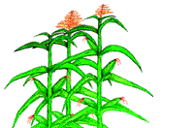
- Corn, like other grass plants, is wind pollinated, which means pollen is carried by the wind instead of by ________________. Corn has different male and female flowers. In a corn plant, a cluster of male flowers is called a tassel. The male flowers produce ____________ which is carried by the wind to female flowers. Pollen falls onto the silks of female flowers, which develop into individual corn kernels. Typically the male and female flowers on a single plant mature at different times, to prevent self-pollination. Label the parts of a corn plant on the picture below.

Corn Cobs
- The kernels on one corn cob represent a population of potential individual corn plants. Each kernel resulted from the fertilization of one egg by one sperm. The sperm and eggs could be genetically different, so each kernel may have different genetic traits and therefore may also look different. Observe the sample corn cob. From what you learned in the first part of the activity, what are the likely genotypes of the kernels (using the letter “A” or “a”)? ____________

Corn Kernel (Seed) Anatomy
- Referring to the Corn Seed model and Germination poster, label the following structures on the photo below: seed coat (protects the embryo); endosperm (stored nutrients); cotyledon (embryonic seed leaf); hypocotyl (will become the shoot or stem); and radicle (will become the root):
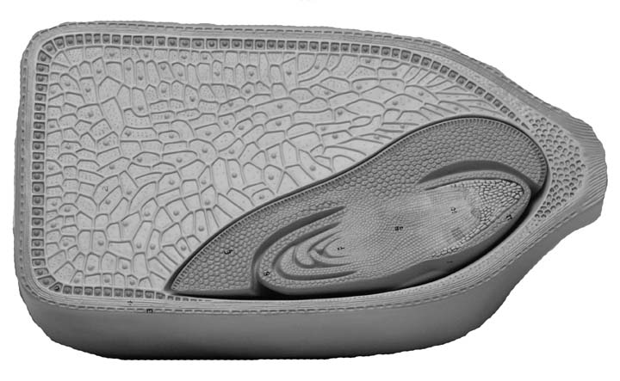
Corn Germination
- Germination is the process of a seed breaking dormancy, the embryo becoming a seedling, and eventually a developed plant. Using the posters and the corn seed display, label the following structures on the photos below: “true” leaves and roots:

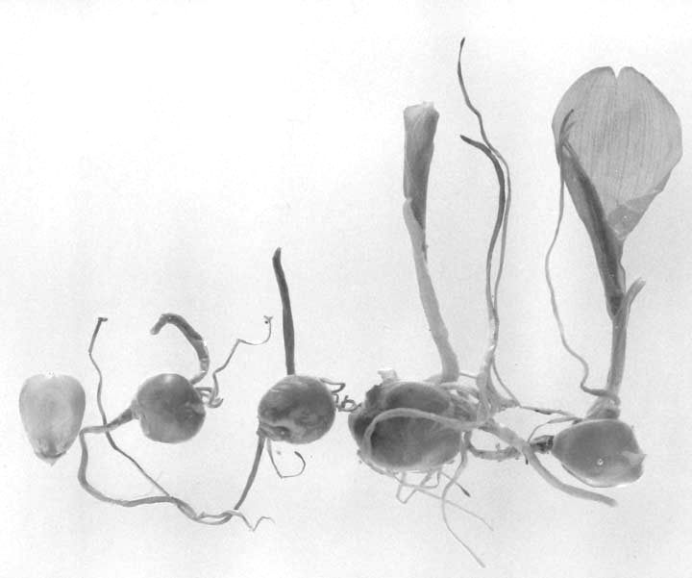

- Initially a germinating corn kernel can rely on sugar stored in the endosperm to grow. However, at some point the leaves have to begin producing sugars through the process of _______________________________.

Station C: Corn Traits
Chromosomes and Traits
- From Part I of this activity, the parts of chromosomes that produce traits are called ____________. The different versions of genes (like dark purple vs. yellow) are called _________________.

- From the display, corn’s genome (genetic make-up) is ____________ different chromosomes containing ____________ genes.

Kernel Color
- The color of a corn kernel is controlled by many genes that determine the phenotypes of two tissues: the aleurone (outer layer of the endosperm) and the endosperm. The endosperm is usually yellow or white, and if the surrounding aleurone is colorless, we have kernels that are yellow or white. Yellow kernels are due to carotenoid pigments in the endosperm, white kernels lack carotenoids. From the display, what other foods are colored by carotenoid pigments? ____________________________________________________

- The aleurone can be dark purple and red, and this color is due to the pigment anthocyanin. Whether the kernels are dark purple (DD, Dd) or red (RR, Rr) depends on different genes that lead to production of different amounts of the pigment. From the display, what other foods are colored by anthocyanin pigments? ___________________________________________ Looking at the cob with the red and white kernels, which pigment is present in the red kernels? _________________________ Which pigment is missing in the endosperm of the white kernels? _______________________________

Station D: Monohybrid vs. Dihybrid Crosses
- In the first part of the activity you studied a monohybrid cross with one trait (one gene) and two alleles. A dihybrid cross involves __________ traits.
- In this sample dihybrid cross, kernel color is again being used. What is the second trait? _____________________. One parent is dark purple and _______________; the other parent is yellow and _______________What are the two versions (alleles) of this trait. Looking at the F₁ cob, dark purple is still dominant, which version of the other trait is dominant? ____________________

- What phenotypes (kinds of kernels) appear in the F₂ generation (what combinations of traits)?

Station E: Corn Today
World production
- From the display, approximately how much corn is produced globally each year? ___________ Approximately how much of that is produced in the U.S.? ____________________

Types of Corn
- Describe the characteristics and uses of each of these types of corn:

Type of Corn | Characteristics and use
Popcorn
Sweet (sugar) corn
Field corn (yellow dent corn)

Corn Products
- From the display, list various products made from the corn plant:

Agricultural Issues
There are many agricultural issues that impact corn, including genetic issues that will be discussed later this term. A long-term concern has been organisms eating corn and corn products.
- Corn can be eaten by numerous organisms. Even the dry kernels and cobs used in this activity are eaten if not protected. Looking under the microscope at the corn remnants from cobs left in a box, what do you see? ______________________________________________

- Corn flour can become contaminated with corn smut, a type of fungus. Looking at the microscope slide containing finely ground flour, what does the corn smut look like?

Station F: Check Your Understanding (Complete this after you have finished the other stations)
For each of the following terms covered so far in this activity, fill in what they mean.

Genetics Terminology | Meaning
Heterozygous vs. Homozygous
Genotype vs. Phenotype
Dominant vs. Recessive
Monohybrid vs. Dihybrid Crosses
P, F₁, and F₂ Generations

Use the Genetics I poster to check your answers. You will be introduced to the rest of these terms over the next two weeks.

Part III: Corn Seedling Observations and Analysis (For Portfolio #1, stamp required)

Skill: Observe corn seedlings and analyze information.

Assignment: Two groups of corn seeds have been germinated. One is a standard corn seed (AA) that is acting as a “normal” control, the other is homozygous (aa) for a recessive albinism mutation that block’s the seedling’s ability to produce chlorophyll. This assignment has two parts.

Part I: In class today, observe the two groups of seeds and fill in your observations on the next page. Include: number of kernels that have germinated; root characteristics (indicate if roots are not visible); seedling height above ground; and physical appearance of seedling above ground (color, shape, etc.). Be specific and thorough in your observations. Also, be sure to get the stamp that you have completed the observations in class.

Part II: As homework, provide bulleted answers to each of the following questions: 1. Is there any evidence of an effect of the albino mutation on the homozygous recessive (aa) seeds? Explain your answer. 2. Besides the albino mutation, list at least four other factors that could impact seedling growth. 3. Predict what may happen as the two seedling groups continue to grow. Support your prediction with information from this activity. Answers to these questions can be typed or neatly written on the back of the stamped observation sheet.

Assessment: This assignment is worth 5.0 pts.: 2.0 points for observations recorded on the observation sheet, and 1.0 point each for thoroughly answering each of the three questions. The observations need to be completed and stamped in your scheduled laboratory or during GTA office hours weeks 1 or 2 (no later) to receive credit for this assignment.

Portfolio assignments represent your individual skills. Do not submit an assignment that is a duplication of any other individual’s work.
STAMP

Corn Seedling Observations
(Include this stamped page in Portfolio #1)

Characteristics | Seeds Without Mutation (AA) | Seeds With Mutation (aa)
Number of kernels that have germinated
Root characteristics (indicate if roots are not visible for observations)
Seedling height above ground (approximate)
Physical appearance of seedling above ground (color, shape, etc.).

