BIRDS

This activity introduces bird diversity, ecology, and relationships to humans.

Objectives for Exam #1:
- Classify birds and compare birds to other animal species.
- Explore how characteristics like tracks, scat, castings, and field marks can be used to distinguish between bird species.
- Explain the significance of bird anatomical structures, including; bones, muscles, and feathers.
- Provide examples of variation in eggs, nests, beaks, and talons.
Objective for Portfolio #1:
Make detailed bird field journal entries, including photos or drawings, written information, and identification.
Safety:
Be cautious when handling any animal specimen. Use a probe when it can replace touching directly and wash hands after handling specimens.
Clean-up:
Leave the stations in good condition for the next class.

Part I: Bird Stations
Station A: Bird Ancestry
- Compare the rooster legs with the rattlesnake skin. What do they have in common? __________________________ Birds, reptiles, and dinosaurs also lay/laid ______________.

- Looking at the fossil replica of Archaeopteryx, what did this dinosaur species share with modern birds? ______________________ Birds may be the only living descendents of dinosaurs.

- Before Archaeopteryx there were large reptiles that could fly using membranous wings. From the poster (and replicas), which reptiles are now thought to be the first vertebrate (backbone) animals to fly? __________________________________

Station B: Bird Taxonomy (Classification)
General Classification
- Organisms are classified by placing them in groups with similar organisms. The largest (most inclusive) to the smallest (least inclusive) classification groups are typically: Domain, Kingdom, Phylum (or Division), Class, Order, Family, Genus, species. These can be remembered in a variety of ways, including: Did King Phil Come Over For Good soup? or Daddy Keeps Putting Cashews Out For Gray squirrels. From the information provided at the station, provide the classification of an American crow, a bird commonly seen in Corvallis:
Domain: _________________ (organisms with complex cells, including a nucleus)
Kingdom: _________________ (multicellular eukaryotes that move, feed on others)
Phylum: _________________ (animals with a nerve cord)
Class: _________________ (birds: have feathers, wings, eggs)
Order: _________________ (perching birds)
Family: _________________ (crows, ravens, jays)
Genus: _________________ (crows, ravens)
Species: _________________

- “American crow” is a common name. The scientific name of an organism contains the Genus and species names, with the Genus name capitalized, and both names italicized or underlined. Write the scientific name for the American crow: ________________________ The “common raven” Corvus corax is a different ______________ than the American crow.

- Because of complexity in classifying organisms, some taxonomic groups are broken into separate sub-groups, like “Sub-Phylum.” Birds are classified in Subphylum Vertebrata, which means all organisms that have a vertebral column (also called a spine or backbone). From the vertebral displays, what are five other animals besides birds that are classified in Subphylum Vertebrata?

Station C: Bird Diversity
Bird Orders
Use the Birds poster for these questions.
- There approximately 10,000 species of birds classified in 27 Orders (different groups). Which Order of birds includes birds humans most often use as food? ____________________

- Crows, robins, finches and many other birds are classified in the largest order of birds, Order Passeriformes, once called songbirds, now known as the ____________________ birds.

Perching Birds
- There are over 5,000 species of “perching birds,” typically small birds with a special foot structure that allows them to perch on vertical surfaces like trees and rock cliffs. Looking at the bird specimen, how are the toes arranged on a perching bird’s foot?

- From the U.S.A. State Birds and Flowers poster, many of the state birds are perching birds. What is the most common state bird, a perching bird found east of the Rocky Mountains? _______________________ What is Oregon’s state bird? ___________________________

Station D: Nests and Eggs
- Thought Question: Birds and many animals are oviparous, meaning development of the embryo occurs within an egg laid by the mother. This is different than viviparous development, in which the embryo develops within the mother who then gives birth to live young. Give an example of two viviparous species: ________________________ and __________________________

Bird Egg Identification
- From the bird egg display, which North American bird has the smallest egg? _______________ What do American crow, horned lark, and kildeer eggs have in common? ________________ Why may this coloring be important?

- American robin eggs are a characteristic _______________ color instead of white like many other species. How may this color be important?

Cowbirds
- Cowbird species lay their eggs in the nests of other species, including song sparrows. The song sparrows do not realize the cowbird eggs are not their own, and raise the cowbird hatchlings, reducing the food available to the sparrow hatchlings. From the smaller egg display, describe the appearance (size, color) of the cowbird and song sparrow eggs.

Egg | Description
Cowbird
Song Sparrow

Nests
- Birds are incredibly diverse and their nests reflect this diversity. Looking at the nest and chart provided, classify the nest type of the sample nest (this is the most common type of bird nest) ___________________________

- Birds choose specific materials to build their nests. From the table of information provided, adding wild carrot leaves to a nest may reduce _____________________.

Station E: Bird Anatomy
Bird Skeleton
- Examine the bird bones provided, including the broken pieces. What do the bones look like inside? _________________________ Why is it important for a bird skeletal system to be more lightweight than the skeletal system of other animals? _________________________

- Many animals have similar skeletal structures. Looking at the forelimb skeletal models, bird wings are analogous to human ______________________.

- The furcula (“wishbone”) in birds is analogous to the two clavicles (“collar bones”) in humans fused together. What purpose does the furcula serve? _____________________________

Other Bird Organs
- Looking at the anatomical model of the chicken, what massive organs (in red) move the wings? _________________________ When humans eat “meat,” this typically refers to eating the muscles of different species, including birds, fish, cows, and pigs. Domestic chickens have been bred to increase the size of particular muscles. On the photo of the chicken model below, label the chicken “breast” and chicken “thigh” muscles:
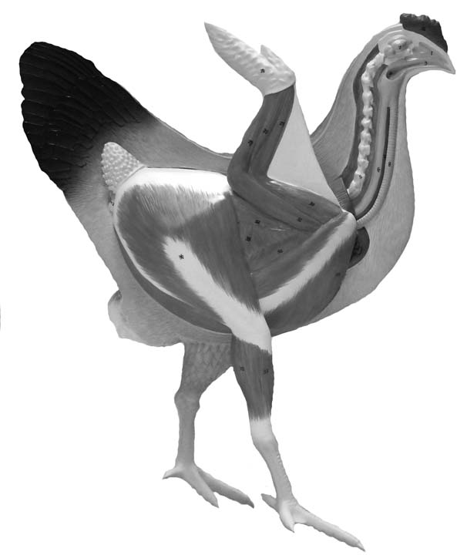
Bird Tracks
- Birds are bipedal (“walk” on two feet) like humans. Using the animal tracks guide provided, which birds were most likely to have made these tracks in mud?

___________________
2.5 inches

__________________
2.5 inches

Station F: Feathers and Wings
Color
- In some birds, color indicates information about diet. What makes flamingoes a bright pink? ________________________________________________________________

- Male and female birds of the same species often differ in coloration. For both the male mallard duck (see model) and the male peafowl (peacock), what characteristic of the feathers can attract the female’s attention? _______________________________________________

Feather Structure
- Feathers are a form of highly modified scales that enable birds to fly. From the first feather display, there are three primary types of feathers: the largest outermost feathers in the wings and tail that are used to propel a bird forward and provide lift are called the ________________ feathers. The ______________ feathers are smaller and give the bird an aerodynamic outline. The fluffy _______________ feathers provide insulation.

- Using the pigeon wing as a reference, label on the photo below the location of the flight feathers and the contour feathers.
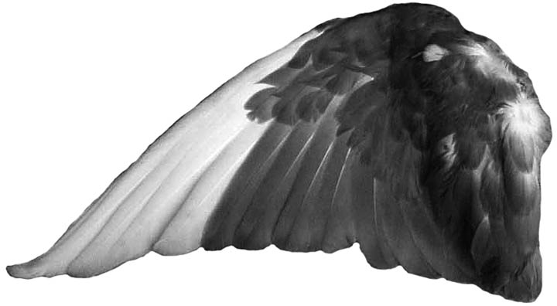

- In the photo below, label the flight feather and the smaller semiplume feather that is commonly found between downy and contour feathers. Also label the rachis, the central shaft of the feather and the calamus (also called “quill”) end of the rachis that inserts into the bird skin. The two parts of the feather extending off of the rachis are called the vanes, and the vane on the edge of the feather that leads in flight is typically smaller than the vane that trails in flight. Label the side of the flight feather below that faces the direction of flight.

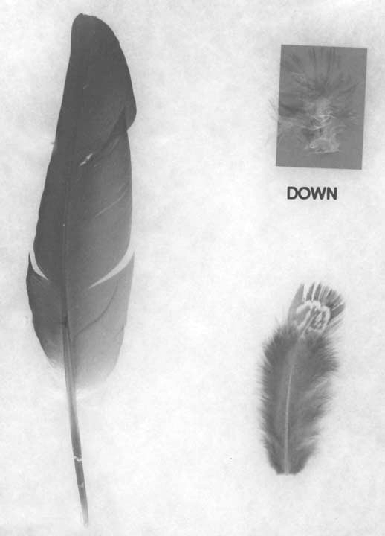

- Look at the flight feather that has been cut open. The calamus is ___________________. This helps make the feathers _______________ in weight.

- Coming off of the rachis are side branches called barbs. Pick up a feather and probe gently between the barbs with your fingers. Observe how the barbs tend to cling together as you slowly move your fingers. Why may it be important that the barbs behave this way? __________________________________________________________ Gently rub your finger and thumb against the barbs from the tip of the feather back toward the base, causing the barbs to separate without damaging them. Holding the calamus (quill) end, briskly wave the feather through the air. Now smooth the barbs back into position and wave again. Explain how this relates to birds consistently grooming their feathers.

- Looking at the feather under the microscope, each barb has hundreds of smaller barbules. Sketch how these barbules create a solid surface for flight.

Station G: Bird Diets
- Thought Question: There are no leaf-eating flying bird species. Flying birds eat prey and/or fruits/seeds instead. To explain why, is there more protein in animal prey, seeds, and nuts or in leafy vegetables? ________________ Are there more energy-rich molecules in the tissues of animal prey and the tissues of seeds/fruits or in the tissues of leaves? ____________ Finally, does flying take more or less energy than most ground-based movement like walking or crawling? ___________________ Summarize why there are no leaf-eating flying bird species.

Bird Beaks and Diet
- Beaks are specialized structures that assist birds in acquiring food. Using the bird beak replicas, sketch or describe the general structure (shape and size) of each bird’s beak

Bird | Osprey | Crow | Turkey | Toucan | Duck
Diet | Tears flesh | Omnivorous Diet | Seeds and Insects | Plucks fruit | Cuts water plants
Beak Structure

- Referring to the display of small preserved birds, fill one of the three common names into each of the blanks (Sparrow, Hummingbird, Sanderling). Which bird has a narrow drill-like beak that can drill small crustaceans out of the sand? _________________ Which bird has a short powerful beak that can crush seeds? __________________ Which bird has a long narrow beak that can extract nectar from a flower? ____________________

Scat
- Another way to identify birds that have been in an area is to exam their fecal waste, also called scat. What characteristics of scat can you use to distinguish between a chicken, a goose, and a wild turkey?

Chicken Scat | Goose Scat | Wild Turkey Scat

Station H: Raptor Ecology
Raptor Classification
- Raptor is a common name used to describe large birds of prey. Many of these species are actually classified separately based on their structures and ancestry. For example, from the Avian Raptors poster (top), owls are classified in Order ______________________, separate from eagles and hawks. Not all raptors are even primarily predators. From the bottom of the poster, vultures are primarily _____________________, meaning they eat carrion (dead animals). Despite these classification differences, these species do share many similarities.

- Thought Question: One characteristic that raptors share is that there are generally few of these birds in an ecosystem relative to other animals, including other smaller birds. We will be discussing the reason for this in more depth next week. Looking at the raptor food web at this station, what are your initial thoughts as to why there are not many raptors in an ecosystem?

Eyes, Talons and Beaks
- Flesh-eating birds of prey have structures that enable them to track, catch, and incapacitate prey. One of the features they share is the size and placement of the eyes. Look at the skull replica of the bald eagle, red-tail hawk and/or great horned owl head-on. Are the eyes looking right back at you? ___________________ Now compare this to the placement of the eyes in the pigeon skull in the comparative skull display. How can eye placement impact an ability to detect and catch prey?

- Raptors also have beaks that can tear flesh. How do the bald eagle, red-tailed hawk, and great horned owl beaks primarily differ? ________________________________________________

- Referring to the talon replica display, Which of the following birds-of-prey have the largest talons? (circle one)

Bald Eagle | Golden Eagle | Harpy Eagle | Red-Tailed Hawk | Great Horned Owl

Castings
- Hours after eating prey and digesting the meat, many raptors regurgitate (throw up) a casting, a compact pellet of bones, fur, and other hard-to-digest body parts. Hawk castings can contain a large amount of feathers or fur, small falcon castings can contain insect wings and legs, and owl castings can contain bones and teeth. Looking at the casting provided, what raptor did it most likely come from? ___________________

- From the Owl Food Web flip chart, what do Barn Owls (found in the Willamette Valley) typically eat? _______________________________________________________________________

- Looking at the bones collected and cleaned from the castings, as well as the bone ID sheet, what types of prey (birds, mole, rodents, shrews) were primarily eaten by these owls? (you can use the probes to move the bones around) _________________________________________

Station I: Penguin Ecology
- Birds are endothermic or “warm-blooded.” How do birds and other endothermic animals like mammals generate heat?

- Where are most penguin species located? ___________________________

- From the food web, what do penguins eat? ________________________

- Typically birds have light-weight skeletons, from the Penguins poster, penguin skeletons are heavier, which helps them ______________________________________

- Also from the Penguins poster, what are two structural features of penguins that help them survive cold water temperatures? __________________________ and ______________________
Station J: Observing and Identifying Birds
Bird Identification Techniques
To identify a bird, there are five types of information that can be helpful:
Location (specific area and time of day)
Size of bird
Shape (thin, rounded, large-headed, long-tailed, etc.)
Behaviors, movements, postures
Field marks (A field mark can be used to distinguish between bird species)
Tail markings (bars, bands, colors and direction)
Wing markings (wing bars or other colors and colors)
Body markings (spots, stripes, a bib color under the throat or a neck band of color)
Head markings (eyebrow colors, rings around the eye, a crest of long head feathers)

- Looking at the preserved bird specimen, take notes on its size, shape, and field markings.

- Using your notes and the “Backyard Birds” poster, the specimen is most likely a ____________________________ Is it a male or female? _______________________

Bird Identification Resources
- The easiest way to identify an unknown bird is to compare its appearance directly to an image in a field guide or computer program. Find the bird you have identified in the National Audubon Society Field Guide to North American Birds, Western Region.” What is the bird’s scientific name? ____________________________ What does it typically eat? ____________________ Where does it nest? __________________________________________________

- On the computer, select the bird guide section of All About Birds on the Cornell Lab of Ornithology website. Locate the listing for the bird you have identified. You can watch the bird in action by clicking “video” and also listen to “sound” clips. What does its territorial call sound like? (you can represent the song with text) _________________________________________

- Another on-line bird identification resource is the Oregon Department of Fish and Wildlife website. Clicking the “Kingfishers and Woodpeckers” link, what are two other woodpecker species that can be found in the Willamette valley?

Safe Field Observations
- Thought Question: As with any field excursions, it is critical to anticipate potential safety issues. Even experienced field biologists can encounter unexpected hazards. The general rule is to “Stay alert” to your surroundings and to travel with companions when possible. What are other precautions that can be taken to reduce risk in outdoor field settings?

- Thought Question: In addition to your own safety, there are techniques to reduce negative impacts on organisms and their environment. The saying often used is to “Take nothing but photos, leave nothing but footprints.” What steps can be taken to reduce impact on natural habitats?

Part II: Bird Field Journal Entries (for Portfolio #1)
Skill: Make detailed bird field journal entries, including photos or drawings, written information, and identification.

Assignment: Find, observe, make field journal entries on, and identify two different species of wild birds. First, you need to find the birds. Many birds can be found in the shrubs around the classroom buildings on campus. Also consider looking early in the day, and at times during classes when there is less foot traffic. Photograph or quickly sketch each bird as you see it, trying to capture the general shape and posture, and when it moves you can then fill in other information from memory. Label your photo or drawing, including each bird’s size, shape, field markings, and write about the bird’s behavior (what each was doing as you were observing). Also include general field information including the specific location of each bird and the time of each observation. Finally, use your information to identify each bird, including the common and scientific names. To summarize, for each of the two birds you will have (1) a photograph or drawing, (2) labels (size, shape, field markings), (3) the bird’s behavior, (4) general field information (location, time), and identification (common and scientific names).

Assessment: This assignment is worth 5.0 points. Each bird entry is worth 2.5 points: 0.5 point for the drawing, 0.5 point for labels (size, shape, field marks), 0.5 point for the bird’s behavior, 0.5 point for general field information (location, time), and 0.5 point for correct identification (common and scientific name).

Safety: This journal assignment can be successfully completed on the main OSU campus. Exercise the same caution on or off campus (traveling with friends, avoiding isolated locations, staying alert) that you normally would to stay safe.

On-Line Bird identification Websites:
http://www.allaboutbirds.org/page.aspx?pid=1189 (Cornell University)
http://www.dfw.state.or.us/species/birds/ (Oregon Department of Fish and Wildlife)

