Photoexcitation and Electron Transport
Kyle Vogt
Phys 671
Spring 2016

The scope of this paper will be mostly limited to the study of transport of electrons created from different types of photoexcitation in non-organic materials and devices. There are three basic types of photoexcitation which will be discussed: the photovoltaic (PV) effect (we’ll spend most of the time here), photothermal effect, and the Bolometric effect. I will provide a brief history, background on equilibrium statistics in semiconductors, different semiconductor structures for solar cells, and non-equilibrium statistics in photoexcitation events. Additionally, I would like to do a brief discussion on the valley-hall effect, which is a hall-effect that is dependent on the helicity of incoming light.

0. A Brief History
The history of light to electric current conversion dates back to 1839 when Alexandre Becquerel, who was 19 at the time, put silver chloride in an acidic solution connected to platinum electrodes, then illuminated the device with light. In doing so, he was able to measure the first recorded photovoltage and photocurrent ever created¹. In the few decades that followed, no advances were made in the field of photovoltaics, though a lot of attention was paid to fluorescence and phosphorescent studies, as those phenomena also involved the absorption of light, but led to something which was more prevalent and more easily observable. However, at this point in time, the idea of the photon and energy quantization based on color had not yet been explained and so the idea of absorption as we know it today didn’t really even exist.
As always in physics, though, experimentation does happen, and in 1876 William Grylls Adams and his student, Richard Evans Day, discovered that illuminating a junction between selenium and platinum had a photovoltaic effect², after which they published the first paper on the photovoltaic effect, ‘The action of light on selenium,’ in the Proceedings of the Royal Society, A25, 1133 (though Willoughby Smith noted a change in the resistance of selenium bars exposed to light in a 1873 publication in Nature⁵). Shortly after in 1883, an American inventor named Charles Fritts created the first thin film solar cell from a thin layer of selenium on gold that achieved near 1% efficiency. In 1887, Heinrich Hertz discovers the photoelectric effect, and the first patent for a solar cell was awarded in 1888 Edward Weston. Interestingly enough, Weston’s solar cell model was based solely on the (Seebeck) thermoelectric effect caused by placing two dissimilar metals in contact with each other, and doing so with many of these in series so as to create a thermopile⁴.
Aside from the photoelectric effect observed in metals, few materials were known to produce a measureable photovoltaic effect, with cadmium selenide being added to the list in 1932. Then in 1939, the first P-N junction was made by Russell Ohl while

Figure 1. Efficiency timeline
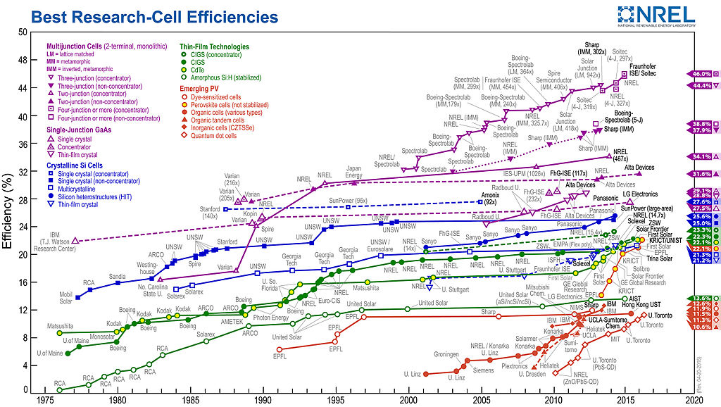

Sarah Kurtz and Keith Emery - National Renewable Energy Laboratory (NREL), Golden, CO
Conversion efficiencies of best research solar cells worldwide from 1976 through 2016 for various photovoltaic technologies. Efficiencies determined by certified agencies/laboratories.

working at AT&T’s Bell Labs, and he received the patent for what is considered the first modern solar cell⁶. This work and similar work done by Ohl, would lead to the first diodes and transistors, with help from the utilization of single crystal silicon and germanium, also grown at Bell Labs. Then the space race in the 1950s would ultimately lead Bell to create the first practical solar cell, boasting 6% efficiency.
Advances in understanding of the photovoltaic effect and other photoelectric mechanisms would lead to increases in efficiency which can be summed up by the chart in figure 1. Indeed, over the next 60 years, we’ve managed to achieve near 50% efficiencies based on multilayer solar cells and concentrator solar cells.

1. P-N Junctions and Photovoltaics Under Illumination

In order to talk about what happens when light is absorbed by a semiconductor, it is necessary to invoke nonequilibrium processes, as the generation of electrons and holes no longer obeys Fermi-Dirac statistics. This is because the generation and recombination of electrons and holes causes the carrier densities in the conduction and valence bands to depart from equilibrium⁷. In this section, we will begin by defining equilibrium, then describe diffusion in the most simple structure--a semiconductor with no electric field. Then, because the P-N junction is the most prevalent form of solar cell, we will focus mostly on this structure, but make mention of other P-N heterojunction structures and the Schottky barrier.

1.1 Detailed balance and the intrinsic situation

In thermal equilibrium, we describe the occupancy of the conduction and valence bands of a semiconductor as the quantities n_{o} and p_{o,} respectively. What is not always obvious when thinking about these populations is that the electrons and holes are dynamically populating their regions in k-space. That is to say that electrons that are being thermally populated by temperature T are doing so in parallel to the process of recombination, which would be mediated by either phonons or blackbody radiation, or more realistically, both. We then define thermal equilibrium as the steady state in which those processes perfectly balance each other out, making the occupancy a parameter which only depends on T.
Although it is largely review and won’t be all that useful in the discussion to come, I would like to at least define our normal carrier population densities at temperature T using some handy notation found in Blakemore’s Solid State Physics. We will use the following definitions, as does Blakemore
n_{o} = electron density in conduction band at thermal equilibrium
n = total density of conduction band electrons (not necessarily at equilibrium)
n_{e} = (n - n_{o}) = excess electron density in conduction band caused by a departure from equilibrium
We can define all of the same parameters for holes in the valence band as well. Then we have the normal definition for n_{o} as follows:
$$n_{o}=\int_{ϵ_{c}}^{∞}{f_{FD}\left(ϵ\right)g\left(ϵ\right)dϵ=\frac{1}{2π^{2}}(\frac{2m_{c}k_{b}T}{ℏ^{2}}})^{3/2}\int_{\frac{ϵ_{c}}{k_{b}T}}^{∞}{\frac{[(ϵ-ϵ_{c})k_{b}T]^{\frac{1}{2}}}{1+e^{(\frac{ϵ-ϵ_{f}}{k_{b}T})}}d(ϵ/k_{b}T)}$$
$$=\frac{1}{2π^{2}}{\left(\frac{2m_{c}k_{b}T}{ℏ^{2}}\right)}^{3/2}F_{1/2}(\frac{ϵ_{f}-ϵ_{c}}{k_{b}T})$$
Where _{f} is the Fermi energy, _{c} is the conduction band minimum, and m_{c} is the effective mass of an electron in the conduction band. We’ve also adopted the use of some notation here for the Fermi-Dirac integrals F_{j}(y_{o}) (check this reference for some deeper definitions⁸), which I think are good general integrals to have, and they are defined as follows
$$F_{j}(y_{o})=\int_{0}^{∞}{\frac{y^{j}}{1+e^{(y-y_{o})}}dy}$$
(1)
(2)
(3)
We generally can’t solve integrals in this form, but we can approximate them for large positive values of y_{o} and large negative values of y_{o}.
When y_{o} is large and negative (there is a <5% error when –$y_{o}$>2), which is the case when ${}_{f}$ is roughly <.5 meV below the conduction band minimum at room temperature. Then we have
(4)
$$F_{j}(y_{o})≈Γ(j+1)e^{y_{o}}$$
(yes, that is the gamma function).
When y_{o} is large and positive, as it would be for a metal, we can use the expansion
$$F_{j}(y_{o})≈\frac{y_{o}^{j+1}}{\left(j+1\right)}[1+\frac{π^{2}j\left(j+1\right)}{6y_{o}^{2}}+…]$$
where continuing terms decrease by powers of y_{o}⁻², but the first two terms are good enough for y_{o}>>1. Similarly, we can find the population density, p_{o}, in the valence band by taking
$$p_{o}=\int_{-∞}^{ϵ_{v}}{{[1-f}_{FD}\left(ϵ\right)]g\left(ϵ\right)dϵ=\frac{1}{2π^{2}}(\frac{2m_{v}k_{b}T}{ℏ^{2}}})^{3/2}F_{1/2}(\frac{ϵ_{v}-ϵ_{f}}{k_{b}T})$$
(6)
(5)
In the next section we will mostly be dealing semiconductors at room temperature, where it will be assumed that the Fermi level lies below the conduction band minimum. In this case, we can use equations 2, 4, and 6 to get
$$n_{o}≈\frac{1}{2π^{2}}{\left(\frac{2m_{c}k_{b}T}{ℏ^{2}}\right)}^{3/2}e^{(\frac{ϵ_{f}-ϵ_{c}}{k_{b}T})} \\ =N_{c}e^{(\frac{ϵ_{f}-ϵ_{c}}{k_{b}T})}$$
(7)
and similarly,
$$p_{o}≈{\frac{1}{2π^{2}}{\left(\frac{2m_{v}k_{b}T}{ℏ^{2}}\right)}^{3/2}e^{(\frac{ϵ_{v}-ϵ_{f}}{k_{b}T})}}_{}$$
(8)
$$=N_{v}e^{(\frac{ϵ_{v}-ϵ_{f}}{k_{b}T})}$$
where we’ve adopted more short hand notation. It is somewhat useful to think about these quantities in this way since both N_{c} and N_{v} have units of 1/m³ which seems to act like some sort of number density that is dependent only on the effective mass or band curvature and temperature. The exponential term looks like a classical thermodynamic probability.
We will go one step further and quickly define the intrinsic electron density which comes from the intrinsic condition $n_{i}=n_{o}=p_{o}.$ This is the simplest example of detailed balance at a temperature T, and two bands with different effective masses. It is somewhat of a toy model, but with the intrinsic condition we can see that $n_{i}=\sqrt{n_{o}p_{o}}$, and it can be shown that the Fermi energy should have some dependence on temperature, but this is only the case since we have invoked a model that has inequivalent effective masses.
(9)
$$ϵ_{F}=\frac{1}{2}\left(ϵ_{c}+ϵ_{v}\right)+\frac{1}{2}k_{b}Tln\left(\frac{N_{c}}{N_{v}}\right)$$
This is just a very simple example of how the equilibrium energy, or intrinsic Fermi energy can shift around in a semiconductor. There are many other ways to make this happen at equilibrium with different types of doping, at which time we depart from the intrinsic situation. However, in all cases, we say that the balance between carrier excitation and relaxation events is maintained, as are the population densities under equilibrium conditions.

1.2 Illumination, diffusion and photoconductivity
So now that we’ve defined equilibrium, we’re going to look at what it means to add light into a semiconductor and shift our equilibrium. There are a couple of important phenomena here that we will note. The first will be the diffusion process, whereby carriers must move from a place of higher concentration to a place of lower concentration in order to equilibrate the spatial charge distribution. The second will be the modification of the conductance of a material based on photoexcited carries, or photoconductivity.
Before we talk about any movement of carriers though, it will be useful to see how our number densities for electrons and holes differ once a bunch of extra carriers are dropped in to the system. We can do this easily by simply assuming that $n$ and $p$ will both be counted in reference to some new energies $φ_{n}$ and $φ_{p}$which are historically called the “quasi-Fermi levels.” So then, this is a simple modification of equations (7) and (8), and we write
(10)
$$n=N_{c}e^{(\frac{φ_{n}-ϵ_{c}}{k_{b}T})}$$
and
(11)
$$p=N_{v}e^{(\frac{ϵ_{v}-φ_{p}}{k_{b}T})}$$
It is worth noting that $φ_{n}$ and $φ_{p}$ are dynamical quantities and they will coalesce to the Fermi energy at thermal equilibrium. If $np>n_{o}p_{o}$, we can see that $φ_{n}>ϵ_{f}>φ_{p}$ as it would be for photoexcitation. Alternatively, if $np<n_{o}p_{o}$, we can see that $φ_{p}>φ_{n}$ as it would be inside the depletion region of a P-N junction.
Now by using the intrinsic condition, we can rewrite equations (10) and (11) in terms the intrinsic carrier populations. For example, since $n_{i}=n_{o}$, we see that
$$N_{c}=n_{i}e^{(\frac{ϵ_{c}-ϵ_{f}}{k_{b}T})}$$
(12)
and therefore
$$n=n_{i}e^{(\frac{ϵ_{c}-ϵ_{f}}{k_{b}T})}e^{(\frac{φ_{n}-ϵ_{c}}{k_{b}T})}=n_{i}e^{(\frac{φ_{n}-ϵ_{f}}{k_{b}T})}$$
(13)
Similarly,
(14)
$$p=n_{i}e^{(\frac{ϵ_{f}-φ_{p}}{k_{b}T})}$$
And from here we may say that
(15)
$$np=n_{i}^{2}e^{(\frac{φ_{n}-φ_{p}}{k_{b}T})}$$
and therefore
$$φ_{n}{-φ}_{p}=k_{b}Tln(\frac{np}{n_{i}^{2}})$$
(16)
where we can read the difference in the quasi-Fermi levels as an energy which attempts to restore the population back toward equilibrium.
For increased carrier concentrations that lead to a disturbance in equilibrium, it will often be the case that charges can be relaxed energetically through radiative or non-radiative means. However, there is the mechanism of diffusion that will always play a small role in the reduction of carrier concentration. While we won’t be too thorough in deriving the diffusion equation, we can set it up pretty easily by considering a 1-d electron distribution that changes is a function of space, but can vary with time. This derivation will follow that used by reference 9, which is also a good topical reference for photovoltaics in general.
So we’ll start by asking the question, “what is the flux of carriers through the point $x_{o}$?” This point is shown in Figure 2. So we’ll make a little assumption at this point and just say that all half of the particles on the immediate left of $x_{o}$ have velocities pointing to the right and half of the particles on the immediate right of $x_{o}$ have velocities point the left and so we can write the particle flux density through a point on the line as
$$Φ=\frac{l}{2τ}(n_{1}-n_{2})$$
(17)
where the subscripts are denoting the local population at regions 1 and 2 in space. Further, we assume that they move at some drifting velocity that we will simply define as the mean free path, $l$, divided by the time between scattering events, $τ$. Nominally, we can define the local populations as
(18)
$$n_{1}=n\left(x_{o}-\frac{l}{2}\right), n_{2}=n\left(x_{o}+\frac{l}{2}\right)$$

Figure 2 Carrier diffusion⁹
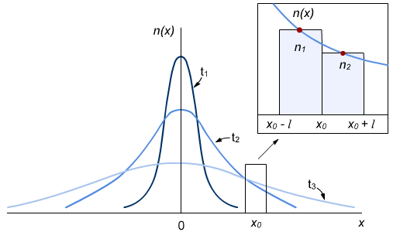
Spatial distribution of electron density as at three different times. The inset shows an approximate representation of carrier densities in regions on either side of an arbitrary point.
Now, if we assume that the slope of the distribution in the small region in space is quasi-linear on the length scale of the scattering length, we can write
$$n_{1}=n\left(x_{o}\right)-\frac{dn}{dx}\frac{l}{2}, n_{2}=n\left(x_{o}\right)+\frac{dn}{dx}\frac{l}{2}$$
(19)
When substituted into equation (17) we see that the $n(x_{o})$ terms cancel leaving us with
(20)
$$Φ=-\frac{l^{2}}{2τ}\frac{dn}{dx}$$
which tells us that the rate of diffusion is proportional to the negative slope of the distribution up to a constant that is normally called the diffusion coefficient, $D_{d}.$ Now we can also define the diffusion current as
$$j_{d}=qΦ=eD_{d}\frac{dn}{dx}$$
(21)
for electrons where $e$ is the charge of an electron. Where the diffusion current for holes is the same form but has a has a minus sign because of the opposite charge.
Now we can complete the expression for the total current density by adding in the regular current that would be attributed to an external bias.
$$j=j_{drift}+j_{diff}=σE+eD_{d}\frac{dn}{dx}$$
(22)
We can express $σ_{n}=neμ_{n}$, $σ_{p}=peμ_{p}$ also where $μ$ can be the mobility of either electrons or holes, which allows us to write
$$j_{p}=e\left(pμ_{p}E-D_{p}\frac{dp}{dx}\right), j_{n}=e\left(nμ_{n}E+D_{n}\frac{dn}{dx}\right)$$
(23)
and we have retained our normal definition of $n$ and $p$ with the caveat that they now have an extra term in the exponent to deal with the applied voltage, and we have introduced the subscript on the diffusion coefficients since electrons and holes won’t generally have the same diffusion coefficient on account of the effective masses.
Now, we can gain some insight onto the nature of photoconductivity by looking at the rate (or continuity) equation which will start by telling us something about the change in the amount of
Figure 3 Evolution of current through a solid⁹

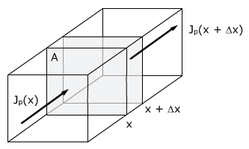
The current density at a point $x$, and then at some time later, it will take on the value $j(x+Δx)$.
carriers in a volume $AΔx$. Basically, the change in the carrier concentration per time is going to be the sum of the change in the particle flux from $x$ to $x+Δx$, the intrinsic (thermal) generation ($g$) and recombination ($r$) rates, and the external generation rate ($G$) or
(24)
$${\left.\frac{dn}{dt}\right|}_{x→x+Δx}=\frac{1}{q}\frac{j_{n}\left(x\right)-j_{n}(x+Δx)}{Δx}+\left(g-r\right)+G$$
Which we can write in derivative form as
(25)
$$\frac{dn}{dt}=\frac{1}{q}\frac{dj}{dx}+\left(g-r\right)+G$$
At this point I should probably mention that I’ve been being a little bit lazy with my notation, since we have been in one dimension for most of this derivation, but in general, $j$ should be written as a vector and the spatial derivative should be replaced by the gradient operator.
In any case, the term $\left(r-g\right)$ is often times assumed to be proportional to the excess electron density, $n_{e}$, which was defined at the beginning of this chapter, and we will write the constant of proportionality as a time constant, $τ_{n/p}$, to denote the electron or hole lifetime in the material so that
(26)
$$n_{e}=τ_{n}\left(r-g\right).$$
and we can expand the spatial derivative of the $j$ term in order to write the full expression for the continuity equation, this time with proper vector notation so that
$$\frac{dn}{dt}=\frac{1}{e}∇∙\vec{j}+G-\frac{n_{e}}{τ_{n}}$$
(27)
$$\frac{dn}{dt}=μ_{n}\left(n∇∙\vec{E}+\vec{E}∇n\right)+D_{n}∇^{2}n+G-\frac{n_{e}}{τ_{n}}$$
where the electric field is assumed to be a constant in the material so that
(28)
$$\frac{dn}{dt}=μ_{n}\left(\vec{E}∇n\right)+D_{n}∇^{2}n+G-\frac{n_{e}}{τ_{n}}$$
Now that we’ve, found the master rate equation, we’ll look at the steady state illumination so that the change in carrier concentration goes to $0$, and also that the illumination is spatially homogeneous so we can ignore the concentration gradient terms. When this is the case, we see that
(29)
$${Gτ}_{n}≈n_{e}.$$
Doing so makes it much easier to find an expression for the photoconductivity. So, when an external bias is applied, we can write
(30)
$$\vec{j}={\vec{j}}_{p}+{\vec{j}}_{n}=σ\vec{E}=e\left(pμ_{p}+nμ_{n}\right)\vec{E}$$
and since $n=n_{o}+n_{e}$, and $p=p_{o}+p_{e}$, we can separate the conductance into the intrinsic conductance of carriers $σ_{o}$ and the photoconductance $σ_{ph}$. Additionally, we will assume that the generation rate of electrons and holes is the same, which sounds very plausible when thinking about exciton generation, and also that the lifetime for electrons and holes is also the same, or $τ_{n}=τ_{e}=τ$ and therefore $n_{e}=p_{e}=Gτ$. This second assumption doesn’t seem like it would work as well, but it gives us the nice simple form
$$σ_{o}=e(p_{o}μ_{p}+n_{o}μ_{n})$$
(31a)
$$σ_{ph}=e\left(μ_{p}+μ_{n}\right)Gτ$$
(31b)
And with this we will end our discussion of the diffusion and photoconductance in a solid.
1.3 The P-N junction
No discussion of photoexcitation in a semiconductor would be complete without talking about the P-N junction, in which we bring together two semiconductors with different dopants at a sharp interface so that one side has an excess of electrons and the other an excess of holes. This can be achieved in numerous ways, but I’m not really concerned about the practical considerations, though reference 7 certainly is.
Figure 3 The P-N Junction¹¹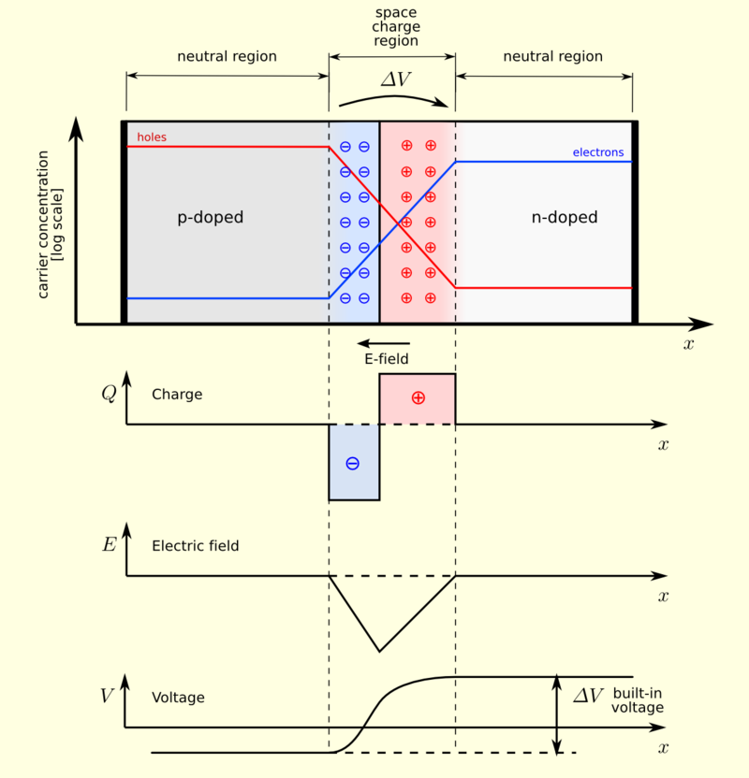
x_{n}
0
-x_{p}

We’ll begin by finding the width of the depletion region, and then continue on to calculate the current due to carriers generated near the depletion region.
As depicted in Figure 3, we can see that the interface between some bit of material that is positively charged and one that is negatively charged will have some electric field near the interface due to the charge imbalance there. We can find the width of this region by considering Poisson’s equation, $∇\vec{E}=ρ/ϵ$, where $ρ$ is the charge density and $ϵ$ is the permittivity in the material. We can write
(32)
$$ρ=e(N_{D}-N_{A}-n+p)$$
for the charge density there, where $N_{D}$ is the density of n-type dopants and $N_{A}$ is the density of p-type dopants. We generally consider the intrinsic charge densities in the depletion region to effectively cancel each other out so that $p-n=0$. We will also use $x=0$ as the barrier location, and the edges of the depletion region on the p-doped and n-doped sides will be called $-x_{p}$ and $x_{n}$, respectively. (We will follow the derivation from reference 12 here in all of its glorious detail) Then we can integrate Poisson’s equation to get
(33a)
$$\vec{E}=\int{ρ}dx=\int{-\frac{eN_{A}}{ϵ}dx}=-\frac{eN_{A}}{ϵ}x+C_{1}, -x_{p}≤x<0$$
$$\vec{E}=\int{ρ}dx=\int{\frac{eN_{D}}{ϵ}dx}=\frac{eN_{D}}{ϵ}x+C_{2}, 0<x≤x_{n}$$
(33b)
These integrals are solved simply, but we must solve for the constants of integration in each case using boundary conditions. In order to do this, we assume that the electric field on the very edge of the depletion region is $0$. Then we find that
$$\vec{E}=-\frac{eN_{A}}{ϵ}\left(x+x_{p}\right), -x_{p}≤x<0$$
(34a)
$$\vec{E}=\frac{eN_{D}}{ϵ}\left(x_{n}-x\right), 0<x≤x_{n}$$
(34b)
Now we can integrate one more time to find that
(35a)
$$V\left(x\right)=\int{-}E\left(x\right)dx=\int{\frac{eN_{A}}{ϵ}\left(x+x_{p}\right)=\frac{eN_{A}}{ϵ}\left(\frac{x}{2}+x_{p}\right)}x+C_{3}, -x_{p}≤x<0$$
(35b)
$$V\left(x\right)=\int{-}E\left(x\right)dx=\int{\frac{eN_{D}}{ϵ}\left(x_{n}-x\right)=\frac{eN_{D}}{ϵ}\left(x_{n}-\frac{x}{2}\right)}x+C_{4}, 0<x≤x_{n}$$

Solving for the constants here is pretty simple. One can just set $V(x=-x_{p})=0$, since we always measure the potential in reference to something and we get to make the choice to make our lives easy. Doing so will let us solve for $C_{3}$ Then, from boundary conditions, we require that $V_{A}\left(x=0\right)=V_{D}(x=0)$ which will allow us to solve for $C_{4}$. Then finally we find that
$$V\left(x\right)=\frac{eN_{A}}{2ϵ}(x+x_{p})^{2}, -x_{p}≤x<0$$
(36a)
$$V\left(x\right)=\frac{eN_{D}}{ϵ}\left(x_{n}-\frac{x}{2}\right)x+\frac{eN_{A}}{2ϵ}x_{p}^{2}, 0<x≤x_{n}$$
(36b)
Now, we can define the maximum voltage to be $V(x_{n})≡V_{0,}$ or the “built-in voltage,” as it is often referred to. Thus
(37)
$$V_{o}=\frac{e}{2ϵ}(N_{D}x_{n}^{2}+N_{A}x_{p}^{2})$$
We can also get one more condition that will help us in understanding the depletion region. It is the condition that $E_{A}\left(x=0\right)=E_{D}(x=0)$, which when applied to equations (34a,b) tells us that
(38)
$$N_{D}x_{n}=N_{A}x_{p}$$
With this, we can solve for the depletion regions on the n and p sides, respectively, to find that
$$x_{n}=\sqrt{\frac{2ϵV_{o}}{e}\frac{N_{A}}{N_{D}(N_{A}+N_{D})}}, x_{p}=\sqrt{\frac{2ϵV_{o}}{e}\frac{N_{D}}{N_{A}(N_{A}+N_{D})}}$$
And finally, the width of the depletion region is
(40)
(39)
$$W=x_{n}+x_{p}=\sqrt{\frac{2ϵ}{q}V_{o}(\frac{N_{D}+N_{A}}{N_{D}N_{A}})}$$
The last remark we will make about this is that equation (16) can be employed to separately calculate the built-in voltage $V_{o}$. We just divide both sides of the equation by the charge of an electron to give us units of voltage, then recognize the fact that n and p in that equation must but equal to the dopant concentration in the depletion region, since there is no other source for the charge density there. Then we find, independently, that
$$V_{o}=\frac{k_{b}T}{e}ln⁡(\frac{N_{A}N_{D}}{n_{i}^{2}})$$
Now, we should have almost everything we need to find out what the current will be due to illumination at the edge of the depletion region of the P-N junction. Almost. We are going to ignore the current that is made as a result of majority carrier diffusion near the depletion region edges, since both electrons and holes will produce pretty close to the same amount of current in opposite directions. Also, since there are effectively no intrinsic charges in the depletion region, we will not worry about current generation coming from there. It is the case that when talking about currents due photoexcitation, one usually only considers the minority carriers in the region of interest. That is to say, in the n-type side of your junction, one will only consider the p-type population due to excitation. This is because the fractional change in the amount of carriers is only significant for the minority carriers, and so the quasi-Fermi level of the majority carriers will move very little (unless the illumination is very strong), but the quasi-Fermi level of the minority carriers will be affected by a much more appreciable amount¹⁰. With this in mind we will define the minority terms $p_{n}$and $n_{p}$to denote the carrier (letter) and region (subscript). Further, we’ll need the boundary condition that¹³
$$p_{n}\left(x=x_{n}\right)=p_{no}e^{\frac{eV}{k_{b}T}}, n_{p}\left(x=-x_{p}\right)=n_{po}e^{\frac{eV}{k_{b}T}}$$
(42)
(41)
where the $e$ in the argument of the exponential function is the electron charge and V is the voltage. In every reference I’ve been able to find, I haven’t been able to find a good explanation for how to come up with this boundary condition, so we’re going to take it as canon, and move on.
So, now we want to solve the continuity equation (28). We’ll do so under the condition of steady state illumination, so there will be no time dependence, and we’ll assume that the generation term $G$ is a constant that doesn’t vary spatially, even though generally this is not the case. Also, the electric field just on this edge is very very close to zero and so the drift term will also disappear. Then the continuity equation on the n-type side becomes
(43)
$$∇^{2}p_{n}=\frac{p_{ne}}{τ_{p}D_{p}}-\frac{G}{D_{p}}=\frac{p_{ne}}{{l_{p}}^{2}}-\frac{Gτ_{p}}{{l_{p}}^{2}}$$
where we have used $l_{p}=\sqrt{D_{p}τ_{p}}$. Now, since $p_{ne}=p_{n}-p_{no}$, it just so happens to be the case that $∇^{2}p_{n}=∇^{2}p_{ne}$, so we will find the general solution for this differential equation by making that change of variables. Nominally, the general solution is
(44)
$$p_{ne}\left(x-x_{n}\right)=Ae^{-\frac{x-x_{n}}{l_{n}}}+B{e }^{\frac{x-x_{n}}{l_{n}}}+Gτ_{p}$$
Here, we can throw out the $B$ term immediately, because we must require that $p_{ne}\left(x→∞\right)≠∞$, so that our carrier concentration remains over all space. Then from equation (42), we find that
(45)
$$A=\left[p_{no}\left(e^{\frac{eV}{k_{b}T}}-1\right)-Gτ_{p}\right]$$
and then finally,
(46a)
$$p_{n}\left(x-x_{n}\right)=\left[p_{no}\left(e^{\frac{eV}{k_{b}T}}-1\right)-Gτ_{p}\right]e^{-\frac{x-x_{n}}{l_{p}}}+Gτ_{p}+p_{no}$$
where we’ve substituted the original quantity of interest, $p_{n}$, back into the equation instead of the excess concentration term. Similarly, we can go through this derivation on the other side of the junction to find that
$$n_{p}\left(x+x_{p}\right)=\left[n_{po}\left(e^{\frac{eV}{k_{b}T}}-1\right)-Gτ_{n}\right]e^{\frac{x+x_{p}}{l_{n}}}+Gτ_{n}+n_{po}$$
(46b)
where we actually took the positive coefficient, $B$, in this case since $x$ will always be negative on this side of the junction
And now that we’ve found the general expression for the carrier concentrations, we are free to calculate the current from the definition, and in particular, we want this at the edge of the depletion region of interest so we’ll calculate
(47a)
$$j_{p}=-eD_{p}\frac{dp_{n}}{dx}|_{x=x_{n}}=\frac{eD_{p}p_{no}}{l_{p}}\left(e^{\frac{eV}{k_{b}T}}-1\right)-\frac{eD_{p}}{l_{p}}Gτ_{p}$$
$$j_{n}=eD_{n}\frac{dn_{p}}{dx}|_{x={-x}_{p}}=\frac{eD_{n}n_{po}}{l_{n}}\left(e^{\frac{eV}{k_{b}T}}-1\right)-\frac{eD_{n}}{l_{n}}Gτ_{n}$$
(47b)
$$j_{tot}=j_{p}+j_{n}=\left(\frac{eD_{p}n_{i}^{2}}{l_{p}N_{D}}+\frac{eD_{n}n_{i}^{2}}{l_{n}N_{A}}\right)\left(e^{\frac{eV}{k_{b}T}}-1\right)-eG(l_{p}τ_{p}+l_{n}τ_{n})$$
(47c)
Or in the more standard form
(48)
$$j_{tot}=j_{o}\left(e^{\frac{eV}{k_{b}T}}-1\right)-j_{ph}$$
We can interpret this response as follows. The first term represents the standard dark current from a biased P-N junction and gives essentially the same curve for a diode. In order to reflect this, I’ve rewritten the equilibrium minority carrier density in terms of the intrinsic carrier density and defect density in equation (47c), as this is generally how it is presented in the literature. The second term is the term that is associated with photoexcitation and carrier generation due to illumination. This term acts like a constant offset which allows for current to be flowing even under negative bias and has the effect of shifting the open circuit voltage. Figure 4 gives a nice depiction of what is happening.
Figure 4 Current as a function of voltage¹⁵
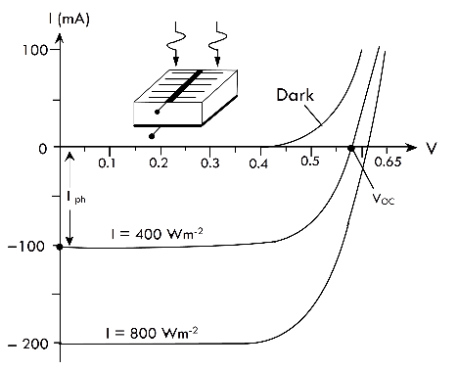
The dark current is labeled above and is reminiscent of the standard P-N junction or diode turn-on behavior. The other lines are the same transport curve, but with under different intensity illuminations, where I is intensity and the units are labeled.
With this, we’ll conclude our discussion of photoexcitation and subsequent transport in semiconductors.

.

Bibliography
1. https://en.wikipedia.org/wiki/Edmond_Becquerel
2. https://en.wikipedia.org/wiki/William_Grylls_Adams
3. https://en.wikipedia.org/wiki/Timeline_of_solar_cells#1800s
4. https://www.google.com/patents/US389124
5.http://www.nature.com.ezproxy.proxy.library.oregonstate.edu/nature/journal/v7/n173/abs/007303e0.html
6. https://en.wikipedia.org/wiki/Russell_Ohl
7. H. J. Moller, Semiconductors for Solar Cell, Artech House, 1993 Chapter 2
8. https://nanohub.org/resources/11818/download/notes_on_FD_integral3rdEd_revised_080411.pdf
9. http://www.pveducation.org/pvcdrom/pn-junction/diffusion
10.Blakemore, Solid State Physics, W.B. Saunders Company, 1974, Chapter 4
11. https://en.wikipedia.org/wiki/P%E2%80%93n_junction
12. http://www.pveducation.org/pvcdrom/pn-junction/solving-for-depletion-region
13. http://www.pveducation.org/pvcdrom/pn-junction/solving-for-qnr
14. http://www.pveducation.org/pvcdrom/pn-junction/wide-base-diode
15. http://nptel.ac.in/courses/113106062/Lec19.pdf

Other equations for the presentation
$$n_{o}≈\frac{1}{3π^{2}}\left[\frac{2m_{c}\left(ϵ_{f}-ϵ_{c}\right)}{ℏ^{2}}\right]$$
$$\frac{φ_{n}{-φ}_{p}}{e}=\frac{k_{b}T}{e}ln(\frac{np}{n_{i}^{2}})$$
$$E\left(x=-x_{p}\right)=E\left(x=x_{n}\right)=0$$
$$p_{ne}\left(x→∞\right)≠∞$$
$$n_{pe}\left(x→-∞\right)≠∞$$

