X-RAY SCATTERING AND MOSELEY’S LAW

OBJECTIVE: To investigate Moseley’s law using X-ray absorption and to observe X-ray scattering.

READING: Krane, Section 8.5.

BACKGROUND: In 1913, Henry Moseley measured the frequencies of the X rays emitted by the elements and showed that X-ray frequencies could be used to deduce the atomic number Z of the element. This was the first experiment that allowed a direct determination of the atomic number. Prior to Moseley’s work, the periodic table was arranged according to the atomic weight of the elements, which does not always give the same ordering as atomic number. For example, potassium (Z = 19) has atomic weight 39.1, while argon (Z = 18) has atomic weight 39.9. If the elements were ordered by atomic weight, potassium would come before argon and would fall in the inert gas column of the periodic table, while argon would be placed in the first column, among the most reactive of elements. Using atomic number gives the proper positions of these elements.
n = 4
(N shell)

X rays occur in atoms when an inner electron
n = 3
(M shell)
is removed and electrons from higher energy
levels fill the vacancy. The X-ray series are
n = 2
(L shell)
labeled according to the level in which the
L_{α} L_{β}
L series
original vacancy was created. Figure 1 shows
the K and L series.

If an electron is removed from the n = 1 atomic
level (which is also known as the K shell), such
n = 1
(K shell)
as by bombarding the atom with electrons or
K_{α} K_{β} K_{γ}
K series

photons, electrons from the n = 2 levels (2s
or 2 p, known as the L shell) can fill the
vacancy. When an electron makes the transition
from n = 2 to n = 1, a photon is emitted of energy
Figure 1
equal to E₂ − E₁. This is called a K_{α} X ray. It is also
possible for a n = 3 electron (3s, 3p, or 3d, known as
the M shell) to make the transition. This gives the
K_{β} X ray. Electrons that jump to the K shell from successively higher shells are then called K_{γ} (n = 4 to n = 1), K_{δ} (n = 5 to n = 1), and so forth. Note that the series are labeled by the shell that the electron jumps to, not from. The L series of X rays corresponds to jumps from higher levels to n = 2.

In grouping these X rays into series, we are ignoring the small energy differences between orbitals within the shells. For example, the energy difference between 2s and 2p is small and can be neglected. We thus can consider the K_{α} energy to represent all transitions from any n = 2 state to the n = 1 state (the 1s level).
Let’s look at the K_{α} X ray. If an electron is removed from the n = 1 shell, the n = 2 electron that makes the jump to fill the vacancy sees an effective nuclear charge of Z−1 (due to Z positive charges in the nucleus and one remaining n = 1 electron). Under this assumption, the frequency of the K_{α} X ray can be derived as:

(1)

where R∞ is the Rydberg constant (1.097 × 10⁷ m⁻¹). Measuring the frequency of the X ray thus allows the atomic number to be calculated.

In this experiment, a beam of electrons is accelerated through 30 kV and hits a copper target, where X rays are produced by bremsstahlung with energies up to 30 keV. These X rays then strike a metal target, which we shall call the X-ray production target. The X rays can knock loose K electrons from the target atoms, following which the target will emit K-series X rays of discrete wavelengths. These X rays then strike an absorber, and a detector counts the number of X rays that pass through the absorber. A schematic diagram of the process is shown in Figure 2.
X rays
Detector
Bremsstrahlung

30 kV
electrons

Copper
target
X-ray
production target
Absorber

Figure 2

Let’s consider for example Fe as the X-ray production target. It takes 7.11 keV to remove a K electron from Fe (the K electron binding energy). The bremsstrahlung beam extends up to 30 keV, so there is enough energy in the beam to produce K-shell vacancies in the Fe atoms. When those vacancies are filled, Fe emits K_{α} and K_{β} X rays with energies 6.40 keV and 7.06 keV, respectively.

Suppose we also use Fe as the absorber. The K_{α} and K_{β} X rays emitted by the production target have too little energy to remove a K electron from the absorber (they can remove L electrons, which are much less tightly bound to the atom). If we replace the Fe absorber with Cr (keeping the Fe production target), the Fe X rays have enough energy to eject a K electron from Cr (which requires only 5.99 keV). Thus there should be much more absorption of the Fe X rays by Cr than by Fe, and the detector should record a lower counting rate with Cr than Fe.
The following table shows the K_{α} and K_{β} X ray energies and the K electron binding energy of the elements that you will use for either production targets or absorbers in this experiment.
Table 1

Element | Z | K_{α} energy (keV) | K_{β} energy (keV) | K binding energy (keV)
V | 23 | 4.95 | 5.43 | 5.47
Cr | 24 | 5.41 | 5.95 | 5.99
Mn | 25 | 5.90 | 6.49 | 6.54
Fe | 26 | 6.40 | 7.06 | 7.11
Co | 27 | 6.93 | 7.65 | 7.71
Ni | 28 | 7.48 | 8.26 | 8.33
Cu | 29 | 8.05 | 8.91 | 8.98
Zn | 30 | 8.64 | 9.57 | 9.66

Typically the intensity of the K_{α} X rays is about an order of magnitude larger than the K_{β} X rays, so most of your data in this experiment comes from the K_{α} X rays.

APPARATUS: Figure 3 shows a diagram of the X-ray apparatus for this experiment.
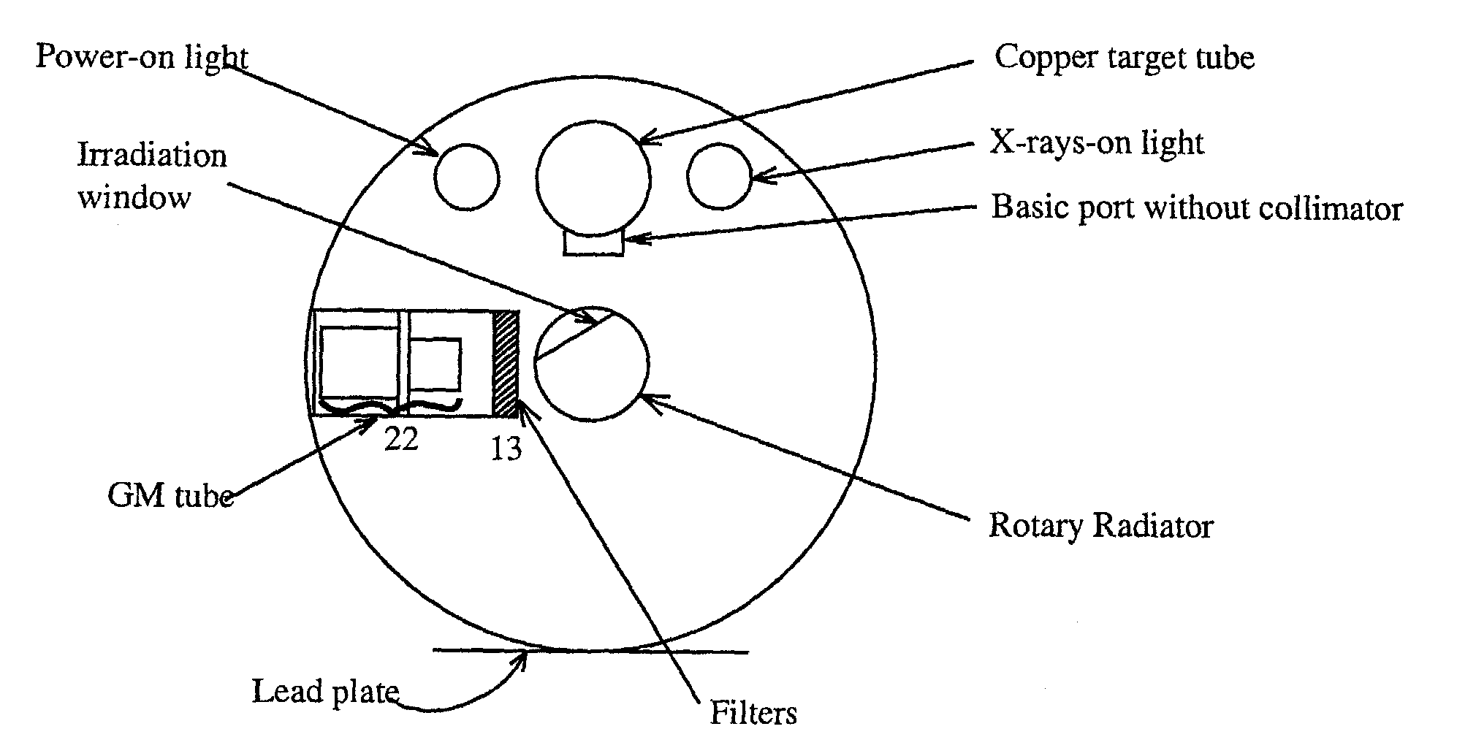
Figure 3

The rotary radiator has two windows. One, called the irradiation window, will contain the X-ray production foil (one of 8 elements). In the other window is displayed the symbol for the element in the irradiation window. A cable attached to the rotary radiator allows you to place one of the 8 elements in the irradiation window.
WARNING: X rays are a health hazard. The equipment has been designed to shield the user from direct exposure to X rays. A safety interlock prevents the lid of the apparatus from being raised when the X-ray beam is on. Do not force the lid open or attempt to tamper with or to defeat the purpose of the safety interlock.

EACH X-RAY UNIT HAS A LOG BOOK. EVERY STUDENT USING THE APPARATUS MUST SIGN WITH THE DATE AND TIME THE APPARATUS HAS BEEN USED.

PROCEDURE: By turning the keylock switch to the horizontal, turn on the filament power. Set the front timer on the X-ray unit to 50 minutes. The purpose of this timer is to preserve the life of the X-ray tube by avoiding its being left operating for too long. During the experiment you can periodically reset the timer to keep the unit from turning off while you are taking data.

With the filament on, allow the X-ray tube to warm up for at least 15 minutes. This is necessary in order to eliminate condensation in the tube.
WARNING: Failure to allow proper warm-up time will damage the tube.

Units A,B,C: Turn on the scaler and the GM tube high-voltage supply. Check that the high-voltage setting for the GM tube is the same as the operating voltage posted just above the control knob.
Units D,E,F: Check the high voltage reading on the GM tube using channel 4 of the display unit. Return the display to channel 1 for counting. The counting unit reads out the count rate per second. To get the actual number of counts, multiply the rate by the counting interval. Pause the count cycle to allow you to move the detector by pressing and releasing the Hold button. Restore the counting cycle by pressing Hold again.

Open the cover of the X-ray apparatus and set the accelerating voltage switch to the 30 kV position.

Close the cover of the X-ray apparatus and slide the cover toward the center locked position. This allows the X-ray tube to be energized.

Depress the X-ray tube power switch and observe that the red light inside the apparatus comes on. If it does not, make sure the cover is centered and try again.

Observe the X-ray tube current on the microammeter. It should be 50 μA. Adjust if necessary. The current has a tendency to drift. During the experiment, monitor the current and adjust it to keep it at 50 μA. DO NOT ALLOW THE CURRENT TO EXCEED 80 μA, BECAUSE DAMAGE TO THE TUBE WILL RESULT.
PROCEDURE: Before taking data, make sure that: (1) the voltage switch is set to 30 kV; (2) the carriage arm is at 90º; (3) the irradiating window is at an angle of 45º with respect to the X-ray beam; and (4) te GM tube is at position 22 on the carriage arm.

Place the blank slide at position 13 in the carriage arm. For each foil in the radiator, determine the intensity I₀ in counts/second. The foils in the radiator can be changed using the cable connected to the radiator, so it is not necessary to raise the lid of the X-ray unit.

Replace the blank slide with one of the 8 filters and measure the intensity I for each of the 8 foils in the radiator. Record your data and repeat for each of the 8 filters.

For each filter, calculate I/I₀ for each of the 8 X-ray production targets in the rotary radiator. Then plot I/I₀ against the atomic number. Do this for each of the 8 filters. You should have 8 separate plots, each with 8 points.

Compare your results with what is expected based on the data given in Table 1.

