SKIN

Objectives for Exam #1:
- List various skin structures and describe their functions.
- Describe skin responses to increases and decreases in body temperature.
- Provide examples of various skin disorders, including characteristics of skin cancers.
Objective for Portfolio #1:
Label different structures found in a model of the skin.
Safety Notes:
Be careful with the microscope slides, they can break into small sharp pieces.
Report any broken glass to your GTA. Avoid placing any food or drink near glass.

Part I: Skin Stations
You will have an opportunity to cycle through different stations. You can work independently, or with classmates at each station.

Station A: Examination of Skin
- Using a hand magnifier, examine the skin on your forearm, the back of your hand, and fingertips. Describe how the skin differs in appearance at these different locations.

Location | Skin Appearance
Forearm
Back of Hand
Fingertips

- What is the advantage of having highly textured fingertips?

- How is the skin structured around the finger joints to allow for flexible movement of the fingers?

- Which area of your skin appears to be driest? ______________________________ Why is it important that skin does not become too dry? (consider what happens when skin on parts of the body, like the lips, becomes extremely dry)

- After your hands and feet are submerged under water for a long period of time, how do they change in appearance? _____________________ There is still debate as to why this occurs. From the display, what is the most likely explanation?

- Most humans have areas of darker skin pigmentation that develop over time (“freckles”), in part due to an increase in the amount of the pigment melanin in cells called melanocytes. Which area of your skin has the most spots of darker pigmentation? __________________________ Considering these locations, what may be the primary cause of increased changes in pigmentation? ________________________________________

- What is the role of the protein keratin in the skin? ________________________________

Touch
- From the Touch poster (bottom left), what can nerve endings in the skin detect?

- Also from the poster, damaged cells release ______________ that activate nerve endings.

- Look at the heavy pressure touch receptors under the microscope. What is their basic shape?

Station B: Skin Models
- Using the model and The Skin poster as a reference, indicate the three basic layers: epidermis, dermis, and hypodermis (also called subcutaneous layer) on the photo below:
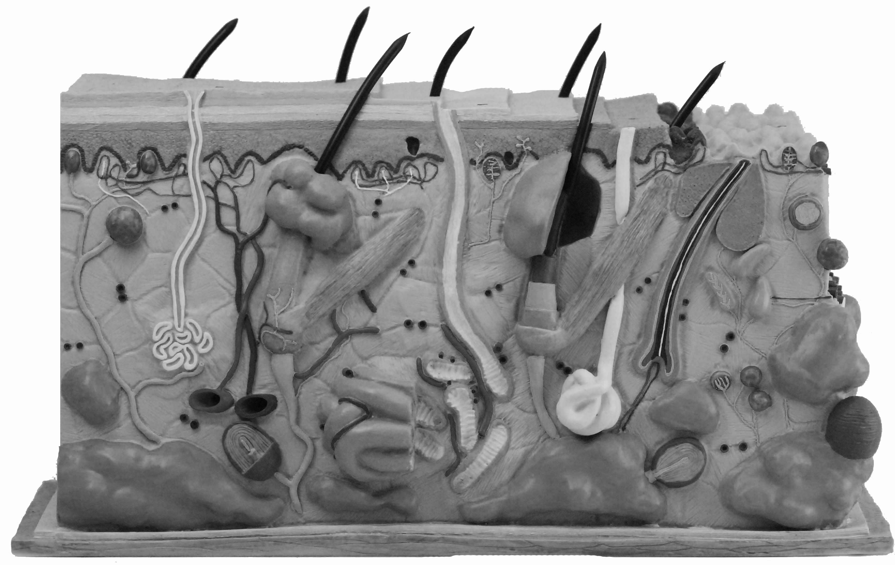

- From the model and Magnified Cut-Out Section of the Skin poster, list structures that are located in the dermis:

- On the photo below, indicate the structural differences between the skin of the scalp and the skin of the sole (bottom) of the foot:

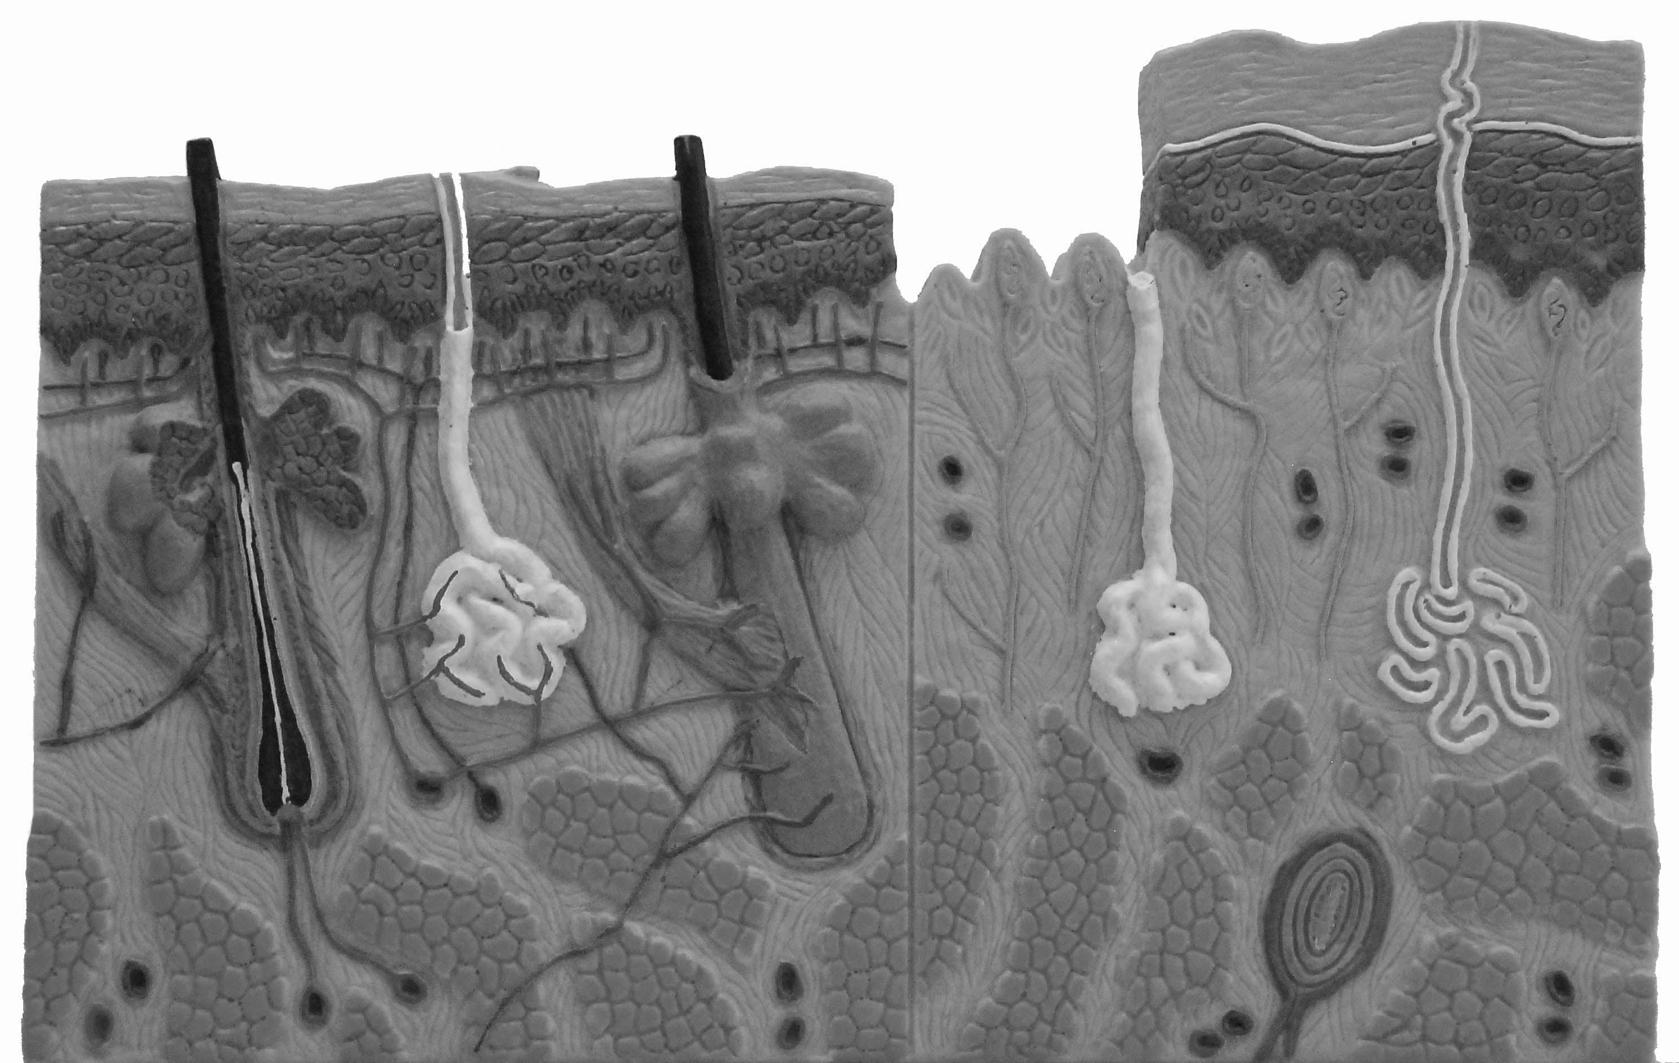
Station C: Skin Functions
- Using the display and the Human Body book, p. 54-55, for each of the following skin structures, summarize their basic function in the table below.

Skin Structure |  | Function
Epidermis | Squamous Epithelial Cell Layer
Epidermis | Prickle Cell Layer
Epidermis | Basal Cell Layer
Dermis | Dermal Loose Connective Tissue
Dermis | Blood Vessel
Dermis | Neurons/Nerve Cell
Dermis | Hair Follicle
Dermis | Arrector Pili Muscle
Dermis | Sweat Gland
Dermis | Sebaceous Oil Gland
Hypodermis | Subcutaneous Fat
Hypodermis | Connective Fibrous Tissue Layer
Hypodermis | Muscle Tissue Layer

Station D: Hair and Nails
Hair
- From the display, each hair has an __________________________ muscle and a ______________________ gland. Examine the miscoscope slide of hair in skin. Are the muscles and glands visible? _______________

- From The Human Hair mini-poster, what cells produce melanin, which gives hair its color? _____________________________ Looking at the microscope at hairs of different colors, what is missing in the grey hair? ___________________________

- Back to The Human Hair mini-poster Each hair follicle goes through a growth cycle. How long does the active growth phase (“anagen”) typically last? ______________________ Following a 1-2 week transition (“catagen”) phase and the 5-6 week resting (“telogen”) phase, what happens to the hair? _______________________________ What does the hair follicle start to produce? ___________________________________

- What biologically produces straight hair versus wavy hair?

Nails
- Human nails are translucent sheets of dead cells produced by the ____________________. Fingernails grow faster than toenails, approximately how much does a nail grow in a month? __________________________

Station E: Microscope Use
- Microscopes will be used extensively in BI 103. From the Microscope Focusing Tips poster, the top three tips for successful microscope are at the top of the poster. What are they?

- Before examining tissues and cells, you will build microscope skills through a classic “color threads” focusing activity. Use the following procedure to examine the sample microscope slide (threads):
- Turn on the microscope (with the power dial set between 7 and 8).
- Turn the objective ring to the lowest power of magnification (4X objective).
- Place the slide on the stage and position under the specimen holder.
- Rotate the focus knobs to carefully move the slide into focus.
- Use the stage knobs to move the slide around.
- Carefully move the objective ring to the next higher power objectives (10X and then 40X) and continue examining the slide.
- Which thread (red, blue, or yellow) is on top of the others? ______________ (check your answer with your GTA)

- The eyepieces on your microscope have a magnification of 10X. If you are using a 4X objective, what is the total magnification of the slide you are observing (multiply the two numbers)? ______ With a 10X objective? ______ With a 40X objective? ______

Station F: Epithelial and Connective Tissues
- From the bottom of the Cells poster, animal cells are grouped into __________________. These tissues are groups of cells that work together. Match each tissue with its primary function

A. Epithelial Tissue | _____ joins the body’s tissues together.
B. Connective Tissue | _____ communication and response to stimulus.
C. Muscle Tissue | _____ lines body surfaces, both internal and external.
D. Nervous Tissue | _____ movement.
- The skin organ primarily contains two tissues. From the display, which two tissue types?

Epithelial Tissue:
- There are three general types of epithelial tissues: simple squamous, simple cuboidal, and simple columnar.
  - From the Epithelial Tissue poster, simple squamous epithelial tissue is made up of ______________ cells with large central nuclei. Where is simple squamous tissue found in the human body? _________________________________________________________
  - Simple cuboidal cells are ___________-shaped. Where is simple cuboidal tissue found in the human body? _________________________________________________________
  - Columnar epithelial cells are __________-shaped. Where is simple columnar tissue located in the human body? _______________________________________________________
- Epithelial tissues can be combinations of different shaped cells. From the Epithelial Tissue poster, human skin is comprised of _________________and _________________ epithelial tissues. The cells start out shaped as cuboidal or columnar in shape at the bottom (basal) layer and become flattened ____________________ cells as they approach the surface.

- Sketch the three general types of epithelial tissue at 400X. Add arrows and the labels that are listed under each tissue name. Hint: Start scanning at a low magnification to find an area to sketch and move up to the higher magnification for your drawing.

Squamous (400X) Cuboidal (400X) Columnar (400X)
Label: plasma membrane & nucleus Label: plasma membrane of cuboidal cells Label: plasma membrane
of the squamous cells & the duct they surround of the columnar cells

Connective Tissue:
- Connective tissues join other body tissues and are diverse in structure. Connective tissues have three components. From the display, these three components are :

- Connective tissues are classified in three groups: embryonic connective tissue (found in embryos before birth), proper connective tissue, and special connective tissues. Using the Connective Tissue poster, fill in where different proper and special connective tissues are located in the human body.

Group | Connective Tissue | Location in Human Body
Proper | Loose (Areolar)
Proper | Dense (Regular)
Proper | Dense (Irregular)
Special | Cartilage (Hyaline)
Special | Bone
Special | Adipose
Special | Blood

- Skin has three types of connective tissue: dense connective tissue in the dermis and within the hypodermis, loose connective tissue surrounding adipose (fat) tissue. Dense and loose connective tissues are made up of elastic fibers, collagen fibers and fibroblasts, the cells that produce the collagen. The fibers are more tightly packed together in the dense connective tissues than the loose connective tissues. Adipose tissue is comprised of adipose (fat) cells within fibers. What is filling up most of the space within the fat cells? __________________

- There are a wide variety of connective tissues. In this laboratory you are examining adipose, loose, and dense connective tissue. Hint: make sure you find the correct tissue before you start to draw.

Adipose (400x) Loose (400x) Dense (400x)
Label: fat cells Label: fibers Label: fibroblasts, collagen

Station G: Skin Microscope Slides
- Examine the skin slide. Make sketches (quick drawings) of what you see. Using the display for assistance, label and draw arrows to the following cell structures in your sketch: epidermis, dermis, sweat glands, adipose tissue.

- The skin slides have been stained with pigments. Why was this staining necessary?

Station H: Thermoregulation
- From your experiences, describe what happens to your skin when your body temperature cools.

- If not in your previous answer, what specifically happens to the arrector pili muscles, hairs, blood vessels, and the muscle layer in the hypodermis when your body temperature cools?

- From your experiences, describe what happens to your skin when your body temperature warms.

- If not in your previous answer, when the body temperature heats up, what happens to the sweat glands and blood vessels?

Station I: Skin Disorders
Acne
- From the display, describe the differences between each of the different forms of acne:

Acne Type | What is occurring in the skin
Blackhead
Whitehead
Pimple

Burns
- From the display, fill in what happens to the skin in different degree burns:

Degree | What happens to the skin
First
Second
Third
Fourth

Station J: Skin Cancer
Ultraviolet light
- One of the leading causes of skin cancer is exposure to ultraviolet light. From display, how does the skin change when exposed to UVB light?

- What type of ultraviolet radiation is most likely to cause the genetic mutations that lead to skin cancer (UVA or UVB)? ___________

- How can UVA damage skin? ____________________________________________________

- Most people think they are mostly exposed to UV light at mid-day and that it is completely blocked by glass. When can you have high exposure to UVB? _________________________ When can you be exposed to UVA? _____________________________

- Are tanning beds “safe” for skin? _____________

- What is the difference between a sunscreen and a sunblock?

- Your GTA can provide you with a “UV bead.” These stay white unless exposed to a range of UV light, typically 360 nm to 300 nm. This includes the high-energy part of UV Type A (400-320 nm) and the low energy part of UV Type B (320-280 nm). Are the beads currently detecting UV light? ___________

Skin Cancer
- From the Skin Cancer poster, moles are _____________________ malformations which mean they are unlikely to spread from their location. However; growth, changes in color, inflammation, or bleeding may indicate the presence of _______________________________. Cancer is a disease in which cells grow uncontrollably in the body. What is the most frequent (and least deadly) type of skin cancer? _____________________ (also called basal cell carcinoma). Malignant melanoma is the most malignant type of skin cancer, meaning it is the most likely to __________________________.

- Staging is the process of identifying how far a cancer has progressed in the body. From the display, what happens to melanoma cancer cells at each of the following five stages?

Stage | What is happening to the tumor (group of cancer cells)?
1
2
3
4
5

- The model has representations of three skin cancers (two types of basal cell, and one melanoma) and other abnormal “pre-cancerous” skin growths that may in some cases develop into skin cancer. In the table below, describe what each of these look like on the surface of the skin, thinking about which of these may be easiest or most difficult to detect.

Skin Disorder | What is Happening in the Skin | What the disorder looks like on the surface of the skin (color, shape, etc.)
Pre-cancer:  Dysplastic Nevi  (DN) | Melanocytes are growing excessively, leaving dark patches of skin like a large irregular mole
Cancer:  Malignant Melanoma (MM) | Melanocytes are growing excessively, this can spread (metastasize) and is the most deadly skin cancer
Pre-cancer:  Actinic Keratosis  (AK) | Cells are growing abnormally producing a rough and dry lesion. This may develop into cancer.
Cancer:  Keratoacanthoma  (KA) | Cell in skin glands grow excessively, this can bleed and spread (metastasize) like squamous cell carcinoma
Cancer:  Nodular Basal Cell (NBC) | Excessive growth of cells in the basal layer of the skin forms a three-dimensional tumor
Cancer:  Morpheic Basal Cell (MBC) | Excessive growth of cells in the basal layer of the skin, these can be flat and shine like a pearl

- From the handout, what are the “A, B, C, D, E s” of detecting skin cancer?

- Basal cell carcinoma is illustrated on p. 312 of Human Body. Examine the basal cell carcinoma slide under the microscope at 400X magnification. The cancerous area typically has irregular structure (“spreading” finger-like projections of cells into surrounding tissue). You can also see this in the skin cancer model you examined for the previous question. Draw what you see and label the skin structures that you are able to observe, including the basal cell carcinoma cancer cells.

400X

Part II: Labeled Skin Structures (for Portfolio #1)
Skill: Label different structures found in a model of the skin. Identifying structures in a three-dimensional model can assist with conceptualizing microscopic structures.

Assignment: Using the large skin model at your table as a reference, label the following structures in the photos on the next page: epidermis, dermis, hypodermis/subcutaneous layer, hair, hair follicle, sebaceous gland, sweat gland, blood vessels, fat (adipose) cells, arrector pili muscle, collagen fibers of the dermis, sensory organ. Use arrows or brackets, if needed, to indicate a specific structure. You do not need to label a structure more than once, for example, if you label the epidermis in one photo, you do not need to label it in the other photo. This assignment needs to be completed in lab (or made up in GTA office hours week two) and stamped to receive credit.

Assessment: This assignment is worth 3.0 points. Each of the 12 correct labels is worth 0.25 point. This assignment requires a stamp to receive credit.

Skin Labeling Assignment
(Include this completed page in Portfolio #1, keep the other skin activity pages)
STAMP

